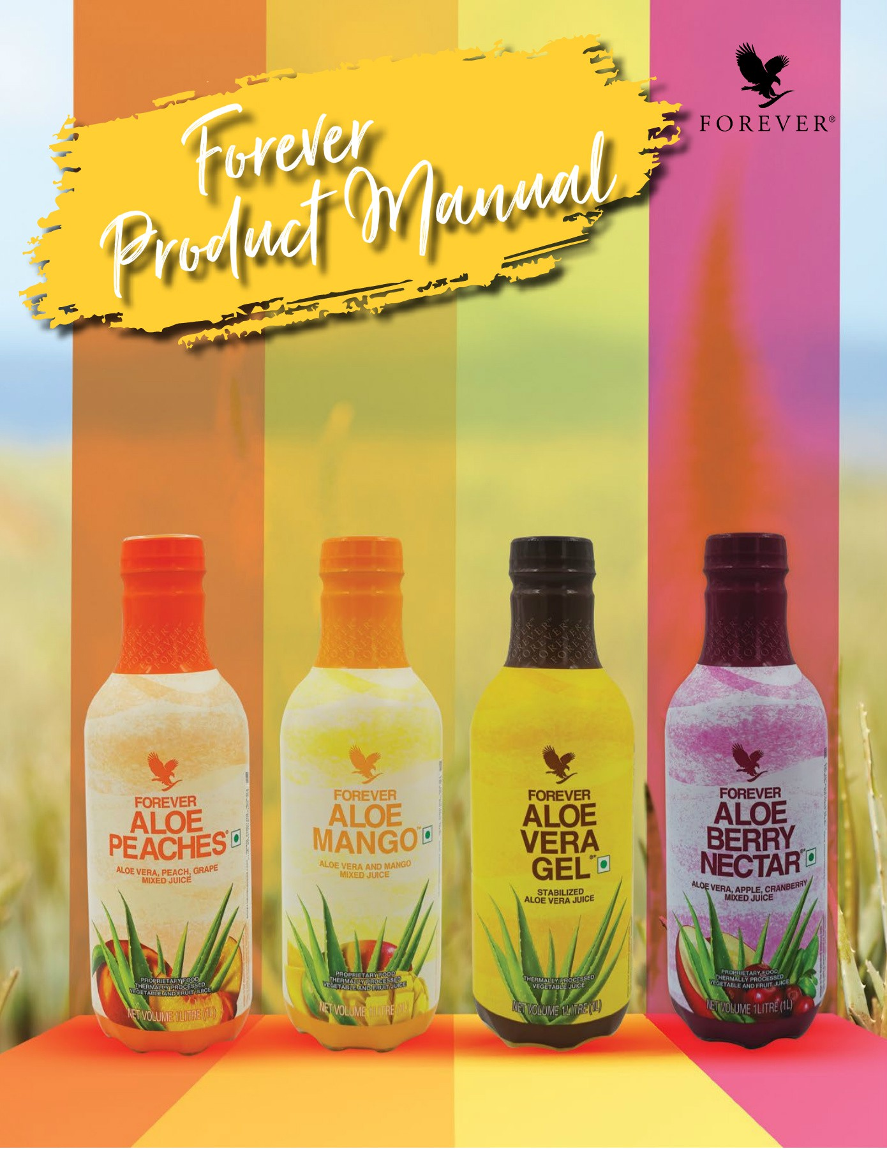

CONTENTS

DRINKS

BEE

NUTRITIONALS

WEIGHT MANAGEMENT

SKINCARE PERSONAL CARE HOUSEHOLD



F O R E V E R‘

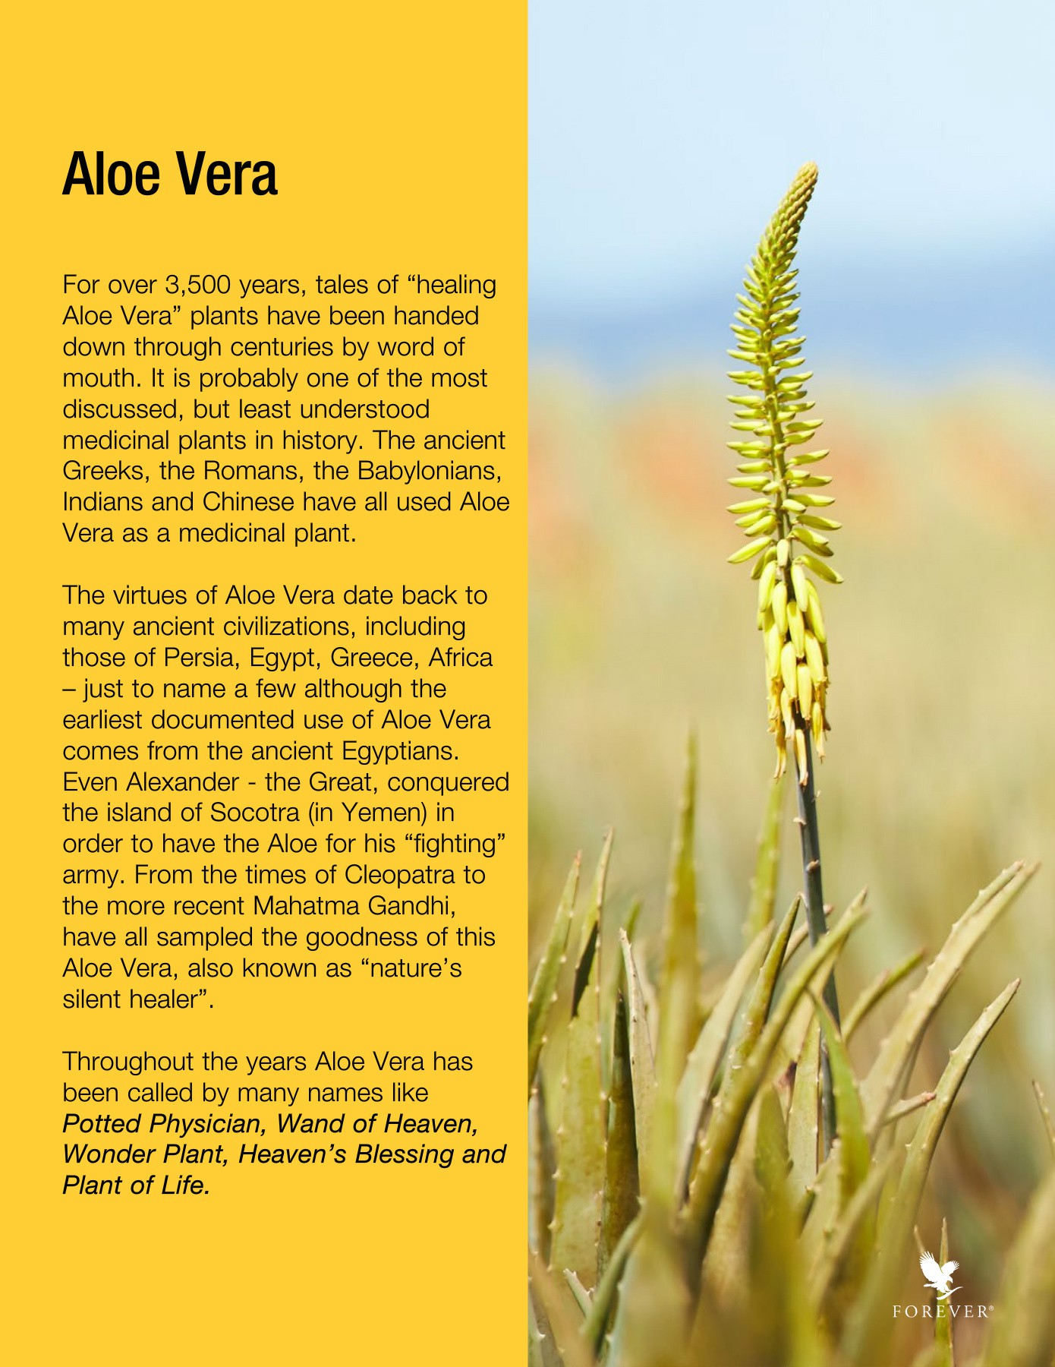



Ouality will always set us apart — Our product, Our people, Our facilities. Next time you are picking up or recommending products, remember this is all made possible by the scientists in our labs, our dedicated farmers, warehouse team and everyone who works to keep the engine running smoothly. You have 45 years of conviction, commitment and quality to stand on. That's not only rare in our industry, it's almost unheard of in any industry and something we can all be

Gregg Maughan

President,

Forever Living Products





In my 30 years of experience with Forever, I've been lucky enough to spend time with the most successful people from across the world and I have observed a few things! And one of the main things is that those leaders who are consistently successful and achieve all that they want to achieve with Forever have something in common!

They are a Product of the Product. What does that mean?

It means that they use the products, understand them, benefit from them, become passionate and knowledgeable experts in the products and then share that passion and knowledge with others.

So, be a Product of the Product and drive GROWTH in your business.

Aidan O'Hare

Presidents,

Forever Living Products



Foreward

: .. ,

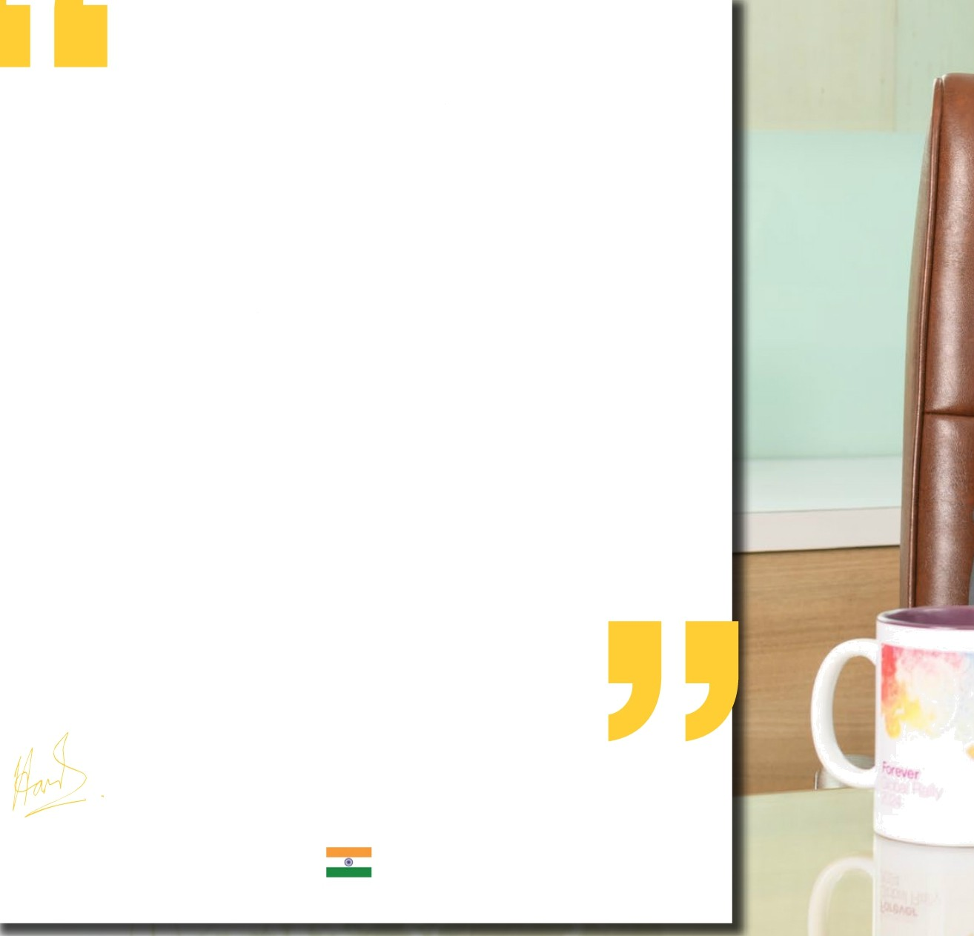We at Forever Living take the business of Nutrition very seriously.

In our quest to bring the best Nutrition supplements to you, we grow, harvest and process the Aloe Vera at our certified farms and factories. Forever ensures that the Aloe Vera reaches you “As Mature Intended”

We not only help the products reach you efficiently, at Forever, we are dedicated to doing our part to positively impact the environment. From every plant that is put in the ground, to the soil it grows in, to the manufacturing plant and the labs where the final product is certified.

Every Forever supplement has a story t0 tell. Every time you think about Forever, think about the high quality “Troon plant to product to you”. Just like the best OT science and nature in our products, we combine technology with the quality to ensure that you get the best out of our products because we put the very best in every step of the way. The stop of every supplement begins with us and continues with you.

We are extremely proud of our heritage and quality of the products. As a result we back our claims with a Product Return Guarantee.

It is our endeavour as a part of this manual to take you on a journey on how

 supplements help fill the nutritional gaps created by our poor eating habits.

We hope you can make informed choices after reading this manual.

We are forever.

Harish Singla

Country Sales Manager - India



F O R E V E R‘





read over m

ucing 65 million p

* There are over 400 species of AI wo Aloe Barbadensis Miller and that is what we grow
* Pure Stabalized Aloe Vera is the heart of It's entire product line
* We Hand fillet every leaf to extract only pure, potent inner leaf Aloe Vera gel. Our aloe is inspected by hand to ensure only inner-leaf Aloe Vera gel makes it into our products

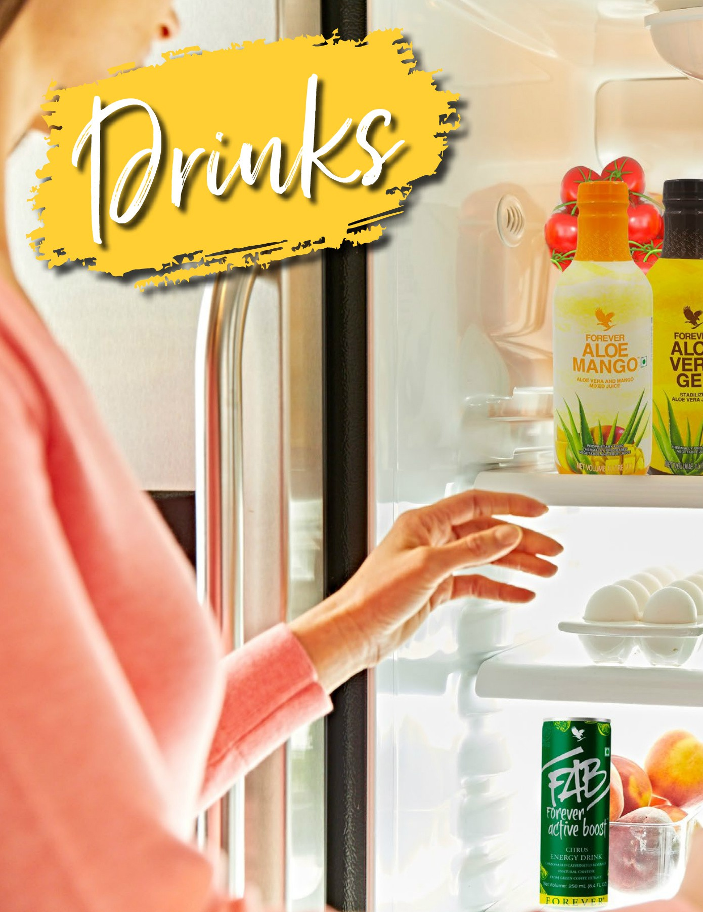



F O R EV E R’



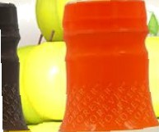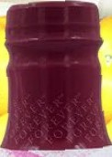

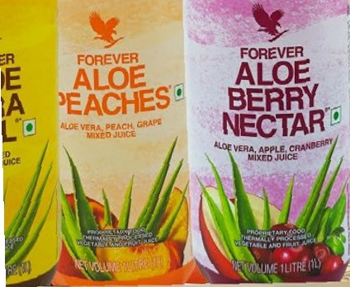

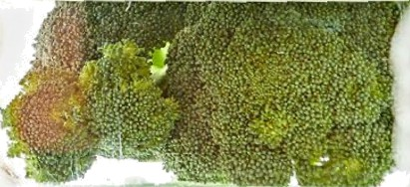





#### Forever Aloe Vera Gel"

#715

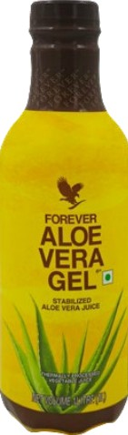

Forever Aloe Vera Gel”* *•O*

The power of Aloe, as nature intended.

Imagine slicing Open an aloe leaf and consuming the gel directly from the plant. Our Forever Aloe Vera Gel * is as close tO the real thing as you can get!

Aloe vera has natural cleansing abilities that help the digestive tract absorb nutrients from the fOods we eat intO the blood stream, while promoting friendly bacteria growth. The unique polysaccharide, acemannan, and Other nutrients in aloe help to support the immune system. In fact, acemannan is one of the key markers used by the IASC to indicate quali aloe vera and FOrever Aloe Vera GeITM has nearly double the amount required for certification!

Forever Aloe Vera Gel * is aseptically processed allowing the fOrmula to remain free of added preservatives and boast an amazing 99.7% pure inner-leaf alOe vera gel. Packaged in Tetra Pak packaging made with 100% recyclable materials, Forever Aloe Vera Gel * ensures that yOu are able to enjOy the fresh taste of undiluted alOe vera gel with all of thg |DOtent properties of aloe just as nature intended.

Els Is only a brand name and 6as nat rmresant its true rature.

Diclaimel•. Foravar LJ'zing products are undei Haahh supqlement/ Nwtraceu egg categories. Tha product is rat intended to diagnose, parent, treat cr cure any disease. Consult your madM cara pmctitionar or diotitian in case of p , lactation a if on any medication. NDT FOR MEDICINAL UBE. Do not excaad tha stated recommended dady usaga. Store out of tha reach of chBdren in a cool, dry placa. Pea refer indlvidW pnzduct label for further details.



1 Liter

OtRECTIDN6

shake wd!. Raf›igetate:after opisnIr›g.



fNQRED?BNT$



|  |  |  |
| --- | --- | --- |
| Nutritional Information  Approximate values | | |
| Serving size: 240 mL  Number of servings: Approx. 4 | | |
| Nutrient | Per 100 mL | 96RDA - |
| Energy  Carbohydrate | 3.So kcal  0.8s g | 09s |
| Total Sugars | D.08 g |  |
| Added Sugars | 0 g | 09s |
| Protein | D.09 g | 09s |
| Total Fat | 0 g | 09s |
| Gholesterol | 1 mg |  |
| Sodium | 23.3 mg | 39d |
| -% Recommended Dietary Allowance (RDA) is calculated per serve (240 mL) basis 2000 kcal diet for an average aduL and ICMR RDA 2020 for aduL men sedentary work.  - RDA not established. | | |



#### Forever Aloe Vera GeI"TriPak

(Pack of3 Minis)

#716

FAST FACTS

* 9g.7% pure inner leaf aloe vea gel
* No added preservatives
* Supports healthy digestion
* Promotes immune health
* Supports nutrient absorption
* Helps maintain natural energy levels

DRINKS

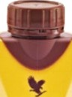

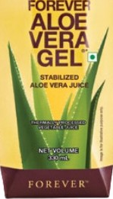

Forever Aloe Vera Gel”* Pack of 3 Minis *O•*

Aloe as nature intended.

Imagine slicing open an aloe leaf and consuming the gel directly from the plant. Our Forever Aloe Vera Gel * is as close to the real thing as you can get!

Aloe vera has natural cleansing abilities that help the digestive tract absorb nutrients from the foods we eat into the blood stream, while promoting friendly bacteria growth. The unique polysaccharide, acemannan, and other nutrients in aloe help to suppon the immune system. In fact, acemannan is one of the key markers used by the IASC to indicate quality aloe vera and Forever Aloe Vera GeITM has nearly double the amount required for certification!

Forever Aloe Vera Gel * is aseptically processed allowing the formula to remain free of added preservatives and boast an amazing 99.7% pure inner-leaf aloe vera gel. Packaged in Tetra Pak packaging made with 100% recyclable materials, Forever Aloe Vera Gel * ensures that you are able to enjoy the fresh taste of undiluted aloe vera gel with all of the potent properties of aloe just as nature intended.

Three of our aloe vera gel minis are equal to one full-size bottle and can be purchased in a TriPak.

* Packaged in mini bottles for convenience

Gluten Free Suitable Air vegetarians Sukable for vegans

CONTENTS

330 mL (pack of 3)

DIRECTIONS

Shake well. Refrigerate after opening.

CERTIFICATIONS

IASC Certified, Kosher Certified



INGREDIENTS

Aloe Vera Inner Leaf Juice [Aloe Vera Inner Leaf Gel

(99.7%), Antioxidant (INS 300), Acidity Regulator

(INS 330)].

|  |  |  |
| --- | --- | --- |
| Nutritional Information  Approximate values | | |
| Serving size: 240 mL  Number of servings: Approx. 1 | | |
| Nutrient | Per 100 mL | 96RDA - |
| Energy | 4 kcal | 0% |
| Carbohydrate | 1 g |  |
| Added Sugars | 0 g | 0X |
| Protein | 0 g | 0X |
| T0taI Fat | 0 g | 0X |
| Cholesterol  Sodium | 0 mg  25 mg | 3% |
| -% Recommended Dietary Allowance (RDA) is calculated per serve (240 mL) basis 2000 kcal diet for an average adult and ICMR RDA 2D20 for adult men sedentary work.  - RDA not established. | | |

Forever Aloe

## Berry Nectar"

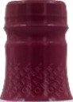#734

FAST FACTS

* 90.7% pure inner leaf aloe vea gel
* No added preservatives
* Supports healthy digestion
* Promotes a healthy immune system
* Helps maintain natural energy levels
* Cranberries support urinary health

DRINKS

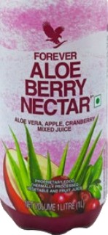Forever Aloe Berry NectaP’ •

All the benefits with a beautiful berry kick.

The refreshing zing of cranberries is paired with the sweet notes of apples for a fresh take on our aloe vera gel. The result a refreshing drink that not only aids in digestion but is packed with phytonutrients and vitamins.

When we say Forever Aloe Berry Nectar* contains our aloe vera, we mean it. This drink contains 90.7% stabilized, inner leaf aloe vera gel paired with natural fruit juice concentrates for sustaining your immune system and maintaining natural energy levels. The aloe used in this delicious drink is hand-harvested from our own fields and is the first of its kind to receive certification by the International Aloe Science Council (IASC) for purity and potency.

Aloe vera has natural cleansing abilities that help the digestive tract absorb nutrients from the foods we eat into the blood stream, while promoting friendly bacteria growth. The unique polysaccharide, acemannan, and other nutrients in aloe help to support the immune system.

A burst of cranberries and sweet apples provide a naturally derived, tangy flavor. Superfood cranberry packs antioxidant power shown to be 20 times higher than that of vitamin C and has proanthocyanidins that provide urinary health suppon in addition to vitamin C. Apple's special phytonutrient, quercetin, is another powerful antioxidant that helps to

make Forever Aloe Berry Nectar* a healthy and delicious drink.

Forever Aloe Berry Nectar* is aseptically processed allowing the formula to remain free of added preservatives and packaged in Tetra Pak packaging made with 100% recyclable materials to ensure that you enjoy the fresh taste of with all of the potent properties of aloe just as

nature intended.

Gluten Free Suitable Air vegetarians Sukable for vegans

CONTENTS

1 Liter

DIRECTIONS

Shake well. Refrigerate after opening.

CERTIFICATIONS

IASC Certified, Kosher Certified



INGREDIENTS

Aloe Vera Inner Leaf Juice (91%) [Aloe Vera Inner Leaf Gel, Antioxidant (INS 300), Acidity Regulator (INS 330)]. Apple Juioe Conoentrate (4%) (24.2 mL Apple Juice Equivalent), Fructose, Cranberry Juice Concentrate (2%) (13.3 mL Cranberry Juice Equivalent).

|  |  |  |
| --- | --- | --- |
| Nutritional Information  Approximate values | | |
| Serving size: 240 mL  Number of servings: Approx. 4 | | |
| hlutrient | Per 100 mL | 96RDA - |
| Energy | GB.64 kcal | 3% |
| Carbohydrate | 7.17 g |  |
| Total Sugars | 6.24 g |  |
| Added Sugars | 3 g | 14% |
| Protein | 0.09 g | 0% |
| Total Fat | 0 g | 0% |
| Cholesterol  S0dium | 1 mg  25.8s mg | 3% |
| -% Recommended Dietary Allowance (RDA) is calculated per serve (240 mL) basis 2000 kcal diet for an average adult and ICMR RDA 2D20 for adult men sedentary work.  - RDA not established. | | |

##### Forever Aloe Peaches

#777

FAST FACTS

* 84.5% pure aloe vera gel
* No added preservatives
* Supports healthy digestion
* Promotes healthy immune system

DRINKS

* + 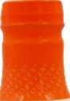Helps maintain natural energy levels
  + 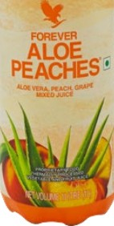Sun ripened peaches for added flavor and nutrition

Gluten Fre0 SultBbl6 for VBgetBrl8f›s Sult‹sbe for V0gan9

**CONTENTS**

1 Liter

**DIRECTIONS**

Shake well. Refrigerate after opening.

Forever Aloe Peaches” J•

The **benefits of** aloe **with** sun-ripened peaches.

Forever has paired the sweet, succulent taste of sun-ripened peaches with all the benefits of pure inner leaf aloe vera gel. The result is a flavorful drink that not only aids in digestion but is packed with nutrients and antioxidants.

Forever Aloe Peaches is a great way to drink your daily aloe. This drink contains 84.5% stabilized, inner leaf aloe vera gel paired

with natural peach puree for sustaining your immune system and maintaining natural energy levels. The aloe used is hand-harvested from our own fields and is the first of its kind to receive certification by the International Aloe Science Council (IASC) for purity and potency.

Aloe vera has natural cleansing abilities that help the digestive tract absorb nutrients from the foods we eat into the blood stream, while promoting friendly bacteria growth. The unique polysaccharide, acemannan, and other nutrients in aloe help to modulate and support the immune system.

Pure stabilized inner-leaf aloe vera gel is paired with juicy peach puree with calcium for a robust drink with a sweet taste that's high in vitamins, antioxidants and boasts all the nutritional power of aloe.

Forever Aloe Peaches is aseptically processed allowing the formula to remain free of added preservatives and packaged in Tetra Pak packaging made with 100% recyclable materials to ensure that you are able to enjoy the fresh taste of undiluted aloe vera gel with all of the potent propenies of aloe just as nature intended.

Great for kids and adults alike, this fresh-tasting drink enhanced with natural peach puree means you'll not only taste the bright peach flavor, you'll feel peachy too!

**CERTIFICATIONS**

IASC Certified, Kosher Certified



**INGREDIENTS**

Aloe Vera Juice (84%) [Aloe Vera Inner Leaf Gel, Antioxidant DNS 300), Acidity Regulator (INS 330)]. Peach Puree (8.5%) (8.5 mL Peach Juice

Equivalent), Fructose, Grape Juice Concentrate (3%)

(12.8 mL Gmpe Juice Equivdent).

|  |  |  |
| --- | --- | --- |
| Nutritional Information  Approximate values  Serving size: 240 mL  Number of servings: Approx. 4 | | |
| hlutrient  Energy | Per 100 mL  GB.B5 kcal | 96RDA -  3% |
| Carbohydrate | 7.18 g |  |
| Total Supars | 7.11 g |  |
| Added Sugars | 5 g | 24% |
| Protein  T0taI Fat | 0.1 g  0 g | 0%  0% |
| Cholesterol | 1.2 mp |  |
| S0dium | 22.03 mg | 2% |
| -% Recommended Dietary Allowance (RDA) is calculated per serve (240 mL) basis 2000 kcal diet for an average adult and ICMR RDA 2D20 for adult men sedentary work.  - RDA not established. | | |



F O R E V E R‘

Forever Aloe Mango

#736

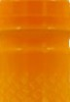







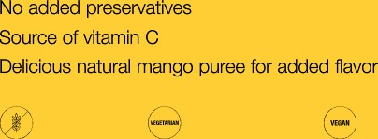**CfiBTtFiCATlON8**

IASG oerttEwl, Kosherñerttfiad

DRINKS

*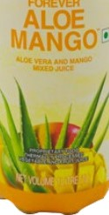***Forever Aloe MangoTM** *O•*

**Everything you love about** aloe **with delicious natural**

mango

What's better than the juicy sweetness of a perfectly ripe mango? How about combining this delicious and healthy fruit with pure aloe vera frOm Forever's own aloe fields! All-new Forever Aloe Mango’M adds a tropical twist to our line of delicious and healthy aloe vera drinks to put the best of nature in your glass.

Forever Aloe MangO M features all the benefits of our flagship Forever Aloe Vera Gel’M with 86% pure aloe vera and an extra kick of nutrition and flavor from natural, tropical mango puree. Mangos are full of nutrients and contain important vitamins like vitamin C. The fruit used in Forever Aloe Mango’M is harvested at peak ripeness to ensure the rich flavor and nutrient content has reached just the right levels.

Aloe vera has natural cleansing abilities that helps your body absorb nutrients. The unique polysaccharide, acemannan, and other nutrients in aloe help support digestion and the immune system.

Like all of our aloe vera gel drinks, Forever Aloe MangoTM is aseptically processed allowing the formula tO rgmain free of added preservatives and packaged in Tetra Pak packaging made with 100% recyclable materials to ensure that you can enjoy the fresh taste of aloe vera gel with all the potent properties of aloe just as nature intended.



Ah‹iox›dan‹ tINs’z0o),ac›d‹y.Rag«l»tor /r‹S.330t|:

M rgo’Puree Cor›pent‹ate t1d,95@ (1’1,2 mL

FrudtR



|  |  |  |
| --- | --- | --- |
| Nutritional Information  **Approximate** values | | |
| Serving size: 240 mL  Number of servings: Approx. 4 | | |
| Nutrient | Per 100 mL | 96RDA - |
| Energy | 27.04 kcal | 39a |
| Carbohydrate | 6.6s g |  |
| Total Sugars | 5.11 g |  |
| Added Sugars | 3 g | 14% |
| Protein | 0.1S g | 09s |
| Total Fat  Cholesterol | 1. g 2. mg | 0% |
| Sodium | TO mg | 29â |
| -% Recommended Dietary Allowance (RDA) is calculated per serve (240 mL) basis 2000 kcal diet for an average aduL and ICMR RDA 2020 for adult men sedentary work.  - RDA not established. | | |





R

R

### Forever Freedom

#196







FAST FACTS

* Supports joint function arid mobility
* Helps maintain healthy carblage
* Natural oiange flavour
* Gluten free

Gluten Free Suitable fbr vegetarians

**CONTENTS**

1 Liter

**DIRECTIONS**

Shake well. Refrigerate after opening.

DRINKS

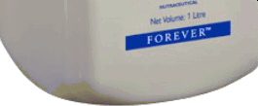Forever FreedomTM D•

Advanced joint support with all the **benefits** of aloe vera

Forever Freedom TM has all the powerful benefits of the original Forever Aloe Vera GeI’^ with a little something extra to help keep you moving.

We've carefully selected ingredients known to suppor healthy joints and compliment your active lifestyle. Whether you're looking to cut a rug or tear across the finish line, reach first for a refreshing bottle of Forever Freedom TM for the right balance of nutrients to help your joints feel strong and lubricated!

Chondroitin, glucosamine and MSM are shown to promote proper joint function, mobility and shock absorption while helping to maintain healthy cartilage. These three important ingredients are found in nature, creating a great harmony with the nutritionally powerful benefits of aloe vera.

The aloe vera gel used in Forever Freedom T^ is hand harvested from our own plantation and processed within hours to ensure you get the freshest, purest product to assist in nutrient absorption, support healthy digestion and provide a natural source of energy.

Forever Freedom TM highlights the fresh and rejuvenating flavor of natural orange and the nutrient absorbing power of aloe vera. Now you can drink in the benefits and embrace the power of aloe as nature intended.

**INGREDIENTS**

Aloe Vera Juice (88.5896), Natural Flavour (Orange), Stabilizer [INS 420()], Fructose, Glucosamine Sulphate (Standardized to 99.4% Glucosamine) (1.2596), Chondroitin Sulphate (1.17%), Methyl Su8onyl Methane (0.696), Antioxidant [INS 300, INS 307a], Acidity Regulator [INS 330], Preservative [INS 202, INS 211]. Contains Cru9tBc8ari.

|  |  |  |
| --- | --- | --- |
| Nutritional Information  Approximate values | | |
| Serving size: 240 mL  Number of servings: Approx. 4 | | |
| Nutrient | Per J00 mL | 96RDA - |
| Energy | 26 kcal | 3% |
| Carbohydrate | 7 g |  |
|  |  |  |
| Added Sugars | 2 g | 10% |
| Dietary Fibre (AI) | 1 g |  |
| Protein  T0taI Fat | 1 g  0 g | 4%  0% |
| S0dium | 107 mg | 13% |
| -% Recommended Dietary Allowance (RDA) is calculated per serve (240 mL) basis 2000 kcal diet for an average adult and ICMR RDA 2D20 for adult men sedentary work.  - RDA not established. Ali Adequate Intake. | | |

|  |
| --- |
| This contains Sorbitol {jNS 420(i)]. |



F O REVE R‘

Fab Forever Active Boost

FAST FACTS

DRINKS

#83

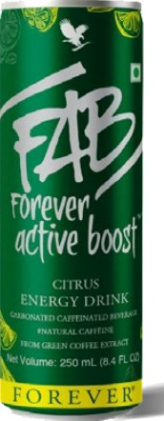

Forever Active Boost FAB •

Power your day with fast, long lasting energy

**From Green Coffee Extract**

Fab Forever Active Boost CitrusT^ is an energy drink that's made with natural ingredients so you can power up with energy that kicks in fast and lasts longer.

When it feels like you're running on empty, why not harness the power of nature's fuel? Forever Active Boost Citrus has a delicious citrus flavour and natural caffeine that comes from Green coffee extracts

Forever Active Boost has ingredients derived from nature. It powers you up with fast, long lasting energy. It has vitamins like B2, BE, B6, B12 which play an important role in energy metbolism.

It's this blend of herbs that works with the other ingredients to provide long-lasting energy and alertness to help you charge up in the morning or power through that afternoon slump.

The addition of stabilized aloe vera gel supports healthy digestion and promotes your body's ability to absorb nutrients and maintain energy levels. When you need energy that embraces the best of what nature has to offer, reach for FAB Forever Active Boostl&' to power your day.

#NaturaI **Caffeine**

* Natural Caffeine from Green Coffee Extract
* Ingredients delved from nature
* Powers up with fast, long lasting enegy
* Loaded with essential B Vitamins
* Cibus flavor for that added taste

**CONTENTS**

250mI

**DIRECTIONS**

75mg/serving size (250m§ Consume not more than 500mI per day. Not recommended for children, pregnant or lactating women, persons sensitive to caffeine.

**INGREDIENTS**

Water, Sugar, Lemon Juice Conoentmte (1.15%)^,

Carbonating agent DNS 290), Energy Premi›¢

|¿aurine, Caffeine (from natural source)# (0.03%), Inositol, Vitamins (B3, B6, B2, B12), Dextrose Monohydmte], Acidity Regulators [INS 331(ii), INS 330], Nature-identical Flavouring Substances

{Lemon), Preservative (INS 211),

Stabilizer (INS 445, INS 419), Permitted synthetic food oolour ( INS 102). ^Equivdent to 8.85% Fruit.

|  |
| --- |
| Nutritional Information  Approximate values |
| Serving size: 250 mL  Number of servings per container: 1  Nutrient Per 100 mL 96RDA - |
| Energy 51.6 kcal 6.45 |
| Carbohydrate 12.8 g |
| Total Sugars 12.8 g  Added Sugars 11.07g |
| Protein |
| T0taI Fat |
| Taurine 400.00 mg  Caffeine 30.00 ^9 |
| Inositol |
| Vitamin B2 0.86 mg 4757 |
| Vitamin B3 2.2mg SOOO |
| Vitamin B6 OZ8nng 50,00  Vitamin B12 0.25 rncg 2B.41 |
| Sodium 1:Z1mg 15.13 |
| -% RDA Recommended Dietary Allowance) calculated per  serve (250 mL) basis 2000 kcal energy for average adult per day and ICMR guidelines, 202D for Women Sedentary Work.  - RDA not established.  Appropriate overages of vitamins and minerals are added to compensate the losses during storage. |



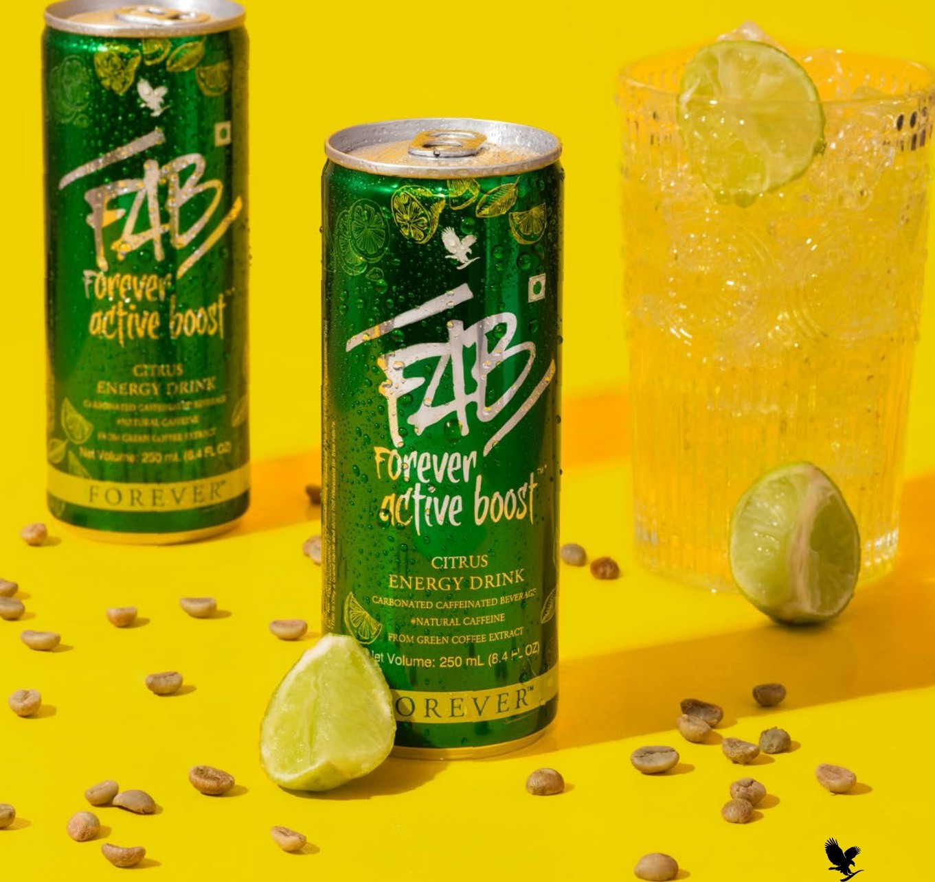

F O R E V E R‘



FOREVER BEE HONEY

TULSI VAN HONEY

...„„.

FOREVER

BEE POLLEN

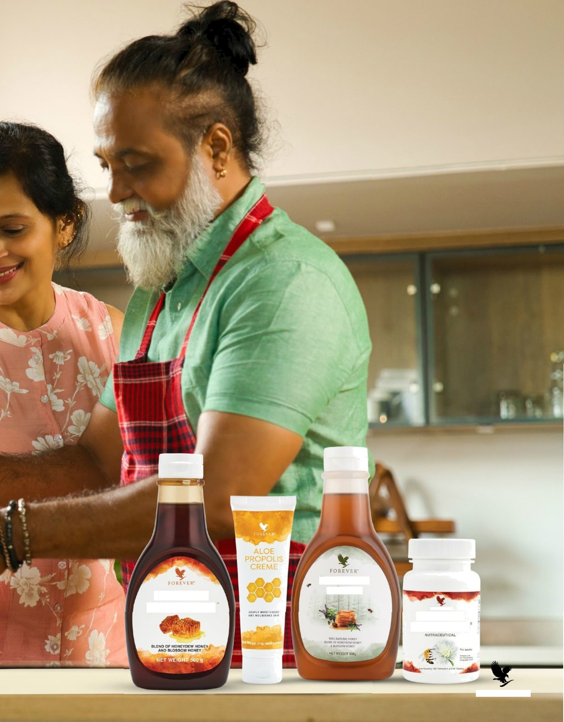

F O R E V E R’

### Forever Bee Ooaey

#207



FAST FACTS

* Natural energy booster
* 100% natural
* Sweet, rich and smooth

Gluten Free Suitable Air vegetarians

CONTENTS

500 g

BEE

DIRECTIONS

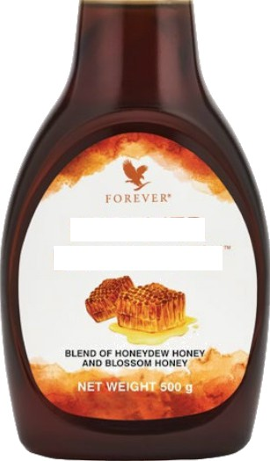

FOREVER BEE HONEY

Consume one tablespoon(21g) or more, as desired or use as a sweetener for bevemges ,tea and food. Store in a cool , dry place.

CERTIFICATIONS

Kosher Certified

INGREDIENTS

Honey

Forever Bee HoneyTM

A bottle of love from honeybees to you!

There's only one thing you'll find in a bottle of Forever Bee Honey’M and that's pure mountain-harvested honey. Mountain bees may take a little longer to make their honey and like a fine wine, the added time lends our honey a more rich and refined flavor. It's smooth, dark and delicious.

Honey is a natural sweetener that has long been revered for its healthy and nutritional properties.

In the calm and quiet Spanish countryside where we harvest our honey, bees gather sweet nectar from lavender and rosemary or groves of oranges to harvest the sweet nectar from the blossoms. As a result, you'll experience some of those notes in Forever Bee HoneyTM, alongside essences of sweet spice. The flavors are so layered and complex, you'll discover something new to love every time you taste it.

Honeybees are incredibly productive. They produce three to four times more honey than is needed to feed the hive for winter. That's why humans have been able to harvest the nutrition of the hive for thousands of years while preserving the safety of bee colonies.

|  |  |  |
| --- | --- | --- |
| Nutritional Information  Approximate values | | |
| Serving size: 21 g (l Tbsp.) Number of servings: Approx. 24 | | |
| Nutrient | Per 100 g | 96RDA - |
| Energy | 324 kcal | 3% |
| Carbohydrate | B1 g |  |
|  |  |  |
| Added Sugars | 0 g | 0% |
| Protein | 0 g | 0% |
| Total Fat | 0 g | 0% |
| Cholesterol  Sodium | 0 mg  0 mg | 0% |
| -% Recommended Dietary Allowance (RDA) is calculated per serve (21 g) basis 2DD0 kcal diet for an average adult and ICMR RDA 2D20 for adult men sedentary work.  - RDA not established. | | |

NOTE - Honey should not be fed to infants unde

one year of age

#### Forever Bee Pollen

#026

FAST FACTS

* Energy booster
* Bioactive compounds
* 100% natural

Gluten Free Suitable for vegetarians

**CONTENTS**

100 Tablets

BEE

FOREVER



„...!,.

BEE POLLEN



Forever Bee PoIIenTM

A bottle of love from honeybees to you!

Forever Bee Pollen T° packs all the power of pure bee pollen and honey for a combination of nutrition and energy straight from the hive! As they fly from blossom-to-blossom, bees pollinate plants and fuel our ecosystem.

Bees use the pollen they gather to create their food, which keeps the entire hive nourished, productive and strong.

Harness the benefits of natural energy and stamina with Forever Bee PoIIen’M. Bee pollen is a great natural source of nutrients including proteins, amino acids, carbohydrates, vitamins and minerals. This easily digestible and absorbed tablet ensures your body gets all the nutrition it needs naturally.

Typically, bee pollen is consumed as bland-tasting granules sprinkled on food or chewed. Not Forever Bee Pollen’M. We've packed all that nutrition into an easy to take tablet by mixing it with smooth and delicious honey!

Our bee pollen supplement is a Forever favorite for good reason. It's an all-natural source of energy and nutrition to help power through your day

**DIRECTIONS**

Begin by taking 1/4 tablet daily, then giadudly increase intake to one tablet three times a day. Consult your physician before taking this or any other dietary supplement.

**CERTIFICATIONS**



**INGREDIENTS**

Bee Pollen (86.9%),Honey, Glidant [ Stearic Acid ], Royal JeIIy{0.02%), Diluent |Maltodextrin]

|  |  |  |
| --- | --- | --- |
| Nutritional Information  Approximate values | | |
| Serving size: 0.6 g (1 Tablet) Number of servings: 100 | | |
| hlutrient | Per100 g | %RDA - |
| Energy  Carbohydrate | 361 kcal  67 g | D% |
|  |  | |
| Added Sugars | 9g | D% |
| Protein | 16g | D% |
| TatalFat | 6g | D% |
| Saturated Fat | 3 g | D% |
| Trans Fat | Not more than D.5g | D% |
| Cholesterol | Dmg | D% |
| Sodium | 27mg | D% |
| Bee Pollen | B6,9D0 mg | |
| -% Recommended Dietary Allowance(RDA) is calculated per serve (D.6g) basis 20DD kcal diet far an average adult and ICMR RDA 2D20 for adult men sedentary Work.  - RDA not established. | | |

Forever Tulsi Van honey

#9207

FAST FACTS

* Rich in anti oxidants
* 100% natural
* Single Floia honey (Tuls)

Gluten Free Suitable Air vegetarians

CONTENTS

500 g

BEE

DIRECTIONS

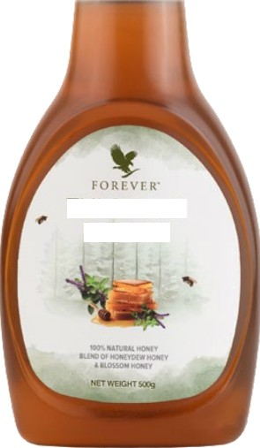

TULSI VAN

HONEY

Consume one tablespoon(21g) or more, as desired or use as a sweetener for bevemges ,tea and food. Store in a cool , dry place.

INGREDIENTS

Honey

Forever Bee HoneyTM

|  |  |  |
| --- | --- | --- |
| Nutritional Information  Approximate values | | |
| Serving size: 21 g (l Tbsp.) Number of servings: Approx. 24 | | |
| Nutrient | Per 100 g | 96RDA - |
| Energy | 324.3 kcal | 3% |
| Carbohydrate  Total Sugars | B1 g  BO.4 g |  |
| Added Sugars | 0 g | 0% |
| Protein | 0 g | 0% |
| Total Fat  Sodium | 0 g  4.3 mg | 0%  0.05s |
| -% Recommended Dietary Allowance (RDA) is calculated per serve (21 g) basis 2DD0 kcal diet for an average adult and ICMR RDA 2D20 for adult men sedentary work.  - RDA not established. | | |

A bottle of love from honeybees to you!

Experience the puri of Forever Tulsi Van Honey, a natural golden elixir crafted from the nectar of blooming basil flowers. Sourced from pristine fields, this honey embodies the rich aroma and wellness benefits of tulsi, making it a perfect addition to your daily routine.

Combines the essence of sacred Van Tulsi with the sweetness of honey.

Immerse your senses in the aromatic notes of this rare and revered herb, while enjoying the nourishing benefits of honey.

Indulge in nature's sweetness while embracing a healthier lifestyle with Forever Tulsi Van Honey. Taste the essence of tulsi in every drop!

NOTE - Honey should not be fed to infants unde one year of age

#### Aloe Propolis Creme

#051

FAST FACTS

SKINCARE





Aloe Propolis Creme

The best of aloe and the hive.

Only Forever could create a product as inventive as Aloe Propolis Creme. This nourishing cream combines two of our most prized ingredients, pure inner leaf aloe vera gel and bee propolis. Together, these two fundamental elements help your skin maintain beautiful tone and texture.

Bee propolis is a resinous substance that bees create to fonify their hives. Turns out it also has propenies that create a natural barrier on your skin, locking in the natural skincare benefits of aloe.

Aloe vera combined with vitamins A, E and C work to nourish and moisturize the skin while bee propolis helps rejuvenate skin's appearance for smoother, suppler look and feel. Aloe Propolis

Creme also enhances the soothing power of aloe with the addition of chamomile.

Of course, we use pure, inner leaf aloe vera gel from our own fields. The aloe is hand harvested and filleted to avoid damage and ensure only the highest quality aloe vera makes it into our products.

It's easy to see why Aloe Propolis Creme is one of Forever's flagship products. Treat your skin to the soothing, nourishing and protecting power packed inside every bottle.

* Rich blend of aloe vera and bee propolis
* Helps maintain beautiful skin tone and texture
* Nourishing and moisturizing
* Helps soothe skin irritation

Suitable for vegetarlan9

CONTENTS

4 OZ. (113 g)

DIRECTIONS

Apply liberally as needed.

CERTIFICATIONS

IASC Certified



INGREDIENTS

Aloe Barbadensis Leaf Juice (Stabilized“ Aloe Vera Get, Glyceryl Stearate, Propylene  Cetyl Alcohol, PEG-100 Stearate, Lanolin, Sorbitol, Ethylhexyl Palmitate, Ethylhexyl Stearate, Diethylhexyl Adipate, Allantoin, Propolis Extract, Lanolin Alcohol, Dimethicone, Tocopherol, Beta Carotene (Provitamin A), Zea Mays (Com) Oil, Chamomilla Recutita (Matricaria) Flower Extract, Triethanolamine, Ascorbic Acid, Disodium EDTA, Diazolidinyl Urea, Methylparaben, Propylparaben, Fragrance (Parfum).



F O R E V E R‘

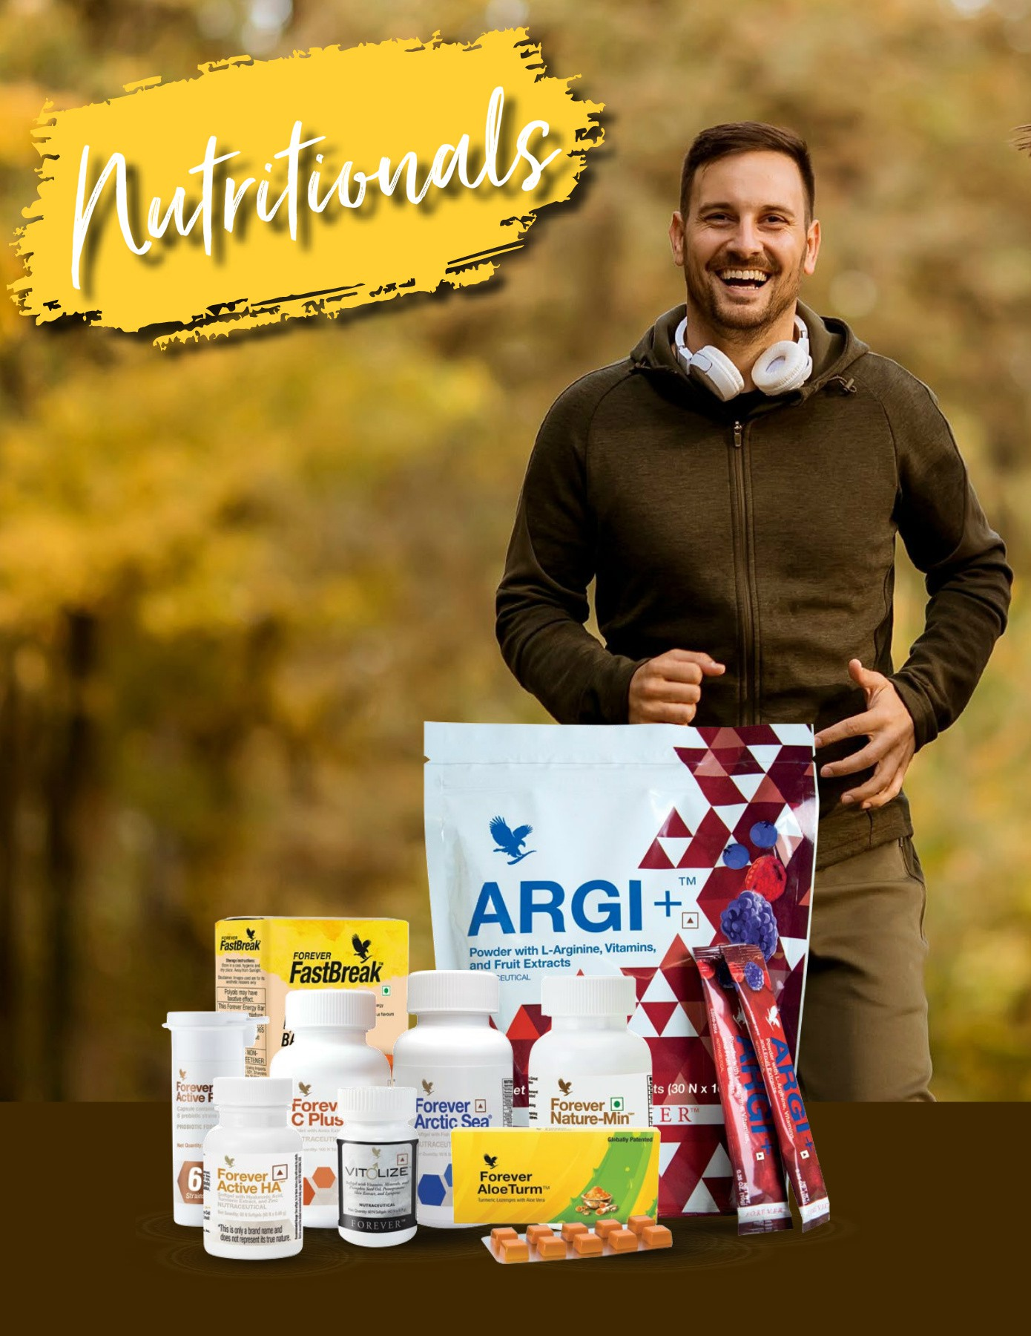

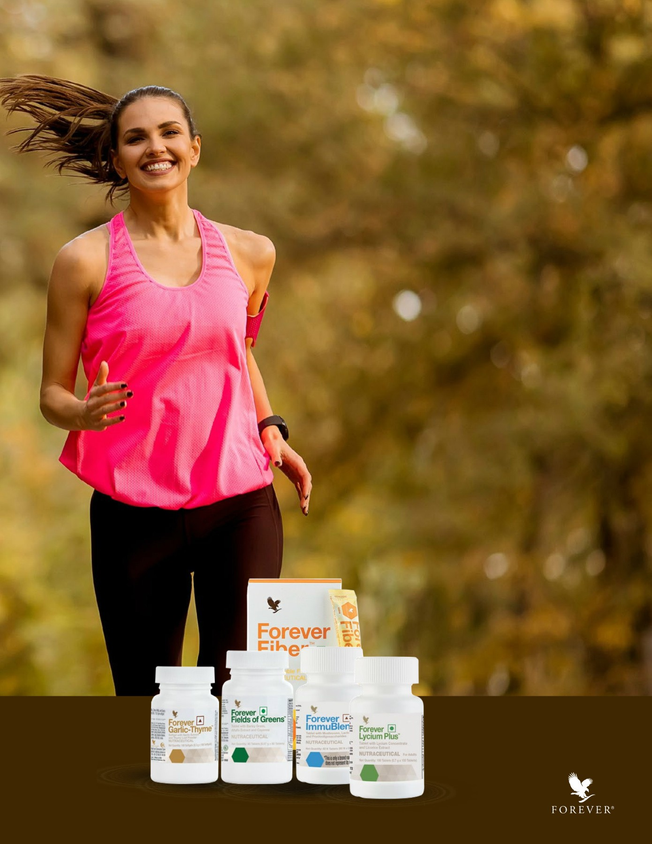

ARGI+ Powder wth

L-Arginine, Vitamins, 

Fruit EAracts

#473

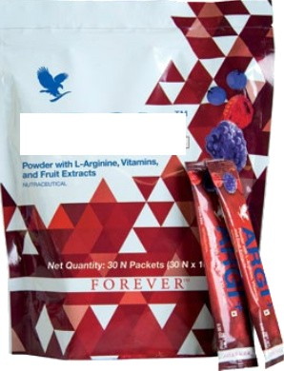

ARGI+

ARGI+TM Powder with L-Arginine, Vitamins, •. & Fruit Extracts

**Convenient power pack of nutrition and performance.**

Forever's ARGI+TM packs a lot more than delicious berry flavor into every packet. The primary ingredient, L-Arginine, is a powerful amino acid that helps the body create the “miracle molecule” nitric oxide.

When L-Arginine is convened into nitric oxide, it plays an imoonant supposing role in cardiovascular health by supposing optimal circulation and inner blood vessel health by allowing oxygen, blood and nutrients to travel more efficiently throughout the body. The dilation of blood vessels created by nitric oxide not only promotes optimal circulation, but also plays an imponant role in cell division and healthy immune function.

ARGI+’M takes the cardiovascular benefits even funher by including key heart-promoting nutrients. Vitamin D is essential for immunity

and skeletal health while B vitamins contribute energy Droduction and

metabolism. We also added grape skin and pomegranate for their strong antioxidant properties.

To put it simply, one packet of ARGI+TM helps support circulation and cardiovascular health, immunity, athletic performance, muscle function, energy and more to power your routine and keep you performing at your absolute best.

Simply stir a packet into water to enjoy the lively berry flavors or add it to your favorite beverage. ARGI+’M pairs deliciously with Forever Aloe Berry NectarTM or our 99.7% pure Forever Aloe Vera GeITM. Fuel your active lifestyle with ARGI+TM and discover your potential.

Diclaimcf! Fcw'cr Living prod acts arc under Hc*hh supplement'' N'utraccut I categories. The product is not intended to diagnose, p'evcnt, trc*t or cure zny dIscasc. Consuh your mcdiczlI come practitioner or dictitiari in case of prcgnot'. lactation or if on ay’

**COMTAINS NON-CALORIC SWEEYENER**

NUTRITIONALS

FAST FACTS

* Supports nitric oxide production
* Helps support the œrdiovascular system
* Promotes athletic performance
* DeliCiOUS D0rry #avOr



**CONTENTS**

30 Packets of 10g each

**DIRECTIONS**

Mix one packet of ARGI+ with 8 fi. oz. (240 mLJ of water or other beveregn once daily. Read euter pouch D0f0r0 u9e. THIS UNIT NOT LABELED FOR INDIVIDUAL SALE. KEEP OUT OF REACH OF

CHILDREH. Not recommended for pregnant and lactating warren or

any person wrth a medical c0nditi0n.

CERTIFICATIONS

Kosher Certûed

INGREDIENTS

L-Arginine (51.0%), Acidity Regulator DNS 330], Maltodextrin, Stab1!izer DNS 967], Anti-Caking Agent DNS 551], Stabilizer [INS 414], Natural Flavour (Mixed Berry, Mixed Fruit), Bilberry (Vaccinium myrtiI!us) Mract (0.5%), Vitamins, Sweetener [INS 955, INS 421], Anthocyanin (0.21%), Pomegranae (Punica granatum) Fruit Extract (0.09%), Black Cherry (Prunus ser@@ Extras (0.07s), Blue Grape /itis vinifera) Fruit Standardized Concentrate (0.04%)

|  |  |  |  |
| --- | --- | --- | --- |
| Nutritional Information  Approximate values  Serving size: 10 g (1 Packet) Number of servings: 30 | | | |
| Nutrient  Energy  Carbohydrate |  | Per 10 g  23 kcal  4 g | 96RDA -  1% |
| Total Sugars  Added Sugars Protein  Total Fat Sodium Vitamin C Vitamin D3 Vitamin B6 Vitamin BU  Folic Acid | ” | 0 g  0 g  . 0 g  0 g  1 mg 2D mg 5 pg"  1 mg  0.5 pg  1D0 | g | . 0%  0% OP  . Ono  25%  33%  53%  ' 23%  57% |
| L- Arginine  Anthocyanin  Bilberry fVaccinium mvrtilius) Extract |  | 5.1 g  21.2 mg  50 mg |  |
| Pomegranate (Punica granatum! Fruit Extract B.P mg  Black Cherry (Prunu* scrotina! Extract 6.6 mg Blue Grape (Viis vinilcra] Fruit Extract 4 mg  -to Recommended Dietary Allowance (RDA) is calculated per serve (10 g) basis 2000 kcal diet for an average adult and ICMR RDA 2020 far adult men sedentary work.  - RDA not established. Appropriate averages added. | | | |

|  |
| --- |
| **This ARGI+ containa an admixtuæ of Sucraloee (INS**  sssj, xyia»t **ENS s6r} and Mannitol (INS ëg1).** |

### Forever Fiber

#464

FAST FACTS

NUTRITIONALS

* Suppons healthy digestive function
* Promotes healthy bacteria groMh
* Quick dissolving
* Mild, grit-free taste

’

Gluten Free Suitable for vegetarians Suitable for vegans

CONTENTS

30 Packets

DIRECTIONS

Mix one packet of Forever FiberTM with water, Forever

” Aloe Venn Gel’M, or other beverage dais. For best

results, pour contents of one packet into a glass, add your beverage of choice and mix thoroughy. You can at sprinkle on food.

Forever Fiber’M •M

Quick-draw fiber on the go.

There's no question that fiber is a crucial part of a healthy diet. Yet with all the demands of everyday life, it’s not always possible to get enough fiber from food alone. Another downside is that fiber rich foods are typically rich in calories as well! Wouldn't it be nice if there were a way to load up on fiber without loading up on calories? Well, now there is.

Fiber up on the go with Forever FiberT^. These convenient packets are ready to help you get your daily fiber when you need. Pack in an extra five grams of fiber with each serving of this easy-dissolving, grit free formula. The pleasant, mild taste works well with any beverage, including your favorite aloe vera drinks.

Each packet gives you the same amount of fiber as a cup-and-half of brown rice or two slices of whole wheat toast without the calories or carbs! Forever FiberTM is a great between meal choice because it can contribute to feelings of fullness, therefore helping you control appetite and cravings. Forever FiberT^ also includes prebiotic fiber, which helps strengthen and promote good bacteria. This is a great way to add some balance to your diet and fuel a healthier lifestyle.

Because fiber promotes optimal health and digestive function, expens recommend taking in around TO grams of this power nutrient a day.

Most people only consume half that amount. Forever FiberT^ makes it incredibly easy to hit the ideal daily recommendation, anywhere and an ime.

Diclaimcf! Fcw'cr Living prod acts arc under Hc*hh supplement'' N'utraccut I categories. The product is not intended to diagnose, p'evcnt, trc*t or cure zny dIscasc. Consuh your mcdiczlI come practitioner or dictitiari in case of prcgnot'. lactation or if on ay’

It is suggested to take Forever Fiber” at least 30 minutes away from other dietary supplements as fiber may impact their absorption in the body.

INGREDIENTS

Acacia gum, soluble corn fibre, soluble corn dextrin, fructooligosaccharides.

This fooo is by its nature gluten-free. Contains Oligofructose (dietary fiber) 2 gm/100 gm.

|  |
| --- |
| Nutritional Information  Approximate values |
| Serving Size: 6.I g 1 Packet Numbeer of Servings: 30  Nutrient Amouni 96RDA -  Per 6.1 g  Energy 14 kcal 1Zo  Carbohydrate |
| Total Sugers Og |
| Added Supers Og  Dietary Fibre (AI) 5g  Soluble Fibre 5g  Protein Og Op»  Total Fat ’Og 0%  Sodium  Other Nutritional Ingredients  AGacia Gum 2.5 g  Soluble Corn Fibre 2.2 g  Soluble Corn Dextrin 1.3 g  Fructaoligosaccharides 0.1 g  -% Recommended Dietary Allowance (RDA) is calculated per serve (6.1 g) basis 2000 kcal diet far an average adult and ICMR RDA 2020 for adult men sedentary wark.  - RDA not established. Al: Adequate Intake. |



F O R E V E R‘

Forever Active 

#264

FAST FACTS

NUTRITIONALS

* Lubricates and cushions joints
* Promotes proper joint function
* Supports skin hydration

GIutenFnaO

CONTENTS

60 Softgels



DIRECTIONS

Two softgels daily as a dietary supplement.



Forever Active HA'M @.

Advanced, natural joint health support.

Nourish your joints and keep your athletic lifestyle going strong with Forever Active HA'M. This advanced blend of joint-supposing ingredients, like the beneficial ginger and turmeric, is a great supplement to help keep you moving.

Athletes have long regarded ginger oil and turmeric root to help promote proper joint function. Those ingredients play an important role in Forever Active HATM alongside the powerful addition of hyaluronic acid (HA).

Hyaluronic acid is a special protein created in our bodies that works to lubricate and cushion joints. Our innovative formula uses a unique form of low molecular weight hyaluronic acid. Aside from promoting joint health and function, this substance suppons skin hydration and can hold up to 1,000 times its volume in water!

Maintaining an active lifestyle is a main ingredient for looking and feeling better. Try taking Forever Active HA’^ with our Forever Freedom6 to promote optimal mobility and joint function!

Diclaimcf! Forever Living products arc under Health supplement'' Nutraccutll categories. The product is rot intended to diagnose, prevent, beat or cure any d fscasc. Consult your medical care practitioner or dictitiari in case of pregnancy. lactzition or if on ay’ medication. NOT FDR MEDICINAL UEiE. Do not exceed the stated rooommcndcd dcily usage. Store out of the reach of children in a cal, dry place. Please refer individ'u ! product labs for further details.

INGREDIENTS

Vehicle (Soybean Oil, Ingredient of Capsule Shell (Gelatin), Humectant [INS 422], Turmeric (Curcuma longa), Rhizome Extmct (standardized to 95% curcuminolds)(6.85%), Diluent (Maltodextrin), Ginger Zingiber oficinale) Extract (5.2%), Pursed Water, Hyduronic Acid (1.5%), Znc Oxide, Emulsfier [INS 322()]. Contains S‹›y.

|  |  |  |
| --- | --- | --- |
| Nutritional Information  Approximate values | | |
| Serving size: 0.48 g (1 Softgel) Number of servings: 60 | | |
| Nutrient | Per 100 g | 96RDA - |
| Energy  Carbohydrate | 469 kcal  23 g | Ono |
| Total Sugars | 0 g | |
| Added Sugars | 0 g | OP |
| Protein  Total Fat | 31 g  31 g | OP  OP |
| Saturated Fat | 6 g | OP |
| Trans Fat | 0 g | OP |
| Cholesterol | 2 mg | |
| Sodium | 208 mg | OP |
| Zinc | PCB mg | 27d |
| Hyaluranic Acid | 1,458 mg | |
| Turmeric (Curcuma langa ) Extract  Ginger {Zingiber a1Ticinale) Extract | 6,770 mg  5,2D8 mg | |
| -% Recommended Dietary Allowance (RDA) is calculated per serve (0.4B g) basis 200D kcal diet far an average adult and ICMR RDA 2D20 for adult men sedentary work.  - RDA not established. Appropriate overages added. | | |

|  |
| --- |
| Polyols may have laxative effect |



F O R E V E R‘

VitĄlize Men

VitaliĘ Supplement

FAST FACTS

NUTRITIONALS

#374

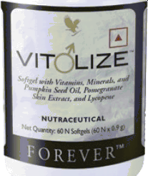

VitdlizeTM Men J*•

**Men's vitality** supplement

Men, it's time to think about nutrition that's unique to you. This is especially true as you advance in age and balanced nutrition becomes more important.

Forever's Vit IizeTM is designed from the ground up exclusively for men. Blend of the highest quality herbs, vitamins and minerals to suppon optimal vitally for men. This unique formulation helps maintain normal testosterone levels and fertility reproduction.

Vitamins C and B6 work to reduce tiredness and fatigue, while vitamin B6 also contributes to the regulation of hormonal activity.

Includes high levels of Selenium and Zinc which can help suppon normal spermatogenesis, fertility, reproduction and testosterone levels in the blood. It contains Pumpkin seed oil full of valuable nutrients, high in anti-oxidant and improves bladder and urinary health. Pomegranates are rich in fiber, vitamins, minerals and bioactive plant compounds and are good for prostrate health.

Contains Lycopene which is a plant nutrient with antioxidant properties. Lycopene supplementation was found to have an effect on maintaining prostate health associated with age. Designed specifically for men's health to support optimum vitality VitaeIizeTM Men . Ithas to be taken One soft gel daily as a dietary supplement.

This powerful blend is packed into an easily digestible softgel, making it incredibly easy to suppon an active and healthy lifestyle.

* Softgel with Vitamins, Minerals, Pumpkin Seed Oil, Pomegranate Skin Extmct, and Lycopene
* Helps maintain normal testosteone levels and fertility reproduction
* Blend of balanced criticd nutrients
* Designed specifically fbr men's health

GIutenFnaO

**CONTENTS**

60 Softgels

**DIRECTIONS**

One softgel daily as a dietaiy supplement.

INGREDIENTS

Vehicle (olive oiI,Com oil, Soybean oil, coconut oil, Ingredient of Capsule Shell [ GeIatin],Pumpkin (Cucurbita pepo) Seed Oil(14.3%), Hurnectant [INS No. 422], Pomegranate (Punica granatum ) skin extract (8.6%) Vitamins, purified water, zinc gluconate, seWium yeast (1.7%), emulsffier [INS No. 322a], pene (0.1%), Diluent (Com Strach, Surose], Com Syrup,Colour | INS 150d], Andtioxidant DNS 301]

|  |  |  |
| --- | --- | --- |
| Nutritional Information  Approximate values | | |
| Serving Size• 0.9 g (l Softgel) Number of Servings: 60 | | |
| Nutrient | Per 100 g | 96RDA - |
| Energy  Carbohydrate | 579kca  2B g | Oto |
|  | 0g |  |
| Added Sugars | 0g |  |
| Protein | 2D g |  |
| Tatal Fat | 45 g |  |
| Saturated Fat | B g |  |
| Trans Fat | 0 g |  |
| Cholesteral | 3 mg |  |
| S0dium  Vitamin B6 | B9 mg  7B mg |  |
| Vitamin C | 4,444mg |  |
| Vitamin D3 | 278ug | 17% |
| Vitamin E | aa7mg a  Tocopherol | 60Po |
| Zinc  Selenium | 555 mg  3,055 >9 | 29Po  6 Po |
| Weast | 300CFU/g |  |
| Other Nutritional lngredients |  |  |
| Pumpkin (Cucurbita pepo) Seed Oil  Pomegranate (Punica granatum  Skin Extract  Lycopene | 13,BB9 mg  139mg |  |
| Selenium Yeast | 1,608mg |  |
| - P Recommended Dietary Allowance (NDA) is calculated per serve (0.9g) basis 2000 kcal diet for an average adult and ICMR RDA 202D for adult men sedentary work.  -RDA not established. Appropriate overages added. | | |







##### Forever Arctic Sea

#039

FAST FACTS

* Supports a healthy heart
* Supports optimal cognition

NUTRITIONALS

* + Exclusive blend of omega-3s
  + Pure source of EPA and DHA

GIutenFnaO

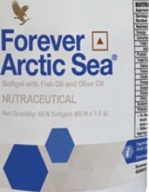**CONTENTS**

60 Softgels

**DIRECTIONS**

Take 1 softgel three times daily.

Forever Arctic SeaTM •

A perfectly balanced blend of omega-3s.

Advanced nutrition that puts the power of the sea in the palm of your hand. Forever Arctic Sea features our exclusive blend of oils to provide you with a perfectly balanced omega-3 supplement.

Forever Arctic Sea is a proprietary blend of: Fish Oil and Olive Oil. This unique blend provides Omega 3 fatty acids EPA and DHA plus Oleic acid. This is a safe and balanced supplement that can favorably support healthy blood cholesterol and triglyceride levels.

Forever Living Products has long been at the forefront of the nutritional products industry, with products consistently recognized for quality, purity and effectiveness. Forever Arctic Sea follows this same tradition. In today's world, it's always difficult to consume an optimal amount of essential fatty acid. Forever Arctic Sea has now made it easy by providing balanced amounts of DHA and EPA Fate Acids.

Forever Arctic Sea’M features our exclusive blend of fish oil and olive oil to provide a perfectly balanced omega-3 fatty acids EPA and DHA plus Oleic acid Fish oil in Forever Arctic SeaT° provides a perfect harmony of EPA and DHA omega-3 fate acids that your body may be lacking. Forever Arctic SeaTM puts the ideal proportion in an easy to take softgel. Omega-3 fatty acids support wellness in key areas of the body, including cardiovascular and immune function. Research has also shown that DHA can support mood, emotional health and optimal cognition. It gives your body the nutrition through a perfectly balanced blend of Omega-3s.

Serving Size is 3 Softgels and it has 20 Servings per container. Anyone in the family who wants a breakthrough balanced supplement that puts the power of the sea in the palm of your hand. A perfect harmony of fish oil and olive oil which provide Omega-

3 fatty acids EPA, DHA plus oleic acid. Forever Arctic Sea is a breakthrough in terms of a balanced supplement.

**INGREDIENTS**

Diluent DNS 460(), Com Starch, Dextrose, Sucrose], Fructooligosaccharides(17.55%), Coating Agent DNS 464], Mineral, Vitamins, Maitake Mushroom (grifola frondose) Extmct(3.4296) (Standardized to 20% Beta-Glucans), Lactoferrin (2.91%), Shfrlake Mushroom (Lentinula edodes) Powder (2.18%), Glidant [Stearic Acid], Antisticking Agent [INS 470(ii)], Disintegrant DNS 468], Stabilizer DNS 322()], Antioxidant DNS 301, INS 307c], Vehicle [Coconut Oi{.

Contains Soy, Milk arid NuL

|  |  |  |
| --- | --- | --- |
| Nutritional Information  Approximate values | | |
| Serving size: 1.5 g (1 Softgel) Number of servings: 60 | | |
| hlutrient | Amount Per 100 g | 96RDA - |
| Energy | 671 kcal | Ooo |
| Carbohydrate | 14 g |  |
| Added Sugars | 0 g |  |
| Protein | TO g |  |
| T0taI Fat | 61 g | 1Po |
| Saturated Fat  Trans Fat | 6 g  1 g | 1Po |
| Cholesterol | 124 mg |  |
| Omega-3 Fatty Acids | 25,000 mg |  |
| Eicosapentaenaic Acid (EPA)  Docasahexaenoic Acid (DHA) | 15,000 mg  10,000 mg |  |
| Oleic Acid | 10,000 mg |  |
| Sodium | 65 mg | OP |
| Vitamin E | 47 mg a -Tocopherol | 7% |
| -to Recommended Dietary Allowance (RDA) is calculated per serve (1.5 g) basis 2DD0 kcal diet for an average adult and ICMR RDA 2020 far adult men sedentary work.  - RDA not established.  Appropriate averages added. | | |



F O R E V E R‘

### Forever Plus

#048

FAST FACTS

NUTRITIONALS

* Fignts free radical and benefits skin and connective tissues
* Helps build the immune system ana fight allergies
* Easy wav to get daily dose of Vitamin C



Forever • C Plus



Forever C PIus'M J•

Advanced daily Vitamin C delivery in a delicious tablet.

Vitamin C is an essential part of anyone's diet. It's the ultimate nutrient when it comes to staying healthy when life has you on the go. Yet it’s estimated that only 10 to 20 percent of adults eat

enough fruits and vegetables to maintain optimal levels of this crucial vitamin. That means most of us have a pretty big gap to fill when it comes to having an adequate amount of vitamin C.

Vitamin C is among the safest and most effective nutrients, helping your body protect itself against immune deficiencies,

cardiovascular problems and aging skin. The antioxidant properties

fight free radicals to protect your body from oxidative stress, which contributes to aging.

Forever C Plus provides an easy, delicious and advanced way for you to make sure your body is supplied with your daily recommended value of vitamin C. This formulation contains Amla fruit and hesperidin Amla fruit is one the best sources of natural

Vitamin C and is absorbed easily and faster by the body. Hesperidin is a bioflavonoid found primarily in unripe citrus fruits line Oranges, grapefruit, lemon, and tangerines thought to have beneficial effects on blood vessels. It helps build the immune system and fight allergies.

Don't let nutritional gaps keep you from living your most active and healthy life. Forever C plus is the perfect companion on your journey to looking and feeling your absolute best.

Suitable Mr veget6na09

**CONTENTS**

100 tablets containing 25 mg of Vrfamin C, 83 mg of Amla fruit extract, 80mg of Hesperidin

**DIRECTIONS**

Recommended Usage: One taDlet to be aken by aduW, two times a oay. Not to exceed the stated recommended dais usage.

**CERTIFICATIONS**

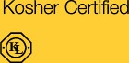

INGREDIENTS

Diluent (Sucrose, Dextrose, INS 46a), Maltodextrin), Isomaltulose, AmIa(Emblica OlTicinalis) Dried Fruit Extract (6.22%), Natural Flavour (Orange & Citrus), Hesperidin (4.01%), Binding Agent [INS 412], Glidant DNS 470(iii)]

|  |  |  |
| --- | --- | --- |
| Nutritional Information  Approximate values | | |
| Serving size: 1.3 g (1 Tablet) |  |  |
| Number of servings: 100 |  |  |
| Nutrient | Amount Per 100 g | 96RDA |
| Energy | 360.0 kcal | ' Ono |
| Carbohydrate | 90 g |  |
| Total Sugars | 69 g |  |
| Added Sugars | s3.a g | 27o |
| Dietary Fibre (AI) | 10.0 g |  |
| lsomaltulose | 23.6 g |  |
| Protein | 0.4 g | Ono |
| Total Fat | 0.8 g | Ono |
| Saturated Fat | Not more than 1 g | Ono |
| Trans Fat Not more than 1 g  Cholesterol 0 mg  Sodium 4.0 mg  Vitamin C 2..260 mg. .. 37%  6,077 mg  Hesperidin 3,846 mg  -“o Recommended Dietary Allowance (RDA) is calculated per serve (1.3 g) basis 2000 kcal diet for an average adult and tCMR RDA 2020 for adult men sedentary work.  - RDA not established. Al: Adequate Intake. | | |

8

’



|  |
| --- |
| **Contains lsomaltulose 94{kca§** |

##### Forever ImmuBlend

#355

FAST FACTS

NUTRITIONALS

* Supports and strengthens the immune system
* Full body appioach to immune health
* Promotes immune œil production
* Helps strengthen immune oells

Glutœ Free Sultable lôr vegetarlans





Forever Ö ImmuBlend



Forever ImmuBlendTM ‹

Fuel your defenses with complete immune support.

Every day you are exposed to germs, bacteria and viruses. From the door handles you touch to the crowded movie theater, you are constantly being exposed to microscopic threats. Your immune system works around the clock to keep your body safe and healthy. Show your immunity some love by strengthening its defenses with an ideal blend of nature's most potent nutrients.

Forever ImmuBIend’^ is an all-encompassing immune support supplement with a powerful combination of natural botanicals and proven ingredients. We've combined the best of science and nature to create a blend that supports all aspects of the immune system.

What happens in your gut plays a key role in your overall health. Between 70 and 80 percent of your immune tissue is located in the digestive tract. Safeguarding your digestive health is the foundation of strengthening your immune system. That's why Forever ImmuBlend TM include both Fructooligosaccharides and lactoferrin to promote healthy levels of probiotic bacteria and support immune cell growth.

But Forever ImmuBlend TM delivers immune boosting power beyond the digestive system. We took a full body approach to bringing

you a comprehensive array of potent ingredients. Vitamins D and C support immune cell production and cardiovascular function while maitake and shiitake mushrooms combat free radicals and strengthen immune cells.

Life can be hectic and you don't always have time to slow down. When you're out and about, be proactive in supporting your immune system and help your body fortify its defenses with Forever ImmuBlend TM!

**CONTENTS**

60 Tablets

**DIRECTIONS**

Take 1 tablets daily as a dietary supplement.

**CERTIFICATIONS**

Kosher Certified



**INGREDIENT6**

Dikient DNS 460$, Com Starch, Oextroee, Sucrose], Fructodigosacchañdes(17.55%), Coating Agmt DNS 464], Minaal, Vttamin9, Maitake MU9hrocrn (GribB frordoea) Extract (3.43%)

dardized to Bda-Glueing), LactoBzin (2.91%), Shi5ake Mushroom (Lmânub edodes) Powde (2.18%), G!idart

Acid], Aritisticl‹ing Agmt DNS 47@i)], DisintegW DNS 468], Stablfzer DNS 322a], Antioxidant DNS 301, INS 307c], VehkJe [Coconut C\§.

D¥Jzirs Soy, MZk8nd M/t

|  |
| --- |
| Nutritional Information  Approximate values |
| Serving size: 0.7 g (1 Tablet) Number of servings: 60 |
| Nutrient Amount Per 100 g 96RDA - |
| Energy 302 kcal  Carbohydrate ” B4 g |
| 3 g |
| Added Sugars 1 g |
| Dietary Fibre (AI) 43 g |
| Protein 4 g |
| Total Fat 4 g |
| Saturated Fat 4 g |
| Trans Fat 0 g |
| Cholesteral 1 mg  S0dium 160 mg |
| Vitamin C 6,429 mg |
| Vitamin D3 714 pg |
| Zinc 1,071 mg 44%  Other Nutritional Ingredients |
| Fructooligosaccharides 17 g |
| Lactofernn 2,429 mg |
| Maitake Mushroom (Grifola 3,357 mg  Ændasa) Extract  -P Recommended Dietary Allowance (RDA) is calculated per serve (0.7 g) basis 2DD0 kcal diet for an average adult and ICMR RDA 2020 far adult men sedentary work.  - RDA not established. AI: Adequate Intake. Appropriate averages added. |







#### Forever Active Pro-B

#610

FAST FACTS

NUTRITIONALS

* Probiotic promoting a he.althy di.gestive. syet‹.rn. . .
* Contains 6 syrergistic strains
* Over 8 billion CFU
* Supports immunity
* Strain9 freeze dried for protection, potency ard shelf stability
* Soy and allergen-free

A ve B



Forever Active Pro-BTM *O•*

Support Your Digestive System

Support your body like never before with the latest in scientific advancements and new, clinically studied probiotic strains. Designed to promote a healthy digestive system, Forever Active Pro-B’s* includes FIoraActive—a range of beneficial probiotic strains from Copenhagen University Hospital, a leader in the gastroenterology field.

With a proprietary blend of 6 different strains, Forever Active Pro-B’M* probiotic provides 8 billion CFU per dose. These strains were researched and selected based on their beneficial propenies, clinical research and their ability to work synergistically. This formula also includes a prebiotic fiber to sustain the probiotics during storage, transport and delivery to the gut.

Prebiotics provide the ideal environment for the probiotic to function and thrive. The prebiotic fiber selected is a short chain fructo- oligosacharide that is known to suppon fermentation of the healthy bacteria used in the Forever Active Pro-B’M“ formula.

We added zinc to the formula to provide another layer of support for your immunity. Studies show that zinc promotes a healthy immunity and supports metabolism function. Give your body advanced digestive support with clinically-studied ingredients when you choose Forever Active Pro-BTM*!

his Is only a brand name arid does not represent its true nature.

Gluten Free Suitable fbr vegetarians

CONTENTS

30 Capsules

DIRECTIONS

Take one capsule daily with water 30 minutes before a meal. For best results, do not store at temperatures above 77 degrees F (25 degrees c).

CERTIFICATIONS



INGREDIENTS

Com dextrin (23%), capsule 9he!I §NS 464), Wctooligosaocharides

(21%), B. IBC99 IDA DSM32269j (9%), zinc gluconate, L

09U9 MDA DSM26357] (6%), L. reuterl MDA DSM12246]

(3%), L acidophilug MDA DSM32418] (26), glidant §NS 470{ii)], B. longum {ATOC SD5588] (1%), B. bifdum (IDA DSM32400] (1%),

diIuent}NS 170a].

|  |  |  |
| --- | --- | --- |
| Nutritional Information  Approximate values | | |
| Serving size: 0.34 g (1 Capsule) Number of servings: 30 | | |
| Nutrient | Amount Per 100 g | 96RDA - |
| Energy  Carbohydrate | 311 kcal  82 g | Ooh |
| Total Sugars | 0 g |  |
| Added Sugars | 0 g | Ooh |
| Dietary Fibre SAI)  Protein | 38 g  9 g | Ooh |
| Total Fat | 3 g |  |
| Sodium | 152 mg |  |
| Zinc | 731 mg | 15% |
| B. lactis IDA DSM32269] | 1,529,411,764,706 CFU |  |
| L. rhamnoeue [IDA DBM26357] | 33B,235,294,118 CFU |
| L. reuteri (IDA DSM12246] | 170,588,235,204 CFU |  |
| L. acidophilus [IDA DSM32418] | 170,588,235,204 CFU |  |
| B. longum [ATCC SD55B8] | 58,B23,529,412 CFU |
| B. bifidum [IDA DSM324O3] | 85,294,117,647 CFU |  |
| -% Recommended Dietary Allowance (RDA) is calculated per serve (D.34 9 basis 20DD kcal diet for an average adult and ICMR RDA 2D20 for adult men sedentary work.  - RDA not established. Al: Adequate Intake.  Appropriate overages added. | | |

|  |
| --- |
| Contains Dietary Fibre (Dextrin) 2gg/10tIg  (Source of soluble Dietary Fibre) |



F O R E V E R‘

##### Forever AloeTurm

#031

FAST FACTS

* Globally Patented

NUTRITIONALS



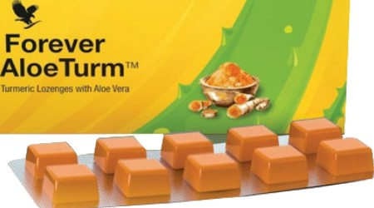

Forever AloeTurmTM

Exprience the goodness of Aloe Vera & Turmeric

Forever AloeTurm TM lozenges with Aloe Vera and Turmeric contain the world's most natural medicinal plant extracts for various health benefits and wellness.

Turmeric is a rhizome with natural antiseptic, antibacterial, antioxidant, anti-inflammatory coupled with immunomodulatory properties. Aloe Vera is a xeroph e with antiseptic, antibacterial, antioxidant and immune-stimulatory actions. Together, they act synergistically with complementary mechanisms to offer health benefits that aid immunity, oral hygiene, skin health, wound-healing, pain relief and general well- being. It is also effective for common cold, sore throat.

These two-plant based ingredients are part of food chain and have established safety profile. Forever AloeTurm T^ is the only patented product in the world today that provides goodness of Turmeric and Aloe Vera in form of a soft mouth dissolving lozenge. It's so sublime, that, its far too away to be classified as a traditional medicine.

This product is power packed with several medicinal benefits such as improvement in immunity, skin health, wound-healing, pain relief, maintaining oral hygiene and treatment for common cold, cough and sore throat.

* Proprietary ayurvedic medicine
* Natural and safe
* Sugar free
* Supports in building Immunity
* Helps in Pain relief
* Good for Oral hygiene
* Relieves sore throat and Coughe

CONTENTS

1N Strip“ 10N lozenges

DIRECTIONS

Recommended Doses (Lozenges/day): Skin Health & Oral Hygiene: 2 Immunity: 1 to 2

Cough & Pain Relief: 3 to 4

Sore throat, cold, minor cuts and bruises. Mouth ulcers and aches: 3 lozenges for at least 5 days If symptoms persist and/ or aggravate, please consult a healthcare professional.

It is recommended that you should not e›¢ceed 4 lozenges a day.

INGREDIENTS

Turmeric extract (Curcuma Longa) (rhizome), Aloe

Vera extract (Aloe Barbadensis) (leaf}

|  |
| --- |
| Nutritional Facts  Serving Size l N Strip  Turmeric Extract 1O0mg Aloe Vera Extract 1DDmg Excipients q.s.  Flavour q.s. |

### Forever Garlic-Thyme

#065

FAST FACTS

NUTRITIONALS

* + Helps promote cardiovascular function
  + Helps provide immune support
  + Odorless softgel

Gluts Free

**CONTENTS**

100 Softgels

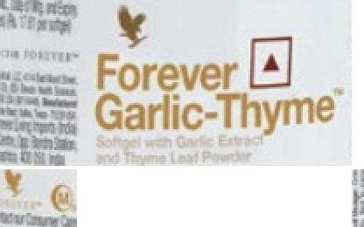

**DIRECTIONS**

One softgel, to be taken three times a day with meals by adults.

Forever Garlic-ThymeTM ‹0

Nature's superfood duo in a convenient sohgel.

Both garlic and thyme have long histories of use for health purposes. Ancient civilizations believed garlic would keep them healthy and strong. Ancient Greeks added thyme to their bathwater and burned it as incense,

believing it had properties that granted courage. Romans would eat thyme regularly, convinced that the herb's healthful properties would protect them if they were poisoned by an enemy.

Forever Garlic-ThymeTM showcases nature's super duo of nutrition. Garlic supports cardiovascular health because it contains beneficial compounds that promote healthy circulation. When garlic is cut or crushed the enzymes react to produce a powerful immune enhancing agent. With Forever Garlic-ThymeTM you'll get all the benefits of a 1,00Omg of garlic!

Thyme contains antioxidant compounds to fight oxidative stress and free radical damage along with saponins, which promote healthy immune function. Together, these ingredients provide a potent fuel to suppon your body's defenses.

The nutrition of garlic and thyme are packed into this easy to take softgel. Reach for Forever Garlic-ThymeT^ for an easy and convenient way to take advantage of nature's immune supporting superfoods.

**INGREDIENTS**

Vehicle [Canola Oil], Ingredient of Capsule Shell [Gelatin], Thyme (Thymus vulgaris) Leaf Powder (15.4196), Humectant DNS 422], Puried Water, Garlic (Allium sativum) Extract (3.08%), Emulsier [INS 322()], Corn Syrup, Colour [INS 150d]. domains Soy.

|  |
| --- |
| Nutritional Information  Approximate values  Serving size: 0.3 g (1 Softgel)  Number of servings: 100  hlutrient Amount Per 100 g 96RDA - |
| Energy 767 kcal D% |
| Carbohydrate 24 g  7Ot&I*lJ9 10g |
| Added Sugars 0 g |
| Protein 26 g |
| Total Fat 67 g  Saturated Fat 17g D% |
| Trans Fat 1 g D% |
| Cholesterol 1 mg |
| Sodium 66 mg D% |
| Garlic (Allium sativum) Extrat 3,021 mg |
| Thyme fThymus vulgaris) Leaf 15,106 mg  Powder |
| -% Recommended Dietary Allowance (RDA) is calculated per serve (D.3 g) basis 2000 kcal diet for an average adult and ICMR RDA 2D20 for adult men sedentary work.  - RDA not established. |

|  |
| --- |
| **Polyols may have laxative effect** |

#### Forever Fields Greens

#068

FAST FACTS

* Cleanses and detoxifies
* Helps alkalize the body

NUTRITIONALS

* + Complements an active and busy lifestyle
  + Maintain healthy digestion and circulation
  + Provides the nutrients your body needs each day

Gluts Free

Forever *J

Fields of Greens



Forever Fields of GreensTM M•

Detoxify with the natural power of greens.

Convenience eating can't always be avoided. Our fast-paced lifestyles often have us reaching for food on the go, making it hard to eat the recommended amount of vitamins and nutrients. Forever Fields of Greens’M is a fast and easy way to cleanse and detoxify while providing the nutrients your body needs each day.

Why are greens so important? Certain good foods are more than just an essential component of any diet. They contain imponant ph onutrients, enzymes, amino acids and vitamins.

Wheatgrass, barley grass and alfalfa are three ingredients that have been shown to help cleanse and detoxify the body. Wheatgrass contains alkaline properties that help support a healthy lifestyle. Cayenne pepper helps your body maintain healthy digestion and circulation.

When you don't have time to eat a balanced diet, make sure Forever Fields of Greens’M is around. Forever Fields of GreensTM is the ultimate supplement to complement an active and busy lifestyle.

CONTENTS

80 tablets

**DIRECTIONS**

One tablet to be taken twice a day by adults.

**CERTIFICATIONS**

Kosher Certified



**INGREDIENTS**

Sorbitol, Vegetable Powders (Barley Grass Powder (19.6596), Wheat Grass Powder (19.65%), Alfalfa Medicago saliva) Extract (19.65%), Honey, Anti- sticking Agent [Magnesium Stearate, Stearic Acid], Cayenne (Capsicum annuum L.) Fruit Powder (0.27%). C0ntains Barley and Wheat.

|  |  |  |
| --- | --- | --- |
| Nutritional Information  Approximate values | | |
| Serving size: 0.67 g (1 Tablet) Number of servings: 80 | | |
| Nutrient  Energy | **Amount** Per 1 00 g  2BD kcal | 96RDA -  D% |
| Carbohydrate | 77 g |  |
| Total Sugars | 23 g |  |
| Added Sugars | 14 g | D% |
| Dietary Fibre (AI)  Protein | 27 g  1D p | D% |
| T0taI Fat | 3 g | D% |
| Saturated Fat | 2 g | D% |
| Trans Fat  Cholesterol | 0 g  1 mg | D% |
| S0dium | 50 mg | D% |
| -% Recommended Dietary Allowance (RDA) is calculated per serve (D.67 g) basis 200D kcal diet far an avera9e adult and ICMR RDA 2D20 for adult men sedentary work.  - RDA not established. Al. Adequate Intake. | | |

|  |
| --- |
|  |

|  |
| --- |
| Polyols { **orbital** may haye laxaBve effect, cause bloatlng and dlarrhea In **chlklren; w›d re‹** ace **catcI\an** absorpBori In poet-menopausal wome |

#### Forever Lycium Plus

#072

FAST FACTS

* Powerful antioxidant

NUTRITIONALS

* + Beneficial to eyesight and skin
  + Powerful tonic
  + Good source of phytonutrients

.

 Forever !*

Lycium Plus



Forever Lycium PIusTM •

Powerful antioxidant with a licorice extract boost.

Forever Lycium PIus’M is our perfectly balanced blend of ancient botanicals specifically formulated to provide your body with the best of what nature has to offer.

Lycium, also known as goji berries or wolfberries, is a fruit that dates back centuries to ancient China, where it is known as the “yin tonic.” This unassuming fruit contains an unbelievable bounty of nutrients and antioxidants shown to enhance the complexion and help maintain good vision and energy.

Licorice also tops the Iist as another herb with antioxidant benefits, containing more than 150 compounds shown to have beneficial effects. It's most commonly used as a complimentary herb that brings out the natural benefits of other herbs, making it a great companion for lycium.

For a modern twist on an ancient traditional herb, stock up on Forever Lycium PIus’M and feed your body the “yin tonic.”

GIut‹r› Free SultBÖl6 for VBgetB#8f›s SuIt‹sÓe fŒ V0gan9

CONTENTS

100 Tablets

DIRECTIONS

One tablet, three tmœ a day. Consult your doctor or health care professiond before use if you have a rnedicd œndltÓn.

CERTIFICATIONS

Kosher Certified



INGREDIENTS

Diluent DNS 460(), Dextrose], Lycium barbarum Standardized Fruit Conœntrate Powder (41.6196), Licoriœ (Glycyrrhiza glabrQ Extract (5.2%), Antisticking Agent [Stearic Acid, Magnesium Steamte, Medium Chain Triglycerides], Disintegrant DNS 468]

|  |
| --- |
| Nutritional Information  Approximate values  Serving size: 0.7 g (l Tablet) Number of servings: 100 |
| hlutrient Amount Per 100 g 96RDA - |
| Energy 383 kcal Ono |
| Carbohydrate B7 g |
|  |
| Added Sugars |
| Protein 2g  T0taI Fat 3 g |
| Saturated Fat 3 g |
| Trans Fat 0 g |
| Cholesterol 1 mg  Sodium 401 mg |
| Lycium barbarum Standardized 37,500 mg  Fruit Concentrate Powder  Licorice (Glycyrrhiza glabra) 4,ß87 mg  Extract  -to Recommended Dietary Allowance (RDA) is calculated per serve (0.7 g) basis 2DD0 kcal diet for an average adult and ICMR RDA 2020 far adult men sedentary work.  - RDA nat established. |



F O R E V E R‘

Forever Nature-Min

#037

FAST FACTS

NUTRITIONALS

* Supports muscle, brain and thyroid function
* Helps regulate fluid balanoe
* Excellent source of electrolytes

Gluten Free Suitable Air vegetarians Sukable for vegans



Forever •

Nature-Min



Forever Nature-MinTM *O•*

A perfect multi-mineral blend.

You already know that multivitamins keep your body fueled with essential nutrients. But did you know multi-minerals are just as imponant? Minerals play a vital role in everything from proper hydration to muscle health and even brain function. Yet the human body does not replace its own lost minerals, so deficiencies need to be addressed with food or supplementation.

Forever Nature-MinT^“ is our advanced supplement formula designed to help your body maintain its ultimate mineral levels with optimal levels of 1O essential and trace minerals.

Our easily digestible supplement contains an ideal blend of both macro and trace minerals. Macro minerals are the ones your body needs

in higher amounts, like magnesium for proper muscle function and electrolytes that help regulate fluid balance and hydration.

Trace minerals are needed in smaller amounts, but that doesn't make them any less important. Zinc, for instance, is known to act as a catalyst for nearly 100 enzymes and assists in many crucial biological functions, including DNA and protein synthesis.

We searched the earth and sea to compile the perfect blend, which includes nutrients once locked deep in an ancient seabed. Make sure your body is getting all the minerals it needs to meet the demands of a healthy, balanced lifestyle with Forever Nature-MinT°“. Take Forever Nature-Min’^* alongside our Forever Daily& multivitamin to ensure you are getting the perfect balance of vitamins and minerals!

Diclaimcf! Forever Living prodr+cts arc undor Health supplement' Nutraccutll categories. The product is not intended to diagnose, prevent, beat or cure any d fseasc. Consult your medical care practitioner or dictitian in case of p . lactzition or if on any medication. NOT FDR MEDICINAL USE. Do not exceed the stated rooommcnded dcily usage. Store out of the reach of children in a cal, dry place. Please refer individual product labs for further details.

**CONTENTS**

180 Tablets

**DIRECTIONS**

Five tabk›ts daily as a dietaiy supplement.

**CERTIFICATIONS**

Kosher Certified



**INGREDIENTS**

Minerals, Diluent DNS 460 ¿], Glidant [Stearic Acid], Disintegrant [INS 468]

|  |  |  |
| --- | --- | --- |
| Nutritional Information  Approximate values | | |
| Serving size: 1 g (l Tablet)  Number of servings: 180 | | |
| hlutrient | Per 100 g | 96RDA - |
| Energy | 7B kcal | Ono |
| Carbohydrate  7Ot&I *LI9 | 29 g  9 | |
| Added Sugars | 0 g | |
| Dietary Fibre (AI) | 28 g | |
| Protein  T0taI Fat | 0 g  2 g | |
| Saturated Fat | 2 g | |
| Trans Fat | 0 g | |
| Cholesterol | 1 mg | |
| S0dium | 110 mg | OP |
| Calcium | 16,667 mg | 17% |
| Iran | 300 mg | 16% |
| Phosphorus  Iodine | 12,B67 mg  2,500 kg | 13%  18% |
| Magnesium | 6,667 mg | 15% |
| Zinc | 250 mg | 15% |
| Selenium | 600 kg | 15% |
| Copper | 33 mg | 19% |
| Manganese | 33 mg | B% |
| Malybdenum# | 600 kg | 13% |
| -P Recommended Dietary Allowance {RDA) is calculated per serve (1 g) basis 2000 kcal diet for an average adult and ICMR RDA 2020 for adult men sedentary work.  - RDA nat established. AI: Adequate Intake.  # Codex (CAC/GL-2-198' Guidelines on nutrition labelling) | | |



F O REVE R‘

Forever iVisionTM

#624

FAST FACTS

* Suppons healthy vision

NUTRITIONALS

* + Helps filter blue light from digital devices
  + Suppons visual processing speed
  + Ennances glare recovery time
  + Provides all three needed carotenoids specific to inner eye health

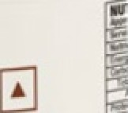Forever

I ision



Forever iVisionTM /‹

Complete eye support for the digital age.

In today's digital age, our eyes wont harder than ever before. We count on them to filter out UV rays and oollution, but also subjem our eyes to hours of anificial blue light coming from mobile devices, computers and

televisions every day Taking care of our eyes is more imponant than ever to protect from eye strain and long-term damage. And while proper nutrition is the first line of defense, most diets fall far show of the recommended levels of eye-promoting nutrients and antioxidants.

Introducing Forever iVisionTM, a breakthrough supplement designed to make it easier than ever to nourish and help protect your eyes. Formulated with vitamins, antioxidant power, botanicals and scientifically-advanced ingredients, Forever iVision’M provides complete, modem day eye suppor.

Bilberry ecract delivers antioxidant compounds that play an imponant role in eye health. We also included beta carotene in the form of natural vitamin A, a nutrient found in carrots and other foods that supports eye health and vision.Forever boosted its power with the addition of zinc, which makes vitamin A more bioavailable and helps to maintain healthy vision.

If there's one ingredient that truly makes iVisionTM the future of eye supplements, it's clinically-studied Lutem 2020. This powerful ingredient takes eye suppon to a whole new level by helping to filter out blue light from digital devices and other artificial light sources like LED and compact florescent bulbs. Lutem 2020 also provides suppor to the retina

and inner eye, panicularly the macula, which provides the clearest, most distinctive vision and manages the way your eyes orocess colors.

Maintaining macular health requires specific nutrients called carotenoids but most eye supplements supply only one of three carotenoids needed

— lutein. Today's digital lifestyle requires more than just lutein to promote optimal eye health. That's why Forever iVisionTM with Lutem 2020 features all three necessary carotenoids: lutein, RR zeaxanthin and meso- zeaxanthin.

With today's modem challenges, eye supplements are not only for adults looking to protect their eyes from age-related macular degeneration. Teens and adults of all ages can benefit from Forever iVision TM to suppor visual processing speed and help replenish macular pigment, enhance glare recovery time and fight exposure to blue light.

With the advanced ingredients supplied by Forever iVisionTMwith

Lutem 2020, you'll see clearly why this is the perfect supplement for the digital age.

Diclaimcf! Fcw'cr Living prod acts arc under Hc*hh supplement'' N'utraccut I categories. The product is not intended to diagnose, p'evcnt, trc*t or cure zny dIscasc. Consuh your mcdiczlI come practitioner or dictitiari in case of prcgnot'. lactation or if on ay’ medication. NOT FDR MEDICINAL USE. De not exceed the stated recommended dais us*gc. Store out cf the men of children in a cal, dry place. Please refer indi ,'id'ual product label for further clztails.



**CONTENTS**

60 Softgel Tablets

**DIRECTIONS**

One Softgel to be taken twice a day with meals by adult.

**CERTIFICATIONS**

Kosher Certified



**INGREDIENTS**

Vehicle [Sunfower Oil, Canola Oil, Com Oil, Soybean Oil], Ingredient of Capsule Snell [Gelatin], Humectant DNS 422], Lutemax@ 2020 [Sunower Oil, Marigold (Tagetes erecta L.) Petal Extract (2.63%), Tocopherol (0.02%)] (7.8%), Bilberry accinium myrtillus) Extract (Standardized to 10% Anthocyanins)(3.7 A), Puried Water, L-Ascorbic Acid, Carrot Juice Concentrate, Zinc Oxide, D-AIpna-TooopheroI, Diluent

|Maltodextrin], Beta-Carotene, Disintegrant [INS 330], Antioxidant [INS 307c] Contains Fish and S0y.

|  |  |  |
| --- | --- | --- |
| Nutritional Information  Approximate values | | |
| Serving size: 0.7 g (1 Softgel) Number of servings: 60 | | |
| Nutrient Energy  Carbohydrate | Amount Per 100 g 635 kcal  14 g | 96RDA -  Dog |
| Total Sugars  Added Sugars Protein  Total Fat | Og    25g  55 g | 1% |
| Saturated Fat | 7 g | D% |
| Trans Fat | 0 g | D% |
| Cholesterol | 1 mg |  |
| Sodium | 39 mg | D% |
| Vitamin A | 53,571 g§„ | 37 o |
| Vitamin C | 1,429 mg | 12 a |
| Vitamin E | 714 kg -Tocopherol | 50% |
| Zinc | 464 mg | 19% |
| Bilberry (Vaccinium myrtillus) Extract 3,571 mg  [Standardized to 10% Anthocyanins  Lutein [from Lutemax* 2020“'  Marigold (Tagetes erecta L.) Petal 1,429 mg  Extmctl  Zeaxanthin [from Luternax* 2020“'  Marigold /agetes erecta L.) Petal 2B6 mg  UFactl  —éSRecommended Dietary Allowance {RDF is calculated per serve (0.7 g) basis 2000 kcal diet for an average adu# and ICMR RDA 2020 for adult men sedentary work.  Appropriate overages added. | | |

”

##### Forever Fast Break •

Protein and Nut Energy Bars

Instant Energy Booster in 5 Delicious Flavours

#86

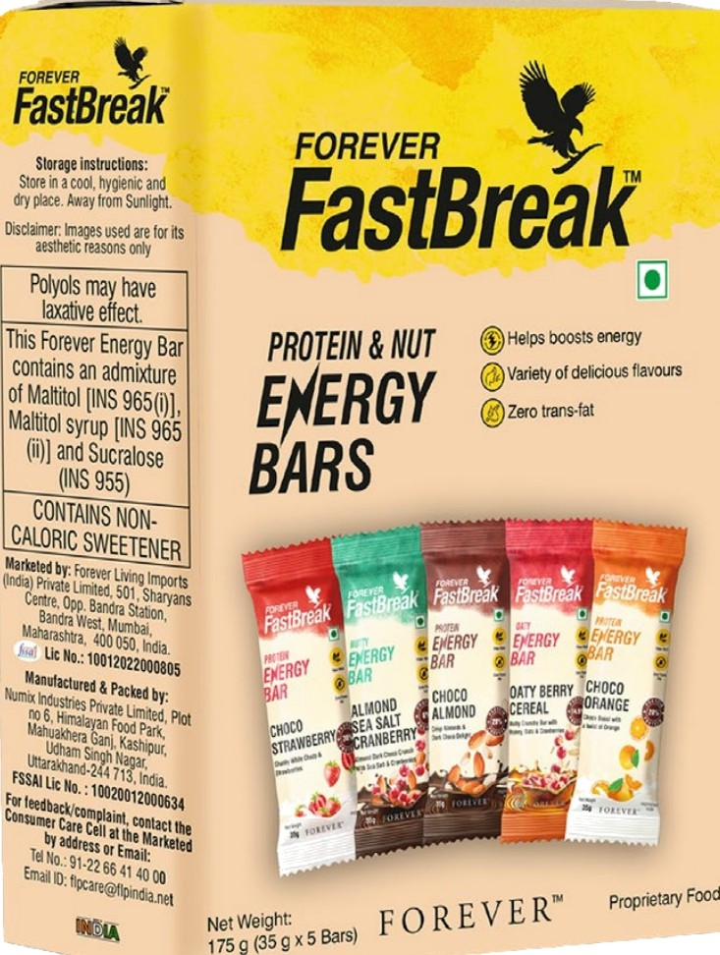

NUTRITIONALS



FOREVER

##### Forever Fast Break

Choco Almond

FAST FACTS

* 20% protein per sewing
* Real almonds for crunch
* High fiber content

NUTRITIONALS



CMOCO

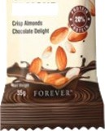

*rN08D

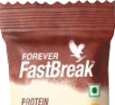

f.¥fRGF

Forever Fast Break - Ch0Co AlmonTM •I

Instant Energy Booster in S Delicious Flavours

Forever Fast Break Protein & Nut Energy Bars are your go-to solution for fulfilling nutritional needs on the go! Each bar is designed to boost

energy levels and is packed with real fruits and nuts, providing a deliciously

satisfying snack. With the added benefits of prebiotics, high fiber, and a healthy protein source, these bars are perfect for anyone looking for a nutritious option without compromising on taste. They are free from

preservatives, artificial flavors, and colors, ensuring that you're enjoying a

wholesome, guilt-free treat that's 100% zero trans fat.

Indulge in the rich, creamy flavor of Forever Fast Break - Choco Almond, featuring 20% protein per serving. This delightful bar combines the goodness of real almonds with the sweetness of chooolate, making it not only a satisfying snack but also a nutritious one. Each bite is packed with high fiber, which aids digestion and keeps you feeling full for longer. The inclusion of prebiotics promotes gut health, ensuring that you feel your best throughout the day. Plus, the absence of preservatives and artificial flavors means you can enjoy this treat without any guilt!

With the advanced ingredients supplied by Forever iVisionTM with

Lutem 2020, you'll see clearly why this is the perfect supplement for the digital age.

* + Contains prebiotics for gut health
  + No preservatives or artificial flavors

CONTENTS

35g

INGREDIENTS

Protein Blend (20.5%) [Soy Nuggets, Isolated Soy Protein, Whey Protein Concentrate], Dark Choco Compound (15%), (Sweetene INS 965()), Hydrogenated Vegetable Fat,

Cocoa Solid, Emulsfiers DNS 322 §}, INS 492], Fructooligosaccharides, Sweetener [INS 065 (ii)], Rice Crispies (9.50%) [Rioe Flour, Salt], Oats, Almonds (696), Humectant (INS 422), Refined Sunflower Oil, Cocoa Mass, Cocoa Powder, Emulsifier [INS 322 ()], Rosemary Extract, Sweetener (INS 955).

|  |  |  |
| --- | --- | --- |
| Nutritional Information  Approximate values  Serving size: 1 Bar (3'i g) Number of serving pack: 1 | | |
| Nutrient | Amount Per 100 g | 96RDA - |
| Energy | 134.72 kcal | 6.745% |
| Protein | | |
| Carbohydrate | | |
| 7Ot&I *lJ9 | 4.91g |  |
| Added Sugars | #9 | D,0% |
| Dietary Fibre (AI) | 2.509 |  |
| Total Fat | 4.909 | 7.31% |
| Saturated Fat | 2.38g | 1D.B2% |
| Trans Fat | 09 | D% |
| Cholesterol | | |
| S0dium  Allergy advice  Contains Soy, Milk, Oats, Nut | 5662m9 | 2.B3% |

##### Forever Fast Break

Choco Orange

FAST FACTS

* 20% protein per sewing

NUTRITIONALS





CHOCO

ORANGE 

t

Forever Fast Break  Ch0Co OrangeTM •I

Instant Energy Booster in S Delicious Flavours

Forever Fast Break Protein & Nut Energy Bars are your go-to solution for fulfilling nutritional needs on the go! Each bar is designed to boost

energy levels and is packed with real fruits and nuts, providing a deliciously

satisfying snack. With the added benefits of prebiotics, high fiber, and a healthy protein source, these bars are perfect for anyone looking for a nutritious option without compromising on taste. They are free from

preservatives, artificial flavors, and colors, ensuring that you're enjoying a

wholesome, guilt-free treat that's 100% zero trans fat.

Brighten your day with the zest favor of Forever Fast Break - Choco Orange! This energy bar offers a perfect blend of chocolate and real orange pieces, providing a refreshing twist on your apical snack. With 20% protein per serving, it delivers the energy boost you need, while its high fiber content helps to keep you satiated. The inclusion of prebiotics ensures digestive health, making this bar a sman choice for those with active

lifes les. Enjoy the delicious taste without worrying about preservatives or anificial ingredients, making it a wholesome addition to your daily routine.

* + Real orange pieces included
  + High fiber for satiety
  + Prebiotics support digestive health
  + Free from preservatives, no artificial flavors

CONTENTS

35g

INGREDIENTS

Protein Blend (22.80%) (Soy Nuggets, Soy Protein Isolate, Whey Protein Concentrate), White

Compound (17%) [Sugar, Hydrogenated Vegetable Fat, Milk Solids, Emulsñer DNS 322())], Sweetener DNS 963(ii)], Fructooligosaccharides, Omnge Pieces (896) [Omnge, Preservative (INS 220)]. Rolled Oats, Rice Crisps |Rice Flour, Salt], Humectant DNS

422), Refined Sunflower Oil, Almonds (4%), Nature Identical Flavoring Substance (Omnge), Emulsñer DNS 322 ()], Rosemary Extract.

|  |  |  |
| --- | --- | --- |
| Nutritional Information  Approximate values | | |
| Serving size: 1 Bar (3'i g) Number of serving pack: 1 | | |
| Energy  Protein | 13 \ .86 kcal  7.60g | 6.5996  14.07% |
| Carbohydrate | 15.00g |  |
| Total Sugars | 5.88g |  |
| Added Sugars | 5.40g | 1D.BD% |
| Dietary Fibre (AI) | 2.S0g |  |
| Total Fat | 4.90g | 7.31% |
| Saturated Fat | 1.S7g | 7.14 No |
| Trans Fat | 0g | D% |
| Cholesterol | 0 mg |  |
| Sodium | 54.6Smg | 2.73% |
| Allergy advice  Contains Soy, Milk, Oats, Nut | | |

#### Forever Fast Break Choco Strawberiy

FAST FACTS

* 30% protein per sewing

NUTRITIONALS

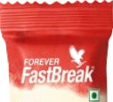



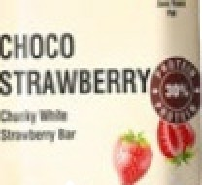

Forever Fast Break  Choco StrawberiyM I•

Instant Energy Booster in S Delicious Flavours

Forever Fast Break Protein & Nut Energy Bars are your go-to solution for fulfilling nutritional needs on the go! Each bar is designed to boost

energy levels and is packed with real fruits and nuts, providing a deliciously

satisfying snack. With the added benefits of prebiotics, high fiber, and a healthy protein source, these bars are perfect for anyone looking for a nutritious option without compromising on taste. They are free from

preservatives, artificial flavors, and colors, ensuring that you're enjoying a

wholesome, guilt-free treat that's 100% zero trans fat.

Get ready to savor the sweet, juicy favor of Forever Fast Break —Choco Strawberry! With 30% protein per serving, this bar is the perfect option for those looking for a protein-packed snack. Real strawberries add a delightful sweetness while providing essential vitamins and minerals. This high-fiber bar not only helps you stay full but also supports your digestive health with the addition of prebiotics. Free from preservatives and artñcial

flavors, Choco Strawberry offers a delicious way to refuel after a workout or during a busy day.

* + Real strawberries for sweetness
  + High fiber content
  + Prebiotics for digestive support
  + No preservatives or artificial additives

CONTENTS

35g

INGREDIENTS

Protein Blend (32.5%) (Soy Nuggets, Say Protein Isolate, Whey Protein Conœntrate), White Chooo Compound (1596) [Sugar, Hydrogœated

Vegetable Fat, Milk Solids, Emulsifier ENS 322())]. Fructo-oligosaccharides, Sweetene [INS 965 ()]. Humectant (INS 422), Rice Crisps (8.50%) [Rice Flour, Salt]. Strawberry Piecœ (5.20%) [Strawberiy Pieces, Sugar], Refîned Surdower Oil, Emulsifier ENS 322 ()], Naturd Bavoring Substanoes, Acidity Regulator (INS 330), Rosemary Extract, Sweetener (INS 955).

|  |  |  |
| --- | --- | --- |
| Nutritional Information  Approximate values | | |
| Serving size: 1 Bar (3'i g) Number of serving pack: 1 | | |
| hlutrient  Energy | Amount Per serving  126.OD kcal | 96RDA -  6.30% |
| Protein | 1D.70g | 19.BU |
| Carbohydrate | 12.20g |  |
| Total Sugars | 2.B0g |  |
| Added Sugars | 2.25g | 4.52% |
| Dietary Fibre (AI) | 4.409 |  |
| Total Fat | 3.80g | 5.67% |
| Saturated Fat  Trans Fat | 1. 52g  09 | b.91%  D% |
| Cholesterol | Ovni |  |
| SOdium | 79.67 mg | 3.98% |
| Allergy advice  Contains Say, Milk, Oats, Nut | | |

##### Forever Fast Break

Almond Sea Salt  Cranberry

FAST FACTS

NUTRITIONALS

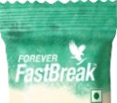

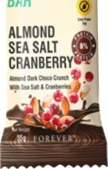

Forever Fast Break  Ch0Co AlmonTM •I

Instant Energy Booster in S Delicious Flavours

Forever Fast Break Protein & Nut Energy Bars are your go-to solution for fulfilling nutritional needs on the go! Each bar is designed to boost

energy levels and is packed with real fruits and nuts, providing a deliciously

satisfying snack. With the added benefits of prebiotics, high fiber, and a healthy protein source, these bars are perfect for anyone looking for a nutritious option without compromising on taste. They are free from

preservatives, artificial flavors, and colors, ensuring that you're enjoying a

wholesome, guilt-free treat that's 100% zero trans fat.

Discover the perfect balanœ of swœt and salty with the Forever Fast Break - Almond Sea Salt & Cranberry bar. This bar contains 3o% almonds, with 10g of almonds per serving, providing a crunchy tenure and a great sourœ of healthy fats. Real cranberries add a touch of tanness, while

the goodness of honey gives it a naturally sweet flavor. High in fiber

and enriched with prebiotics, this bar suppons digestion and provides sustained energy throughout the day. like all Forever Energy Bars, it is free from preservatives and artificiel additives, making it a wholesome choice for your snacking needs.

* + 30% almonds, 10g per bar
  + Real cranberries add tartness
  + High fiber and prebiotics includecl
  + Naturally sweetened with honey
  + No preservatives, no artificial flavors

CONTENTS

35g

INGREDIENTS

Nuts (43%) [Almonds (30%), Peanuts], Dark Chooo Compound (15%) (Sugar, Hydrogenated Vegetable Fat, Cocoa Solid, Emulsifiers [INS 322 ¿, INS 492]), Liquid Glucose, Fructooligosaccharides, Candied Cranberries (8%) (Cmnberries, Sugar, and SuJower Oil, Rice Crisps, Honey, Refined Sunflower Oil, Edible Common Salt (Sea Salt (0.40%)), Coooa Powder, Emulsifier (INS 322()), Nature Identical Flavor (Berry}, Rosemary Extract.

|  |  |  |
| --- | --- | --- |
| Nutritional Information  Approximate values | | |
| Serving size: 1 Bar (3'i g) Number of serving pack: 1 | | |
| Energy | 103.B5 kcal | 5.19% |
| Protein  Carbohydrate | 2.30g  10.40g | 4.26% |
| Total Sugars | 6.00g |  |
| Added Sugars  Dietary Fibre (AI)  Total Fat  Saturated Fat | 5.20g  4.009  5.90g  2.509 | 1D.4D %  B.B1%  11.36% |
| Trans Fat | 09 | D% |
| Cholesterol | 0 mg |  |
| Sodium | 3B.91mg | 1.95% |
| Allergy advice  Contains Soy, Milk, Oats, Nut | | |

Forever Fast Break 

### Oag Berry Cereal

FAST FACTS

NUTRITIONALS







Forever Fast Break  Oa§ Berry CerealTM I•T

Instant Energy Booster in S Delicious Flavours

Forever Fast Break Protein & Nut Energy Bars are your go-to solution for fulfilling nutritional needs on the go! Each bar is designed to boost

energy levels and is packed with real fruits and nuts, providing a deliciously

satisfying snack. With the added benefits of prebiotics, high fiber, and a healthy protein source, these bars are perfect for anyone looking for a nutritious option without compromising on taste. They are free from

preservatives, artificial flavors, and colors, ensuring that you're enjoying a

wholesome, guilt-free treat that's 100% zero trans fat.

Enjoy the hearty and wholesome taste of Forever Fast Break - Oaty BerryCeeaJ Thisflavor combines30o/ almonds with real black currants, seeds, oats, and nuts to deliver a nutritious and satisfying snack. With the goodness of honey, it offers a naturally sweet favor while being high in fiber to keep you feeling full and satisfied. Each bar is designed to suppor digestive health with the addition of prebiotics. As always, you can indulge in this delicious energy bar knowing that it contains no preservatives or anificial ingredients, making it a smart choice for your on-the-go lifes Ie.

* + 30% almonds, packed with nutrients
  + Real black currants for flavor
  + High fiber for fullness
  + Contains seeds, oats, and nuts
  + No preservatives or artificial additives

CONTENTS

35g

**INGREDIENTS**

Seeds & Nuts (24%) [Sesame Seeds, Watermelon Seeds, Almonds (4%), Peanuts (4%), Pumpkin Seeds, Chia Seeds], Fructooligosaocharide, Sweetener (INS 965 (ii)), Oats (11.5%). Ragi Crisp (896) [Ragi Flour, Rioe Flour, Maize Starch, Sugar, 5aIt, Anticaking Agent (INS 170a)]. Soy Nuggets, Honey (5%), Cmnberries (2.5%), Black Curmnt (296), Refined Sunflower Oil, Stabilizer DNS 412), Acidity Regulator (INS 330), Natural favoring Substanoes, Edible Common Salt, Rosemary Extract, Emulsifier DNS 322()].

|  |  |  |
| --- | --- | --- |
| Nutritional Information  Approximate values | | |
| Serving size: 1 Bar (3'i g) Number of serving pack: 1 | | |
| hlutrient  Energy | **Amount** Per serving  127.1D kcal | 96RDA -  6.36% |
| Protein | 5.10g | 9.44% |
| Carbohydrate | 13u0g |  |
| Total Sugars | 2.60g |  |
| Added Sugars | 2.50g | 5 % |
| Dietary Fibre (AI) | 7.409 |  |
| Total Fat | 5709 | B.51% |
| Saturated Fat  Trans Fat | OU9  09 | 9.09%  D% |
| Cholesterol | Ornq |  |
| SOdium | 43.59 mg | 2.1B% |
| Allergy advice  Contains Soy, Milk, Oats, Nut.. | | |



F O REVE R‘



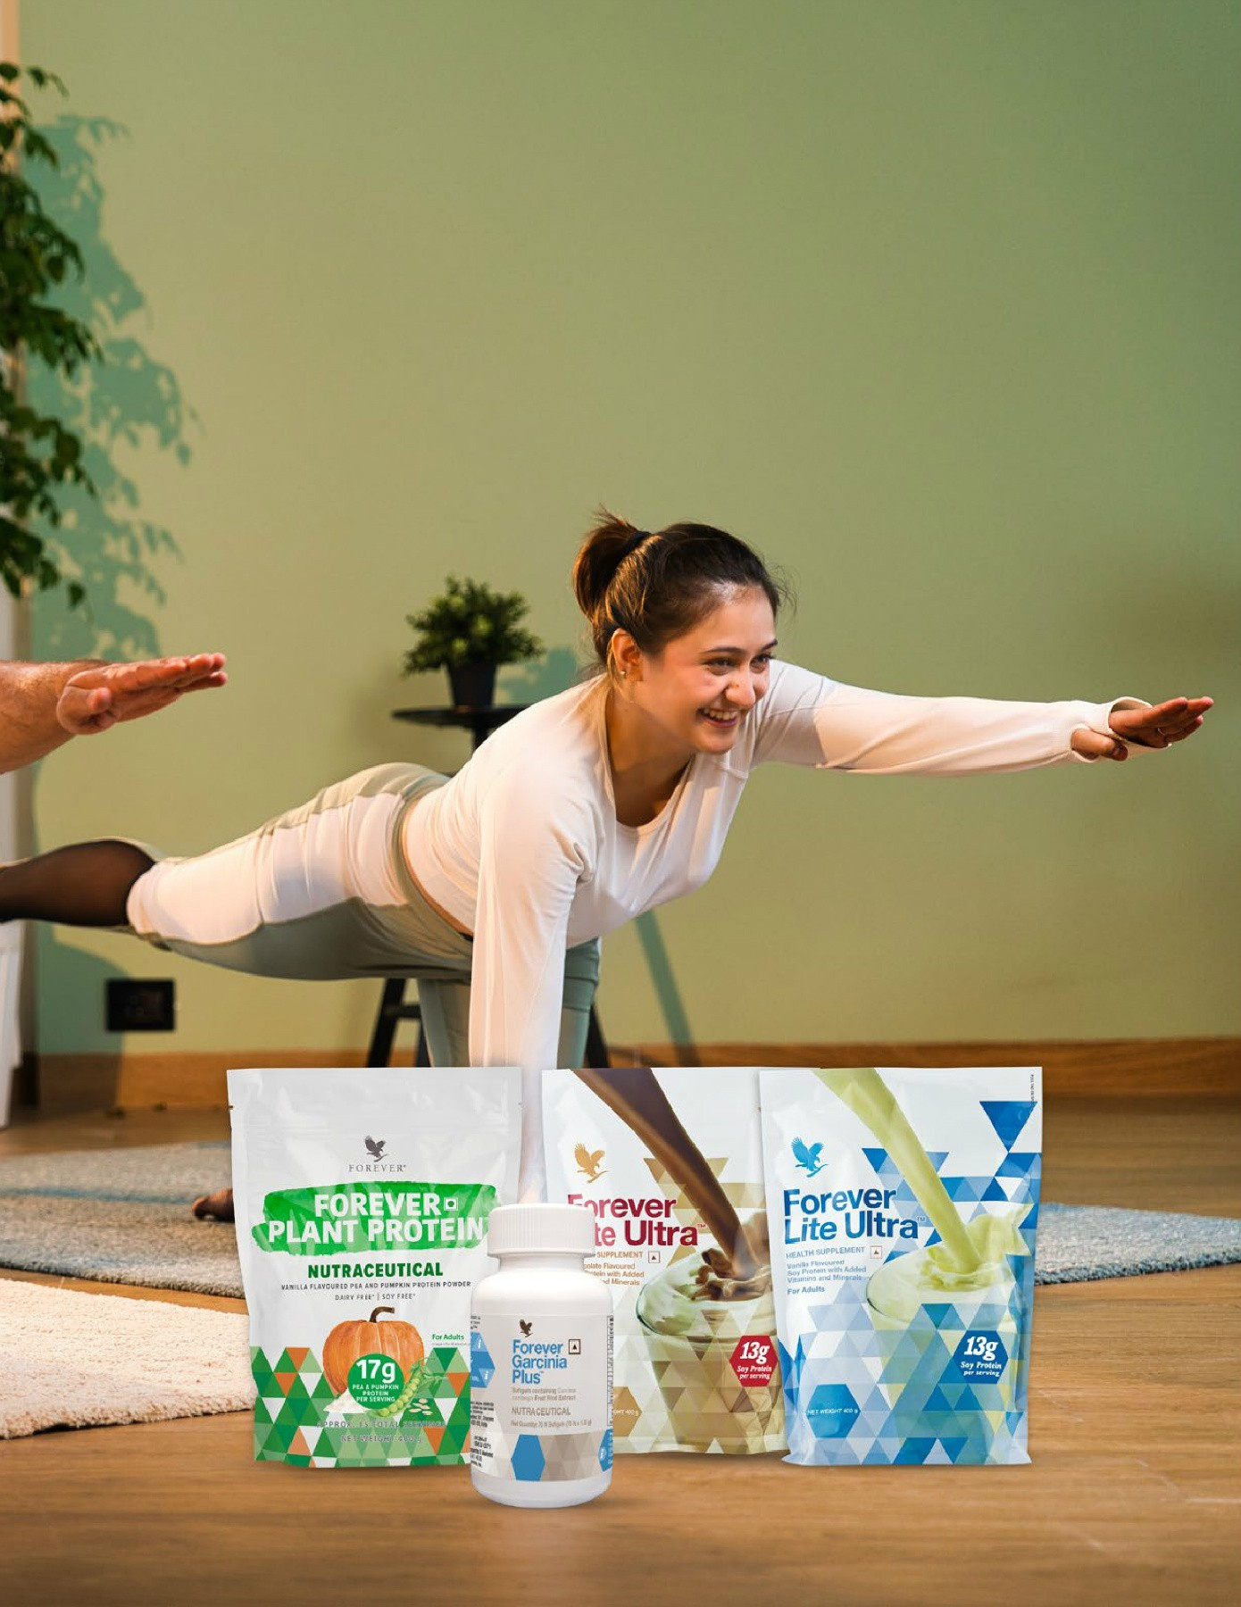

##### Forever Lite Ultra

#471

FAST FACTS

WEIGHT MANAGEMENT

* + - Contributes to lean muscle mass
    - 13 grams of protein per serving
    - Great source of vitamins and nutñtion

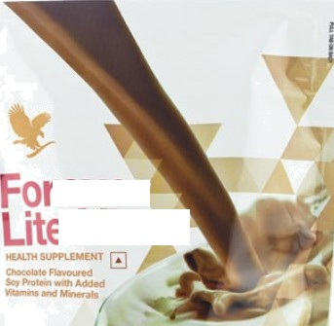

’ever

Ultra

* + - Complements low-carbs lifestyle

Gluteo“Freq Suitadlo f0 0g9tBFi8r\S

CONTENTS

400 g

**DIRECTIONS**

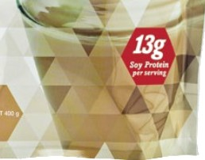Blend or mix 1 level scoop with 300 mL o1 skim milk. (Use scoop provided.) For a special treat, mix with crushed ice or fruit. Stake weI! before each use. This product is intended for adults. Use daily, up to 2 times per day. A health supplement is not to be used as a substitute for a varied diet. Do not exceed the stated recommended daily usage.

**CERTIFICAYIONS**

Kosher Certñed

Forever Lite UltraTM •

Rich natural chocolate flavor to power your healthy lifestyle.

Protein is the basic building block of every cell in your body. A high protein diet can play an imponant role in weight loss by heIDing you control cravings and build muscle. To build and maintain lean

muscle, your body needs amino acids that can only be derived from protein.

Forever Lite UltraTM is a delicious, versatile and easy way to feed your body 13 grams of vegetarian-sourced protein without sugar, fat or carbs. It's a nutritious snack with a decadent natural chocolate flavor that mixes with milk or your favorite non-dairy substitute. You'll love the way you feel when you mane Forever Lite UltraTM pan of your weight management and exercise routine!

Remember, you’II get the best results when you combine this delicious and powerful shake with healthy eating and regular exercise. Raise a glass. Here's to your successful weight management journey!

Each serving of Forever Lite UltraTM, prepared with skim milk as directed, supplies vitamins, minerals and important amino acids, including essential, non-essential and the branched-chain amino acids. With Forever Lite UltraTM, you can rest assured that you are getting the nutrition you want without having to sacrifice taste.

Diclaimcf! Fcw'cr Living prod acts arc under Hc*hh supplement'' N'utraccut I categories. The product is not intended to diagnose, p'evcnt, trc*t or cure zny dIscasc. Consuh your mcdiczlI come practitioner or dictitiari in case of prcgnot'. lactation or if on ay’ medication. NOT FDR MEDICINAL USE. De not exceed the stated recommended dais us*gc. Store out cf the men of children in a cal, dry place. Please refer indi ,'id'ual product label for further clztails.

**INGREDIENTS**

Soy Protein Isolate (55.3%), Maltodextrin, Sunflower Oil, Natural Flavours (Chooolate, Vanilla), Cocoa Powder, Fructooligosaccharides, Honey, Wheat Starch, Hqh Fructose Com Syrup, Sa#ower Oil, Minerals, Anticaking Agent [INS 551, INS 470()], Com Starcn, Stabilizer [INS 412, INS 414], Emulsier DNS 322(i), INS 471], Vitamins, Sweetener [INS 955, INS 421], Colour [INS 150a], Carrier [INS 1518],

Sucrose, Antioxidant [INS 301], Cooonut Oil. Contains Soy , Wheat & Nut.

The product is not intended to oiagnose, treat, cure or prevent any disease. If you are pregnant, nursing, have a medical condition or are taking any medication, consult your doctor before use.

NOT FOR MEDICINAL USE

Keep Tightly Closed. Store In A Cool, Dry Place Out Of The Reach Of Children. Do Not Use If Package Is Tom Or Damaged.

This product is sold by weignt and some settling may occur after packaging.

|  |
| --- |
| **Thia Forever** Lita Uipa"• **contains an admiztgre of Sucraloae (INS 0c5} and Mannitol DNS 421).** |

|  |
| --- |
| CONTAINS NON-CALORIC SWEETENER |



FO R EV ER‘

WEIGHT MANAGEMENT

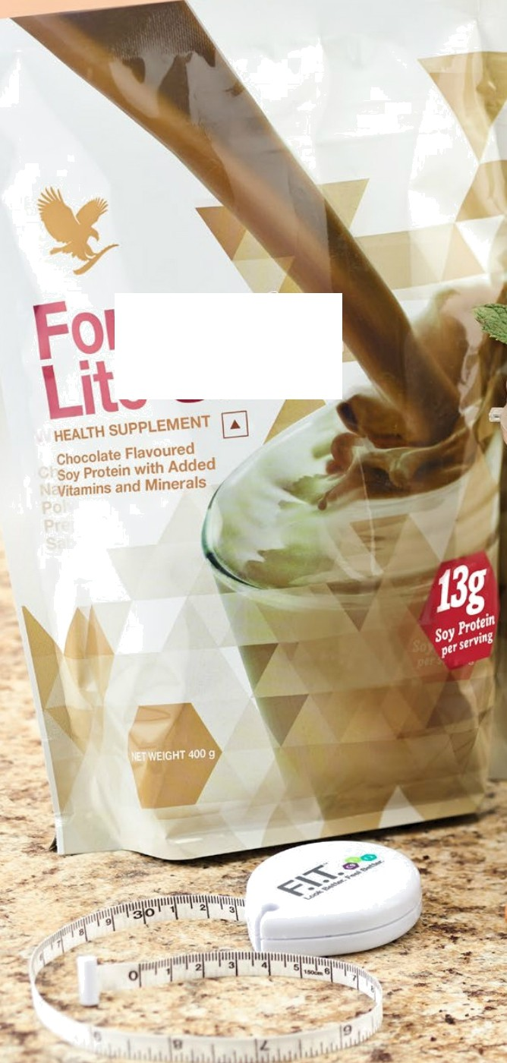

ever

|  |  |
| --- | --- |
| Nutritional Information  Approximate values  Serving size: 26 g (1 Scoop) Number of servings: 15  Nutrient Amount Per 100 g  Energy 375 kcal  Carbohydrate 23 g  Total Sugars 11 g  Add...e.d. Su. g.ars 6...g .  Dietary Fibre (AI) 8 g  Protein 50 g  Total Fat 11 g  Saturated Fat 2 g  Trans Fat 0 g  Cholesterol 1 mg | 96RDA -  'Who  }  }  .. 3Po  }  24%  4Po 2Po Ono  ' } |
| Sodium 815 mg | 11% |
| Magnesium 6' 4 mg | 39,a |
| Calcium 185 mg | Sta |
| Iron 33 mg | 45,a |
| Copper 2 mg | 31% |
| Iodine 28B pg | ' 3, |
| Man..g..a...ne. s. e .. .8..m..g. | ' 2.,... |
| Zinc 19 mg | 29, |
| Selenium 67 | g | ' 43% |
| Vitamin A 1154 pg | 30% |
| Vitamin B1 1 mg | 19a |
| Vitamin B2 2 mg | 26a |
| Niacin 31 mg | ' B,S |
| Vitamin B6 3 mg | 41% |
| Vitamin BU 1 | g | 12a |
| Vitamin C 77 mg | 25,a |
| Vitamin E 19 mg ‹z-Tocopherol | 49,a |
| Pantothenic Acid (AI) 7 mg | ' } |
| Vitamin D3 19 kg | 33% |
| Biotin (AI) 58 | g | } |
| Folic Acid 385 pg ' 7â | |
| -“o Recommended Dietary Allowance (RDA) is calculated per | |
| serve (26 g) basis 2D00 kcal diet for an average adult and | |
| iCMR RDA 2020 for adult men sedentary work. | |
| - RDA not established. Al: Adequate Intake. | |
| Appropriate overages added. | |

^ ” "

” ” W

"



Diclaimer! Forever LJ'zing products are under Hearth supplBmenL NutraccutM categories. The product is rot intended to diagnose, prevent, treat cr cure any dIseasc. Consuh your medical care practitioner or dictitiari in casa of p . lactation or if on ay’ medication. NDT FDR MEDICINAL UBE. Do not exceed the stated rooommcndcd daily usage. Store out of tha reach of children in a cool, dry place. Please refer individual duct label for further details.

F O R E V E R‘

##### Forever Lite Ultra

#470

WEIGHT MANAGEMENT

FAST FACTS

* + - Contributes to lean muscle mass
    - 13 grams of protein per serving
    - Great source of vitamins and nutñtion
    - Complements low-carb lifestyle “”--> ”

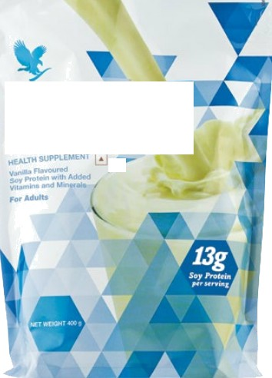

Lite Ultra

T'or-ver

Gluts“ Fra0 Suit0bl0 veg9taFiaf\s

**CONTENTS**

400 g

DIRECTIONS

Blend or mix 1 level scoop with 300 mL of skim milk. (Use scoop provided.) For a special treat, mix with crushed ice or fruit. Stake well belore each use. This product is intended for adults. Use daily, up to 2 times per day. A health supplement is not to be used as a substitute for a varied diet. Do not exceed the stated recommended daily usage.

CERTIFICATIONS

Kosher Certñed

Forever Lite UltraTM •

Power your healthy lifestyle with protein and nutrition.

Protein is the basic building blocs of every cell in your body. A high protein diet can play an imponant role in weight loss by helping you control cravings and build muscle. To build and maintain lean

muscle, your body needs amino acids that can only be derived from protein.

Forever Lite UltraTM is a delicious, versatile and easy way to feed your body 13 grams of vegetarian-sourced protein without sugar, fat or carbs. It's a nutritious snack with a decadent natural vanilla flavor that mixes with milk or your favorite non-dairy substitute. You'll love the way you feel when you make Forever Lite UltraTM part of your weight management and exercise routine!

Remember, you’II get the best results when you combine this delicious and powerful shake with healthy eating and regular exercise. Raise a glass. Here's to your successful weight management journey!

Each serving of Forever Lite UltraTM, prepared with swim milk as directed, supplies vitamins, minerals and important amino acids, including essential, non-essential and the branched-chain amino acids. With Forever Lite UltraTM, you can rest assured that you are getting the nutrition you want without having to sacrifice taste.

Diclaimcf! Fcw'cr Living prod acts arc under Hc*hh supplement'' N'utraccut I categories. The product is not intended to diagnose, p'evcnt, trc*t or cure zny dIscasc. Consuh your mcdiczlI come practitioner or dictitiari in case of prcgnot'. lactation or if on ay’ medication. NOT FDR MEDICINAL USE. De not exceed the stated recommended dais us*gc. Store out cf the men of children in a cal, dry place. Please refer indi ,'id'ual product label for further clztails.

**INGREDIENTS**

Soy Protein Isolate (57.5%), Maltooextrin, Sunflower Oil, Fructooligosaccharides, Honey, Wheat Starch, High Fructose Com Syrup, Sa#ower Oil, Minerals, Stabilizer [INS A12, INS 414], Com Starch, Anticaking Agent [INS 551, INS 470()], Emulsier [INS 322(i), INS 471], Natural Flavour (Vanilla), Articid Flavouring Substance (Vanilla), Sweetener [INS 955, INS 421], Vitamins, Colour [INS 150a], Sucrose, Antioxidant DNS 301], Cooonut Oil.

Contains Soy, Wheat and Nut.

The product is not intended to diagnose, treat, cure or prevent anv disease. If you are pregnant, nursing, have a medical condition or are taking any medication, consult your doctor before use.

NOT FOR MEDICINAL USE

Keep Tightly Cbsed. Store In A Cool, Dry Place Out Of The Reach Of Children. Do Not Use If Package Is Tom Or Damaged.

This product is sold by weight and some settling may occur after packaging.

|  |
| --- |
| **Thia Forever** Lita Uipa"• **contains an admiztgre of Sucraloae (INS 0c5} and Mannitol DNS 421).** |

|  |
| --- |
| CONTAINS NON-CALORIC SWEETENER |



F O R E*\r* E R"

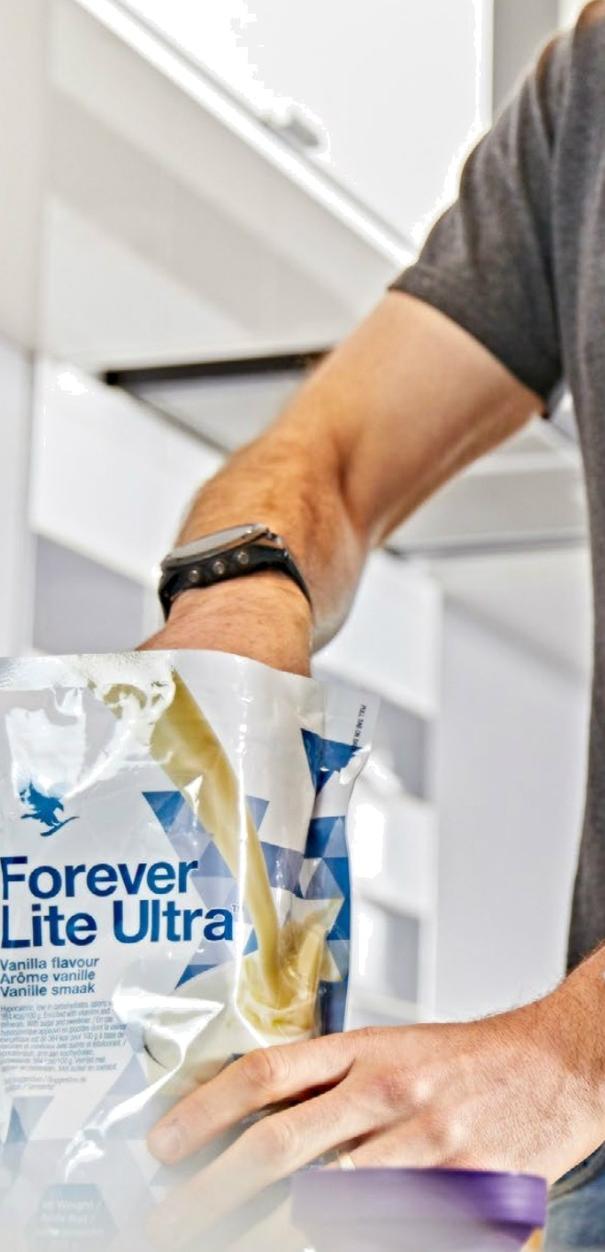



Diclaimel•. Foravar LJ'zing prophets are under Haattfi supglamerit/ Nwtraceu czg categories. Tha praduct is rat intended to diagnose, parent, treat cs cure any diaaase. Gonst I your madM cara pmcdtioner or dietit!ari in casa oI p , lactation a if on any medication. NDT FOR MEDICINAL UBE. Do not excaad the staked renomrnmtded dady ucaga. Store out of the reach of children in a cool, dry placa. Pea rafer indlvidW product label for further details.

WEIGHT MANAGEMENT

F O R E V E R‘

|  |  |  |
| --- | --- | --- |
| Nutritional Information  Approximate values  Serving size: 25 g (1 Scoop) Number of servings: 16  Nutrient Amount Per 100 g  Energy 420 kcal  Carbohydrate 28 g  Total Sugars 8 g | | 96RDA -  'Who  }  } |
| Added Sugars | 7 g | 3Po |
| Dietary Fibre (AI) | 4 g | } |
| Protein | 52 g | 24, |
| Total Fat | 12 g | 4Po |
| Saturated Fat | 1 g | 1 to |
| Trans Fat | 0 g | Ono |
| Cholesterol | ; 1 mg | } |
| Sodium | 82B mg | 10,a |
| Magnesium | 680 mg | 39,a |
| Calcium | 192 mg | 'Who |
| Iron | 34 mg | 45,a |
| Copper | 2 mg | 29, |
| Iodine | 300 pg | 54a |
| Manganese | 8 mg | 50,a |
| Zinc | 20 mg | 29, |
| Selenium | 70 | g | 44a |
| Vitamin A | 1200 pg | 30,a |
| Vitamin B1 | 2 mg | 36ââ |
| Vitamin B2 | *2 mg | 25a |
| Niacin | 32 mg | ' 7, |
| Vitamin B6 | 3 mg | 39a |
| Vitamin BU | 2 | g | 23âa |
| Vitamin C 80 mg 25,a  Vitamin E 20 mg ‹z-Tocapherol 50,a Pantothenic Acid (AI) 8 mg }  Vitamin D3 20 |ug 33a  Biotin (AI) 60 | g }  Folic Acid *400 pg ' 7â  -% Recommended Dietary Allowance (RDA) is calculated per serve (25 g) basis 2D00 kcal diet for an average adult and  \CMR RDA 2020 for adult men sedentary work.  - RDA not established. Al: Adequate Intake. Appropriate overages added. | | |

#### Forever Garcinia Plus

#071

FAST FACTS

\//EI6HT MANAGEMENT

* + - Temporarily inhibits fat production and stomge
    - Helps reduce cravings and suppress appetite
    - Useful weight management tool

Gluts Free



Forever

Garcinia



Forever Garcinia PIusTM ‹0

Designed to help you get your best results.

Forever Garcinia Plus’^ is designed to complement your healthy lifestyle and help you achieve your weight management goals. The star of the show is the Garcinia cambogia fruit, which contains hydroxicitric acid (HCA). This compound has been shown to temporarily inhibit the body's conversion of carbohydrates into fats. The potent Garcinia extract used in Forever Garcinia PIusTMcontains high levels of this important compound.

Because Garcinia helps inhibit fat production, the body leans toward burning existing fat stores, which aids in weight loss when combined with a sensible diet and exercise program. This incredible fruit has also been shown to help reduce cravings as a natural appetite suppressant.

Researchers in the 1960s discovered the Garcinia fruit had compounds that could impact metabolism by inhibiting the enzyme that converts calories into fat. Garcinia is also caffeine free, so you can take this supplement without those caffeine jitters!

To complement Garcinia, we added chromium picolinate. If your body is deficient of this important mineral, it could cause fatigue and excess fat production. You work hard to eat right and exercise. Forever Garcinia Plus’^ is a great tool to help you stay on track!

Diclaimcf! Forever Living prodr+cts arc undor Health supplement' Nutraccutll categories. The product is not intended to diagnose, prevent, beat or cure any d fseasc. Consult your medical care practitioner or dictitian in case of p . lactzition or if on any medication. NOT FDR MEDICINAL USE. Do not exceed the stated rooommcnded dcily usage. Store out of the reach of children in a cal, dry place. Please refer individual product labs for further details.

CONTENTS

70 Softgels

DIRECTIONS

One softgel three times daily, preferably 30-60 minutes before meals.

INGREDIENTS

Garcinia cambogia Fruit Rind Extract (33.7%) (Standardized to 50% Hydroxy Citric Acid}, Vehicle [Safflowe Oil], Ingredient of Capsule Shell [Gelatin], Purified Water, Humeclant, DNS 422], Emulsfier [INS 322()], Corn Syrup, Colour [INS 150d], Chromium (III Chloride. Contains Soy.

|  |  |  |
| --- | --- | --- |
| Nutritional Information  Approximate values | | |
| Serving size: 1.5 g (1 Softgel) Number of servings: 70 | | |
| hlutrient | Amount Per 100 g | 96RDA - |
| Energy | 465 kcal | D% |
| Carbohydrate | 26 g |  |
|  | o g |  |
| Added Sugars  Protein | 09  2Og | D%  D% |
| Total Fat | 33 g | 1% |
| Saturated Fat | 7 g | D% |
| Trans Fat  Cholesterol | 0 g  1 mg | D% |
| S0dium | 305 mg | D% |
| Chromium | 333 pg | 1D% |
| Garcinia cambogia Fruit Rind  Extract (yielding 25D mg  hydroxy citric acid per softge# | 04g |  |
| -% Recommended Dietary Allowance (RDA) is calculated per serve (1.5 g) basis 2000 kcal diet for an average adult and ICMR RDA 2D20 for adult men sedentary work.  - RDA not established. Appropriate overages added. | | |



F O R E V E R‘

Forever Plant Protein

#656

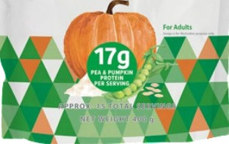

Forever Plant Protein *O•*

Vanilla flavoured pea and pumpkin protein

Introducing Forever Plant Protein’M, a premium choice for those committed tO a plant-based lifestyle and seeking clean label products. Crafted with a blend Of pea and pumpkin proteins, this protein powder offers a holistic approach tO supplementing your daily prOtein needs. Each serving delivers a substantial 17 grams of protein along with fiber, promoting satiety and supporting muscle mass and healthy bOnes.

What sets Forever Plant Protein apan is its use of pea protein isolate, known fOr its high bioavailability and effectiveness in providing all essential amino acids vital for bodily functions. This makes it an

ideal choice for anyone looking to maintain or build muscle while adhering to a plant-based diet. The vanilla flavor is derived naturally from plants, ensuring a deliciOUS taste without relying on artificial sweeteners. AddÏtiOnally, its SmoOth, nOn-gritty texture sets it apart from other plant-based prOteins, enhancing the overall drinking experience.

MoreOver, Forever Plant Protein is committed to sustainability, utilizing rare and sustainably sOurCed protein sources like pea and pumpkin. lt's designed not as a meal replacement but as a complementary way to boost protein intake thrOUghout the day.

Whether you're blending it into smoothies, baking with Ït, *Or* Simply mixing it with Water Or plant-based milk, Forever Plant Protein offers a nutritious and satisfying solution for your protein needs.

Diclaimel•. Foravar LJ'zing products are undei Haahh supqlement/ Nwtraceu egg categories. Tha product is rat intended to diagnose, parent, treat cr cure any disease. Consult your madM cara pmctitionar or diotitian in case of p , lactation a if on any medication. NDT FOR MEDICINAL UBE. Do not excaad tha stated recommended dady usaga. Store out of tha reach of chBdren in a cool, dry placa. Pea refer indlvidW pnzduct label for further details.

WEIGHT MANAGEMENT

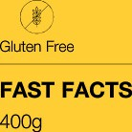

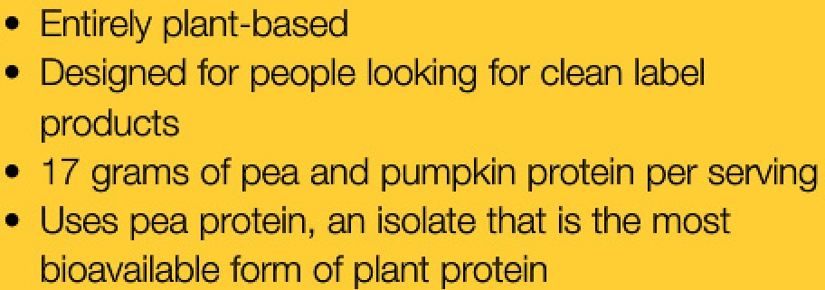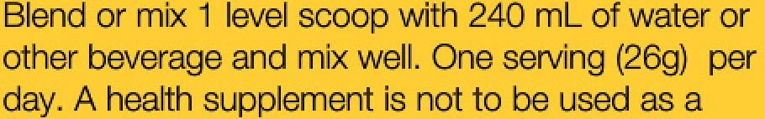

**CERTtRCATlON8**





onoBritrete {25.6%), Mdtodextrin, 5tabiIzw”[IMS 412, lii414j, Fru¢togrszosac¢ha«dBs,.ÏvIedk m

Flegujator SNS.270. INS ö00{ii}, Ih!db2è), Cobur:.



wsssq.›u••yw:e^a«'‹o.16),

a«



|  |  |  |
| --- | --- | --- |
| Nutritional Information  **Approximate** values | | |
| **Serving** size:26g (1 Scoop)  Number of serving per **container: Approx. U** | | |
| **Nutrient** | **Amount Per** 100 g | 96RDA - |
| Energy  Carbohydrate | 3B2 kcal  15.4 g | 5% |
| Total Sugars | 1 g |  |
| Added Sugars | 0.256 g | D% |
| Dietary Fibre (AI)  Protein | 6.38 g  64.4 g | 31% |
| Total Fat | 8.36 g |  |
| Saturated Fat | Z.44g |  |
| Trans Fat | 0g | D% |
| Cholesterol | 1 mg |  |
| Sodium | Z89 mg | 4% |
| -% Recommended Dietary Allowance (RDA) is calculated per serve (26 g) basis 2D00 kcal diet for an average adult and ICMR RDA ZD20 for adult men sedentary work.  - RDA not established. AI: Adequate Intake. | | |

|  |
| --- |
|  |
|  |

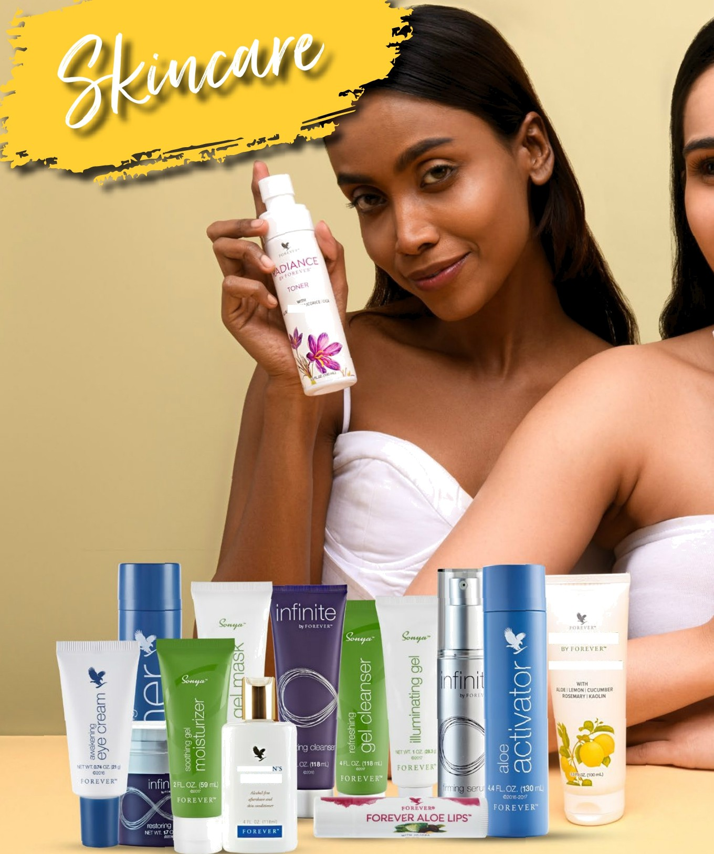

RADIANCE

MUD MASK SCRUE

GENTLEMA

PRIDE

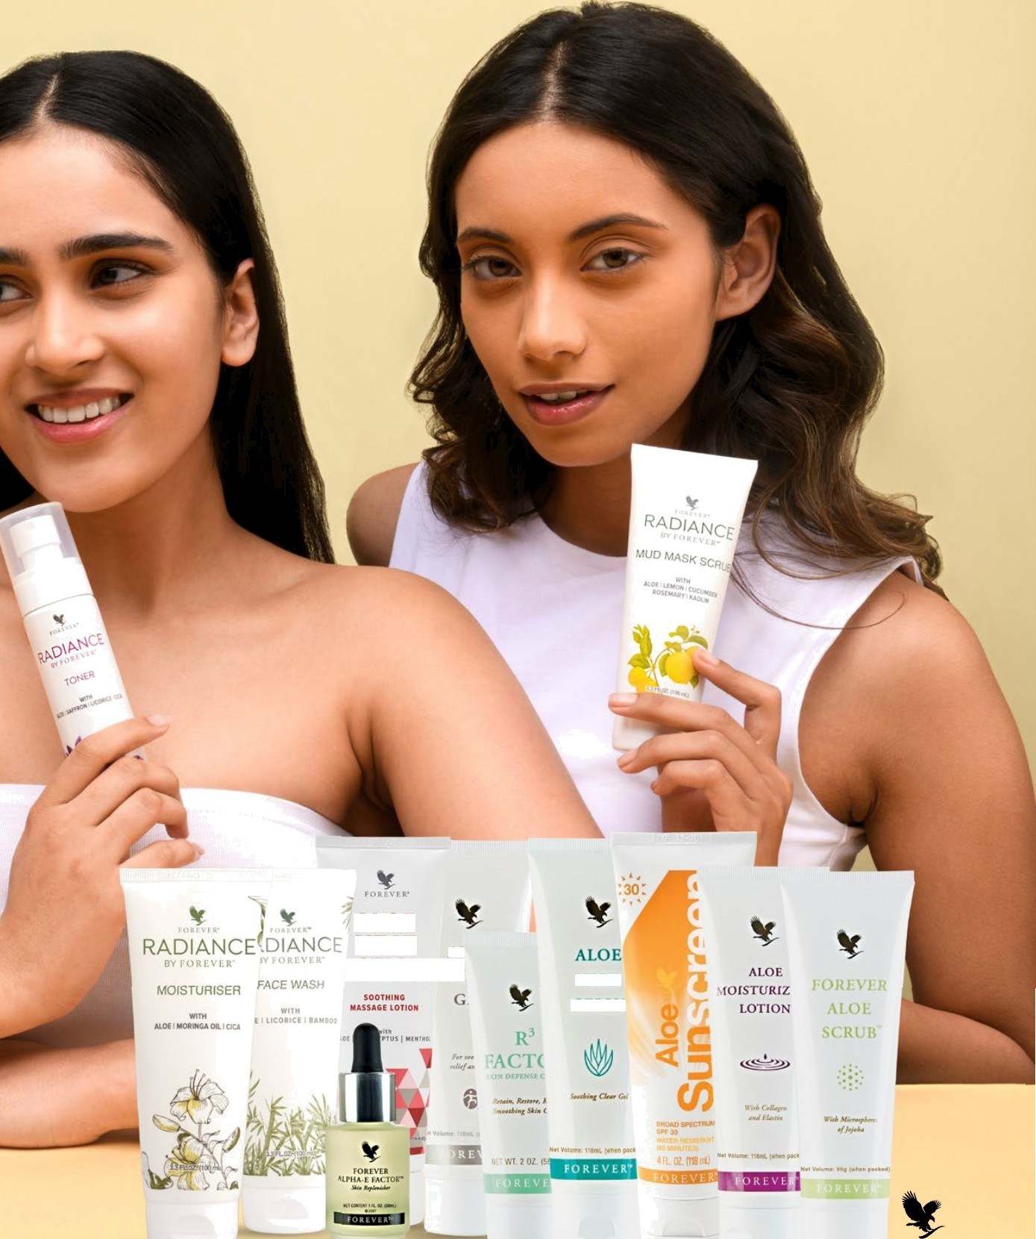

ALOE

HEAT „

LOTION „ VERA

G ELLY

F O R E V E R’

###### Aloe heat Lotion

#064

FAST FACTS

* Helps soothe muscles
* Nourishes the skin
* Menthol and eucaJyptus fmgmnœ

SKINCARE

ALOE HEAT LOTION







Aloe Heat Lotion

Soothe away the pressures ofthe day.

Experience the relaxing sensation of Aloe Heat Lotion after a tough workout or long day at work. This aloe-powered formula delivers heating and cooling effects to help soothe your muscles.

Ultra-rich and non-greasy, this creamy lotion is perfect for a deep, relaxing massage to set your mind and body at ease. Aloe Heat Lotion goes on cool and stimulates with the sensation of aloe and menthol

to soothe on contact. It then warms, while ingredients like eucalyptus helps relax your muscles and create a naturally aromatic experience.

The aloe used in this skin nourishing lotion is grown at Forever's own fields. We hand harvest and hand fillet every leaf to ensure quality stabilized aloe vera is in every bottle of Aloe Heat Lotion.

By combining our aloe with other powerful natural ingredients, Forever has created a lotion that will not only leave you feeling more relaxed, but leave your skin feeling soft, smooth and nourished. Massage

away the stresses of the day and feel refreshed and ready to take on tomorrow.

Gluten Free Sultable for vegetarlans Sukable for vegans

CONTENTS

118 mL (when packeQ

DIRECTIONS

Apply liberally and massage into skin as needed. Avoid contact with eyes. Should contact occur, flush with water for several minutes.

CERTIFICATIONS

IASC Certified



INGREDIENTS

Aloe Barbadensis Leaf Juice (Stabilized Aloe Vera Get, Water (Aqua), Methyl Salicylate, Propanediol, Glyceryl Stearate, Cetyl Alcohol, Arginine, Gtyceryl Oleate Citmte, MenthoI,CapryIic/Capric Triglyoeride, Eucalyptus Globulus Leaf Oil, Prunus Armeniaca (Apricot) Kernel Oil, Sesamum lndicum (Sesame) Seed Oil, Cetyl Ethylhexanoate, Carbomer, Allantoin, Ascorbic Acid, Ethylhexylglycerin, Hexylene GIycoI,PhenoxyethanoI, Caprylyl Glycol.

###### Aloe MSM Gel

#205

FAST FACTS

SKINCARE





E

Aloe MSM Gel

Cool, calming relief for any gym bag.

Forever's Aloe MSM Gel is your ticket to soothing relief when and where you need it. We combined pure inner leaf aloe vera with

methyl sulfonyl methane (MSM), an organic sulfur found in many living organisms. MSM has powerful skin calming properties and combined with pure aloe vera gel provides deep comfort and moisturization.

But the soothing power of Aloe MSM Gel doesn't stop with those two ingredients. This clear, non-staining formula includes natural herbal extracts like tea tree leaf oil, willow bark extract and glycerin to calm and condition skin. The addition of rosemary leaf extract draws water to the skin to keep it hydrated and comfortable.

This versatile gel is a must-have for any gym bag. Apply liberally and massage into skin to soothe sore joints and muscles after a tough workout. If your lifes ie keeps you on the move, show your body the love it deserves and stay ready for the next adventure.

Apply liberally and massage into your skin after a long day or a tough workout to sooth your muscles and joints.

* Combines natural MSM, Joe gel and herbd extmcts
* Great fbr soothing relief anytime
* Essential for any gym bag
* Non-staining formula

Gluten Fre0 Suitable for vegetarians Sukable for vegans

CONTENTS

118 mL (when packet

DIRECTIONS

Apply liberally and massage into skin areas where needed. Should eye contact occur, flush with water for several minutes. Repeat application as needed.

CERTIFICATIONS

IASC Certified



INGREDIENTS

Aloe Barbadensis Leaf Juice (Stabilized Aloe Veia Get, Water (Aqua), Dimethyl Sulfone MSC, Glycerin, Triethanolamine, Dimethicone, Arctostaphylos Uva Ursi Leaf Extmct, Sodium

Hyduronate, Allantoin, Tocopherol (Natural Vitamin E}, Melaleuca Altemifolia (Tea Tree) Leaf Oil, Rosmarinus Officinalis (Rosemary) Leaf Extract, Salix Alba (Willow) Bark Extract, Polysorbate 80, Ascorbic Acid, Carbomer, Dfsoclium EDTA, Methylparaben, Diazolidinyl Urea.

##### Gentleman's Pride

#070

FAST FACTS

* Aloe-powered skin conditioning
* Cooling sensation and fresh feel
* Aftershave and skin conditioner
* Alcohol free

SKINCARE

Gluten Fre0 Suitable for vegetarians Sukable for vegans

fi ENTt.FMAN‘fi

PRIDE



Gentleman's PrideTM

Aloe powered moisturizing ahershave.

Give your post-shave routine a soothing upgrade with Gentleman's Pride’^. This aloe powered aftershave doubles as a super hydrating moisturizer for your entire face and neck.

Forever's formula is free of alcohol and features an exclusive blend of ingredients that provides an icy exhilaration with a clean and classically sophisticated masculine scent. With a backbone of pure inner leaf aloe vera, Gentleman's Pride’M will provide long-lasting comfort and leave you feeling fresh and invigorated.

Shaving can cause irritating nicks, scratches or burn as the blade moves across your face. Most aftershaves have a high alcohol content that can leave your skin feeling dry. That's not the case with Gentleman's PrideTM. Natural skin conditioners like rosemary, vitamin E and cucumber work alongside aloe and sodium hyaluronate to deeply soothe and moisturize.

ęo

Gentleman's PrideTM allows you to face the day with confidence and comfort. This is the next generation of sophisticated skincare developed exclusively for men.

CONTENTS

4 FL. OZ. (118 mL)

DIRECTIONS

Apply liberally after shaving or exposure to the elements.

CERTIFICATIONS

IASC Certified



INGREDIENTS

Aloe Barbadensis Leaf Juice (Stabilized' Aloe Vera Gel), Water, Methyl Gluoeth-20, Ethylhexyl Palmitate, Dimethicone, PolyacryIamide,GlyceryI Stearate, Tocopheryl Aoetate, Rosmarinus

Officinalis (Rosemary) Leaf Extract, Cucumis Sativus (Cucumber Fruit Extract, Hydroxyacetophenone, Glycerin, C13-14 Isoparaffin, Laureth-7, PEG-

100 Stearate, Sodium Hyaluronate, Ascorbic Acid, Allantoin, Caprylyl Glycol, Ethylhexylglycerin, Hexylene Glycol,Phenoxyethanol, Fragrance.

##### Forever Aloe Lips

with Jojoba

#022

FAST FACTS

* Moistens and softens lips
* Soothes dry, chapped lips
* Locks in moisture

SKINCARE

* + Lips look glossy, smooth and healthy

Gluten Free Suitable Air vegetarians

 



FOREVER ALOE LIPS”



Forever Aloe LipsTM with Jojoba

Soothe away the pressures of the day.

When it comes to your skincare routine, don't let your lips feel left out. Soften, condition and soothe with Forever Aloe LipsTM with jojoba.

Forever Aloe Lips’M is the ultimate year-round solution to dry, chapped lips. Aloe, jojoba and beeswax soothe, smooth and comfort your lips while providing a long-lasting moisture barrier for your precious lips.

We didn't stop there. Forever Aloe LipsTM includes jojoba oil, a natural liquid wax that both soothes and protects your lips. We combined jojoba with a skin conditioning agent called myristyl myristate for lips worfh showing off.

The soothing power of aloe combined with a perfectly balanced mix of natural ingredients will leave your lips feeling cool, plump and moisturized, while three types of wax lock in moisture and give your lips a stunning gloss.

From winter snow to summer sunshine, make sure your lips are prepared for an hing the great outdoors has to offer!

CONTENTS

NETWT 0.15 OZ. (4.25 g)

DIRECTIONS

Apply to the lips regularly as a moisturizer, particularly in harsh or extreme weather conditions.

INGREDIENTS

Petrolatum, Mineral Oil, Ozokerite, Simmondsia Chinensis (Jojoba) Seed Oil, Myristyl Myristate, Glycine Soja (Soyabean) Oil, Ethylhexyl Hydroxysteamte, Euphorbia Cerifera (Candelilla) Wax, Beeswax, Aloe Barbadensis Leaf Extract, Conenicia Cerifera (Carnauba) Wax, Flavor, Allantoin, Propylpamben.

Alpha-E Factor

#187

FAST FACTS

* Nourishes and restores hydration

SKINCARE

 



FOREVER

AtPHA-E FACTOR“

Forever Alpha-E FactorTM

Replenish your skin with ultimate moisturization.

Forever Alpha—E FactorTM is a rich elixir that delivers powerful protection from free radicals while restoring moisture, supporting elasticity and helping to prevent premature signs of aging.

The antioxidant power of Forever Alpha-E Factor is fueled by anti- pollution powerhouse vitamin E, which pulls double duty by fighting free radicals while promoting soft and radiant skin. This nourishing formula delivers other antioxidants like vitamins A and retinyl palmitate to defend from free radicals and support aging gracefully.

Free radicals are responsible for 80% of skin damage and come from outside factors like pollution and UV rays. Alpha-E Factor’^’s lightweight formula glides on easily, delivering advanced moisture and protection from free radicals, while vitamin C leads the charge against oxidative stress.

Dryness is one of the most irritating signs of skin distress caused by environmental factors. To hydrate dry or sensitive skin, borage oil provides some of the highest concentrations of essential fate acids that act as natural enzyme remedies to restore moisture.

Give your skin the nourishment it needs to fight free radicals and suppon healthy, younger-looking skin. Just a little bit of Forever Alpha-E FactorTMgoes a long way toward promoting your most

hydrated skin.

* Robust combination of antioxidants and botanicals
* Great fbr all skin types

Gluten Free Suitable for vegetarians Sukable for vegans

CONTENTS

1 FL. OZ. (30 mL)

DIRECTIONS

Apply to face, neck and dry areas where needed. For added moisture, dampen skin lightly with Balancing Toner before application. Forever

Alpha-E Factor’M may also be used in combination

with R3 Factor” Skin Smoothing Creme.

CERTIFICATIONS

Cruelty Free, Kosher Certified



INGREDIENTS

Caprylic/Capric Triglyceride, Cyclomethicone, Tocopheryl Acetate, Retinyl Palmitate, Ascorbyl Palmitate, Aloe Barbadensis Extmct, Bisabolol, Tocopherol, Lecithin, Borago Officinalis Seed Oil, Glycine Soja (Soybeari) Oil, Methylpamben, Propylpamben, Fragrance.

Aloe Moisturizing Lotion

#063

FAST FACTS

SKINCARE





\ OFSTURF Z15

LOTI ON



Aloe Moisturizing Lotion

Silky smooth texture that locks in moisture.

Experience the advanced, deep moisturization that only pure, inner leaf aloe vera can provide. Forever's Aloe Moisturizing Lotion is made with hand-harvested, hand filleted aloe to moisturize, soothe and restore your skin.

Day in and day out our skin is exposed to weather, wind and pollution, all of which can take a toll on your skin. Aloe Moisturizing lotion is a powerhouse formula when it comes to replenishing lost moisture and restoring soft, supple skin.

The rich texture provides your skin a truly indulgent experience. Perfect for the body and hands, the addition of collagen and elastin work to keep skin smooth, soft and elastic while maintaining a natural pH balance.

Another benefit of Aloe Moisturizing Lotion is its outstanding humectant properties to preserve, maintain and lock in moisture. Natural ingredients like apricot kernel oil, jojoba and vitamin E work together condition skin for a radiant glow.

When your skin needs a little extra attention, Aloe Moisturizing Lotion has everything you need to restore and revitalize.

* Restores dry, chafed windblown skin
* Provides smooth, supple skin
* Rich, indulgent texture
* Perfect for hands and body

Gluten Free Suitable Air vegetarians

CONTENTS

118 mL (when packet

DIRECTIONS

Apply to face, hands or body, Gently massage lotion until it is absorbed into the skin. If used as a foundation for make-up, dlow a thin flim to remain.

CERTIFICATIONS

IASC Certified



INGREDIENTS

Aloe Barbadensis Leaf Juice (Stabilized Aloe Veia Get, Water (Aqua), C12-15 Alkyl Benzoate, Stearic Acid, Glyceryl Steamte, Hydrogenated

Polyisobutene, Methyl Gluceth-20, Sorbitol, Prunus Armeniaca (Apricot) Kernel Oil, Polysorbate 60, Triethanolamine, Cetyl Alcohol, Soluble Collagen, Hydrotyzed Elastin, Simmondsia Chinensis (Jojoba) Seed Oil, Tooopherol, Sodium Hyaluronate, Sodium PCA, Chamomilla Recutita (Matricaria) Flower Extmct, Allantoin, Dimethicone, PEG-100 Steamte, Ascorbic Acid, Diazolidinyl Urea, Methylpamben, Propylpamben, Fragrance (Parfum).

##### Forever Aloe Scrub

#238

FAST FACTS

* Natural exfoliator for the body
* Prepares skin for moisturization
* Skin conditioning benefits of aloe
* Reveals radiant skin

SKINCARE

Gluten Fre0 SultBbl6 for VBgetBrl8f›s Sult‹sbe for V0gan9

CONTENTS

99g (when packed)

DIRECTIONS

Apply to wet face or body, and gently massage with fingertips (carefully avoiding the eyes) for two to three minutes using a circular motion. Add more wate as needed. Rinse thoroughly and pat dry with a dean, soft towel.

Forever Aloe ScrubTM

Gentle scrubbing power with the nourishing comfort

of aloe vera.

Only Forever can bring you such a gentle and refreshing exfoliator with the skin conditioning benefits of pure aloe vera gel. There's a powerful secret inside every tube of Forever Aloe Scrub TM - pure jojoba oil beads. These microspheres gently scrub away dead skin cells and debris that accumulate in the pores of your skin.

When you start using Forever Aloe Scrub T^, it won't take long for you to notice radiant, healthier-looking skin. The exfoliation process also clears the way for your skin’s own renewal process and prepares your skin for your favorite Forever moisturizer.

Use Forever Aloe Scrub’^ two or three times a week on your body to reveal the kind of luminescence you just won't find with any other exfoliator. This natural exfoliator has none of the drying or damaging effects of today's synthetic cleansers.

The aloe vera used in Forever Aloe Scrub TM is carefully grown at our own fields, hand-harvested and hand filleted to ensure only the freshest, highest quality inner leaf gel is used in every tube of this incredible exfoliator.

CERTIFICATIONS

IASC Certified



INGREDIENTS

Aloe Barbadensis Leaf Juice (Stabilized“ Aloe Veia Get, Water (Aqua), Hydrogenated Jojoba Oil,

Glyceryl Stearate, Propylene Glycol, Sodium Cocoyl

Isethionate, Cetyl Alcohol, PEG-100 Stearate, Lauramine Oxide, Cocamidopropyl Betaine, Hydrated Silica, Sodium Lactate, Tocopherol, Citric Acid, Ascorbic Acid, Diazolidinyl Urea,

Methylpamben, Propylparaben, Fragmnce (Parfum), Blue 1 (CI 420g0).

R3 Factor

#069

FAST FACTS

SKINCARE

* + Helps maintain skin color, texture and feel
  + Retains, restores and renews skin
  + Fortified with v#amins A and E

Gluten Free Sultable Phr vegetarlans

CONTENTS

2 OZ. (56.7 g)

DIRECTIONS

* • After cleansing, apply to face, neck and other areas whee needed. For best results, use both morning and night.

CERTIFICATIONS

fASC Certified



R3 FactorTM

Restore your skin's youthful glow.

Help your skin retain its natural moisture, restore its resilience and renew its appearance with R3 FactorTMSkin Defense Creme — a rich combination of stabilized aloe vera gel, soluble collagen and alpha- hydroxy acids, fortified with vitamins A and E, each vital to healthy skin.

Vitamin E is a powerful antioxidant, while vitamin A helps in the maintenance of healthy skin and is beneficial for many skin conditions.

Alpha hydroxy acids (AHAs) come from natural plant sources and are also called fruit acids. Together, these fruit acids are exfoliants that loosen dead cells from the skin's surface by dissolving the natural glue-like substances and releasing dead skin cells. These cells create a barrier to moisturizing creams, so getting rid of dead cells evenly means that fresher cells are exposed in the skin's renewal process.

As the skin renewal process takes place, you’II experience the full

benefits of R3 FactorTM in as little as 21 days.

Fruit acid creams have been called the most imponant skincare agents of the decade. By combining AHAs with soothing aloe, R3 Factor Skin Defense Creme provides a first line of defense in fighting the harsh effects of time to preserve your skin's youthful appearance.

INGREDIENTS

Aloe Barbadensis Leaf Juice (Stabilized Aloe Vera Gel, Water (Aqua), Butylene Gtycol, Squalane, Methyl GIuoeth-20, Cetyl Dimethiœne, Prunus Armeniaca (Apricot) Kemel Oil, Glyœryl Stearate, Polyacrylamide, Tocopheryl Linoleate, C13-14 Isoparañn, Sodium Hyduronate, Tooopheryl Acetate, Glyœlic Acid, Laureth-7, Saccharum Œficinarum (Sugar Cane) Extract, Cibus Limon mon) Fruit Extmct, Citrus Aurantium Dulcis (Orange) Extract, Pyrus Mdus (Apple) Extract, Camellia Sinensis

Leaf Extract, Retinyl Palmitate, Soluble Collagen, PEG-100 Steamte, Ascorbic Acid, Triethanolamine, Diazolidinyl Urea, Methylpamben, Propylparabœ, Fragranœ (Parfum).



F O R E V E R‘

Aloe Vera Gelly

#061

FAST FACTS

* Lubricates sensitive ttssue

SKINCARE



A LO E VERA G ELLY





Aloe Vera Gelly

The very best from our fields to you.

Aloe vera is a powerful plant that has been revered for centuries to aid in the soothing of minor skin irritations. Many households kept aloe vera nearby to serve as a “burn plant” because the inner leaf gel is soothing on minor burns, including sunburns.

Forever's Aloe Vera Gelly is a back—to—basics formula that embraces the power of aloe in its purest form. The quality of aloe vera used makes all the difference and our aloe is the first of its kind to receive the International Aloe Science Council (IASC) certification for purity and potency.

It takes a lot of effort to earn such a prestigious designation and we're incredibly proud of the work we do to bring you the very best aloe products, and Aloe Vera Gelly is no exception. Every leaf is hand harvested and filleted by hand to preserve the precious gel contained within every plant.

You'll know the difference as soon as you start using Forever's Aloe Vera Gelly. Perfect for any skin type, it absorbs readily into skin to soothe skin while moisturizing and conditioning.

This thick, translucent gel is almost identical to aloe vera's inner leaf so you know you're getting the best of aloe, just as nature intended.

* Soothes, moisturizes and conditions
* Doesn't stain clothing
* As close to pure, inne leaf aloe as you can get

Glutœi Fre0 Sultable for vegetarlans Sukable for vegans

CONTENTS

118 mL (when packeQ

DIRECTIONS

Thoroughly cleanse skin before liberally applying Gelly. Repeat application as needed.

CERTIFICATIONS

IASC Certified



INGREDIENTS

Æœ Barbadensis Leaf Juice (Stabilized Æoe Vera Gel, Water (Aqua), Glyœrin, Triethanolamine, Carbomer, Tooopherol, Ælantoin, Asœrbic Acid, Diazolidinyl Urea, Disodium EDTA, Methylpamben.

##### Aloe Sunscreen

#617

FAST FACTS

SKINCARE

” • SPF 30 protection from UVA and UVB rays

* Natural zinc aside surecr‹xri ohms sup‹xior protection
* Soothes, moisturizes and protects
* Water resistant for 80 minutes

Gluten Fre0 SultBbl6 for VBgetBrl8f›s Sult‹sbe for V0gan9

CONTENTS

4 FL. OZ. (118 mL)

Aloe Sunscreen

Full-spectrum protection that locks in moisture with skin-soothing aloe

Soak in those beach vibes without letting the sun's harmful rays damage your skin. Whether you're waxing up the surfboard or heading out for a day at the park, Aloe Sunscreen has your whole family covered.

With Aloe Sunscreen, you can go anywhere the sun is shining thanks to broad spectrum SPF 30 protection that guards your skin against UVA and UVB rays. UVA rays make up 95% of the radiation that reaches Eanh.

These rays penetrate the skin deeply and play a major role in aging and the formation of wrinkles.

UVB rays are more damaging to the skin's outer layers and cause reddening and sunburn. The effects of these rays are even more harmful when amplified by high altitude, reflective surfaces, snow and ice, in some cases doubling exposure.

Aloe Sunscreen features a breakthrough blend that includes natural non- nanosized zinc oxide with advanced coating technology. It applies easily, offers superior sun protection without feeling greasy or leaving any residue behind.

But it isn’t just advanced sun blocking technology that makes Aloe Sunscreen such a powerful product. Pure aloe vera from Forever's own fields nourishes the skin, locks in moisture and soothes. Only the highest quality inner leaf aloe is used to comfort and defend your skin. We've ramped up the skin-shielding power even funher with vitamin E, which combats free radical damage, softens and penetrates deeper for greater moisturization.

Aloe Sunscreen is water resistant for 80 minutes. Get the full protective effect by applying generously and every 2 hours when you're out in the sun. \/\Whether you're climbing high toward a mountaintop or enjoying a relaxing weekend cookout, rest assured you can soak in the sun with confidence knowing the power of Aloe Sunscreen is keeping your whole

family protected.

DIRECTIONS

Apply liberally to all exposecl areas 15-30 minutes before exposure to the sun. Reapply when skin feels dry, within 80 minutes of swimming and sweating

CERTIFICATIONS

IASC Certified



INGREDIENTS

Water (aqua), aloe barbadensis leaf juice (stabilized“ aloe vera gel), zinc oxide, octocrylene, homosalate, propanediol, ethylhexyl salicylate, propylheptyl caprylate, diisostearoyl poIygIyceryI-3 dimer dilinoleate, VP/hexadecene copolymer, cetearyl ethylhexanoate, undecane, polyhydroxystearic acid, hydrogenated castor oil, tridecane, magnesium sulfate, caprylyl glycol, phenoxyethanol, fragrance parfum), sodium gluconate, chlorphenesin, ethylhexylglycerin, potassium sorbate, tocopheryl acetate, citric acid, sodium benzoate benzyl salicylate, benzyl benzoate, ascorbic acid, hexyl cinnamaldehyde

Sonya refreshing

## gel cleanser

#605

FAST FACTS

* Conditions while cleansing

SKINCARE

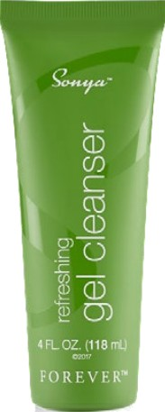

Sonya M refreshing gel cleanser

The latest in cleansing.

You'll notice from the moment the cooling gel touches your skin that this isn’t your high bubble, leave-your-skin-tight type of experience. Our aloe gel, bolstered with worldwide ingredients, makes for the latest and best way to cleanse your face both morning and night for a gentle and soothing experience.

Apple amino acids and deserf date extract enrich the soft lather of refreshing gel cleanser to support combination skin. Acacia concinna fruit extract helps remove dead cell buildup, dirt and makeup for a thorough, but soft cleansing experience.

Refreshing gel cleanser not only uses cleansing agents, but also includes moisturizing agents like cold pressed baobab oil from trees in Senegal. This tree, also know as “the tree of life” to natives, is known to live over 500 years. The strength and longevity of this tree makes it an excellent extract to boost our formula.

Move over traditional cleansers! Sonya refreshing gel cleanser has a new, gel delivery system that will have your skin feeling smooth and clean after every wash. Use as part of the SonyaTM daily skincare

system for optimal results.

* Aloe soothes instead of stripping skin
* A gentle lather for combination skin

Suitable Jar vegetarians Suhable for vegan9

CONTENTS

4 FL. OZ. (118 mL)

DIRECTIONS

Apply a generous amount to wet fingers and massage into skin. Rinse thoroughly for a refreshed complexion. For best results, follow with illuminating gel or refining gel mask.

CERTIFICATIONS

IASC Certified



INGREDIENTS

Aloe Barbadensis Leaf Juice (Stabilized Aloe Vera Gel/gel d'aIoés officinal stabilisé), Water (Aqua/Eau), Decyl Glucoside, Propanediol,

Caprylyl Methicone, Polyacrylate CrosspoIymer-6, Sodium Cocoyl Glycinate, 1,2-Hexanediol, Adansonia Digitata Seed Oil PoIygIyceryI-6 Esters, Sorbitan Oleate Decylglucoside Crosspolymer, Coco-Glucoside, Glyceryl

Oleate, Acacia Concinna Fruit Extract, Balanites

Aegyptiaca Fruit Extract, Gypsophila Paniculata Root Extract, Caprylhydroxamic Acid, Caprylyl Glycol, Ethylhexylglycerin, Sodium Cocoyl Apple Amino Acids, Caesalpinia Spinosa Gum, Hydroxyacetophenone, Disodium EDTA, Potassium Sorbate.

Sonya illuminating gel

#606

FAST FACTS

* Evens skin tone
* Brightens skins' overall appearance

SKINCARE

* + Reduces the appeamnce of large pores

Gluten Fre0 Suitable for vegetarians

CONTENTS

1 OZ. (28.3 g)

DIRECTIONS

After cleansing, gently massage a small amount over entire face for a radiant glow. For best results pair with refreshing gel cleanser, refining gel mask

and soothing gel moisturizer. Rinse thoroughly in the morning for a balanced complexion. Use at least 2-3 timas a week for optimal results.

CERTIFICATIONS

IASC Certified



Sonya M illuminating gel

Make your skin glow.

Licorice root and a unique blend of green and brown algae help to even skin tone and blur the appearance of age spots. This algae blend is paired with liposomes to ensure the benefits get delivered to your skin right where they are needed. We also utilized red clover flower extract to help reduce the appearance of large pores.

Another reason illuminating gel is not like an hing else available on the market is a unique collection of five Asian botanicals: scutallaria baicalensis root, glycyrrhiza glabra root, morus alba root, arfemisia capillaris flower and zizyphus jujube fruit. These oriental plants are known for their ability to even and brighten overall skin tone.

Your improved skin will reflect a soft, smooth texture and emit a healthy glow with envious results. Use as pan of the Sonya’M daily skincare system to control oil and deliver moisture where your skin needs it most.

INGREDIENTS

Aloe Barbadensis Leaf Juice (Stabilized“ Aloe Vera Gel/gel d'aIoés officinal stabilisé), Water (Aqua/Eau), Propanediol, Caprylyl Methicone, Niacinamide, Cetearyl Olivate, Sodium Acrylatas Copolymer, Butylene Glycol, Sorbitan Olivate, Lecithin, lsopentyldiol, Trifolium Pratense (Clover) Power Extract, Scutellaria Baicalensis Root Extract, Glycyrrhiza Glabra (Licorice) Root Extract, Morus Alba Root Extract, Artemisia Caprillaris Power Extract, Zizyphus Jujuba Fruit Extract,

1,2-HexanedioI, Caprylhydroxamic Acid, Caprylyl

Glycol, Ethylhexylglycerin, Hydrogenated Lecithin, Sodium Oleate, OIigopeptide-68, Disodium EDTA, Sorbitan Laurate, Hydroxyethylcellulose, Acetyl Dipeptide-1 Cetyl Ester, Dicrateria Rotunda Oil, Ruttnera Lamellosa Oil, Sodium Ascorbate, Phytic Acid.

Sonya Refining

Gel Mask

#607

FAST FACTS

* Promotes healthy skin tone

SKINCARE

* + Supports fluctuations of combination skin
  + Nourishes skin while you sleep



, Suitable Jar vegetarians Suitable for vegan9

CONTENTS

2 FL. OZ. (59 mL)

DIRECTIONS

Apply a generous amount over entire face befbre bedtime. Leave on overnight. Rinse thoroughly in the morning for a balanced complexion. Use at least 2-3 timas a week for optimal results.

CERTIFICATIONS

IASC Certified



Sonya M Refining Gel Mask

Real Beauty Sleep.

To make the most of your sleep, we infused this gel with a bounty of botanicals, including: carrot seed oil, basil oil, artemisia pallens flower oil and soybean oil.

As the cool gel quickly absorbs into your skin, you'll feel the moisturizing effect of our rich, stabilized aloe vera gel, and moisturizers like: apple fruit extract, clover flower extract that will leave your skin feeling soft with a youthful glow. Sasa quelpaenensis (Korean bamboo) extract, and licorice root, which has been used for over 3000 years, provide antioxidant support in this formula. This high-quality blend moisturizes your skin while you sleep, without leaving a greasy after-feel.

By using it only 2-3 times a week, you'll wake up to skin that looks brighter, younger and more balanced. Use it as part of the SonyaTM daily skincare system for optimal results.

INGREDIENTS

Aloe Barbadensis Leaf Juice (Stabilized“ Aloe Vera Gel/gel d'aIoés officinal stabilise), Water (Aqua/ Eau), Glycerin, Dimethicone, Pyrus Malus (Apple) Fruit Extract, Caprylyl Methicone, Ammonium Acryloyldimethyltaurate/VP Copolymer, Sorbitan Oleate Decyglucoside Crosspolymer, Dimethicone Crosspolymer, Glycyrrhiza Glabra (Licorice) Root Extract, Isopentyldiol, Trifolium Pratense (Clover) Flower Extract, Ethylhexylglycerin, Hexylene Glycol, Propanediol, Sasa Quelpaertensis Extract, Polyacrylate Crosspolymer-6, Disodium EDTA, Glycine Soja (Soybean) Oil, Daucus Carota Sativa (Carrot) Seed Oil, Ocimum Basilicum (Basil) Oil, Artemisia Pallens Flower Oil, Phenoxyethanol, Caprylyl Glycol.

Sonya Soothing

#### Gel Moisturizer

FAST FACTS

SKINCARE

#608

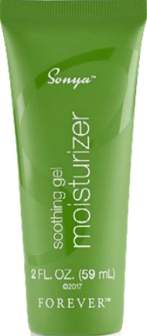

Sonya M Soothing Gel Moisturizer

A hydra-infused moisture Carrier

You've never felt a lotion like this before. Soothing gel moisturizer looks like a lotion, but this gel-based formula melts into your skin. Over 10 natural plant extracts and oils, including jojoba esters and olive oil, help skin feel hydrated and supple. Beta-glucan extracted from mushrooms has been added to this unique formula to soothe the skin and even skin tone.

We also added anti-aging ingredients like linoleic acid and hydrolyzed collagen, scientifically advanced to go into the skin where it's needed most and phytic acid, a powerful support for combination skin, to improve the look of your complexion.

To finish the formula, we infused it with orange peel oil, mandarin orange peel oil, roman chamomile flower oil, geranium flower oil and bergamot fruit oil to leave skin feeling refreshed, making this your new favorite all-around daily moisturizer.

Gently massage into skin on face and neck twice a day in the morning and evening, except when using the refining gel mask, Use it as pan of the Sonya’^ daily skincare system for optimal results.

* Collagen to improve the appeamnce of skin
* Over 10 natural plant extracts and oils
* A hydra-infused moisture carrier

Suitable Jar vegetarians

CONTENTS

2 FL. OZ. (59 mL)

DIRECTIONS

Gently massage a moderate amount into skin to

soothe and condition.

CERTIFICATIONS

IASC Certified

INGREDIENTS

Aloe Barbadensis Leaf Juice (Stabilized Aloe Vera Gel/gel d'aIoés ofcinal stabilisé), Water (Aqua/Eau), Propanediol, Caprylic/Capric Triglyceride, Isoamyl Laurate, Jojoba Esters, Cetearyl Olivate, Sodium Acrylates Copo er, Sorbitan Olivate, Glycerin, Pyrus Malus (Apple) Fruit Extract, Lauroyl Lysine, Punica Granatum Fruit Extract, Ficus Carica (Fig) Fruit Extract, Morus Alba Fruit Extract, Ginkgo Biloba Nut Extract, Lecithin, Caprylhydroxamic Acid, Caprylyl Glycol, Ethylhexylglycerin,

1,2-HexanedioI, Ethyl Canolate, Hydrolyzed Jojoba Esters, Sodium Hyaluronate, Arginine, Beta- Glucan, Linoleic Acid, Linolenic Acid, Phytic Acid, Hydrolyzed Collagen, Citrus Aurantium Dulcis (Orange) Peel Oil, Citrus Nobilis (Mandarin Orange) Peel Oil, Ar›themis Nobilis Flower Oil, Pelargonium Graveolens Flower Oil, Citrus Aurantium Bergamia (Bergamot) Fruit Oil.

#### infinite Forever hydrating cleanser

FAST FACTS

SKINCARE

#554

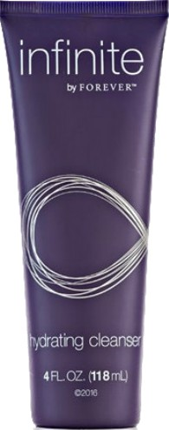



infinite by for Forever M hydrating cleanser

Soothing cleanser for softer, more hydrated skin.

infinite by ForeverTM is a fragrance-free, hydrating cleanser that harnesses the power of aloe vera, coconut and apple to melt away dirt, oil and makeup leaving behind a delicate veil of moisture for skin that feels soft and soothed.

It's believed that the apple tree was the earliest to be cultivated. The juice that flows through this lasting fruit has withstood environmental damage and change for thousands of years. We harnessed two key components of this vitamin-rich fruit: apple evract and apple amino acids to provide your skin with strong protection against the effects of aging.

Mild, moisturizing and milk, this cleanser uses hypoallergenic coco fatty acids to suspend your skin's oils, so they can be carefully and gently washed from your skin — leaving your face soft to the touch without feeling dry.

A key characteristic of youthful skin is being well hydrated and buoyant. This age-minimizing cleanser assists your skin's barrier function to fight against tightness and dryness. Bountiful amounts of linoleic acid and vitamin E, found in sunflower seed oil, suppon skin's lipids and help break down din and debris.

Don't just wash away dirt and makeup, help your skin look and feel younger to the touch while laying a strong foundation for the rest of your anti-aging routine with infinite by Forever’M hydrating cleanser.

* Cleanses skin of dirt, oil and makeup

without drying

* Protects against the signs of aging
* Increases skin hydmtion
* Gentle, sulfate free

Gluten Fre0 Suitable for vegetarians Sukable for vegans

CONTENTS

4 FL. OZ. (118 mL)

DIRECTIONS

Apply a generous amount onto wet fingers and gently work in a circular motion over the entire face and neck. Rinse thoroughly for smooth, clean skin.

CERTIFICATIONS

IASC Certified



INGREDIENTS

Aloe Barbadensis Leaf Juice (Stabilized Aloe Vera Get, Water, Helianthus Annuus (Sunflower) Seed Oil, Caprylic/Capric Triglyceride, Propanediol, Sodium Cocoyl Glycinate, Cetearyl Alcohol, Sodium Cocoyl Apple Amino Acids, Capryloyl GIycerirv'Sebacic Acid Copo er, Pyrus Malus (Apple) Fruit Extract, Glycerin, Sorbitan Laurate, Stearic Acid, Polyacrylate Crosspolymer-6, Diheptyl Succinate, CocoGlucoside, Ethylhexylglycerin, Caprylyl Glycol, Arginine, Acrylates/C10-30 Alkyl Acrylate Crosspolymer, Polyhydroxystearic Acid, Xanthan Gum, Hexylene Glycol, Hydroxycetophenone,Disodium EDTA, Phenoxyethanol, Potassium Sorbate.



F O R E V E R‘

infinite Forever

## serum

FAST FACTS

SKINCARE

#555

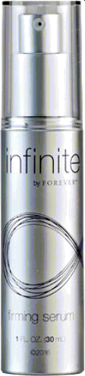

infinite by Forever M firming serum

Target aging from the outside in with this breakthrough formula.

This potent elixir provides clear results. infinite by Forever’M firming serum is a lightweight and fast-absorbing serum that reduces the appearance of fine lines and wrinkles while restoring skin’s natural firmness and elasticity.

This scientifically advanced formula boosts the power of aloe from our own fields with a clinically tested ingredient, trifluoracetyl tripepetide-2. In clinical tests this single ingredient significantly improved skin elasticity and is known to combat progerin, a harmful protein that increases as you age and wreaks havoc on your skin. By mimicking natural skin processes, this three-amino acid peptide improves the feel of skin’s firmness and reduces the look of fine lines and wrinkles.

But we didn't stop there. Paired with hydrolyzed sodium hyaluronate,

a natural humectant, to suppon moisture and skin conditioners, firming serum is scientifically formulated so that aloe achieves its optimal benefits to soothe and smooth skin.

Yeast extract helps support collagen synthesis and natural skin defenses to reduce the appearance of uneven skin tone while whey protein revitalizes the skin by increasing skin's smoothness, firmness and thickness.

This stacked fragrance free formula is a skin scientist's dream

bolstered with the power of nature and the most advanced laboratory findings to help you look and feel your best.

* Reduces appeamnce of fine lines and wrinkles
* Improves the feel of skin elasticity and firmness
* Supports healthy collagen synthesis and assists uneven skin tone
* Features a cutting edge, clinically tested ingredient

Gluten Free Suitable Air vegetarians

CONTENTS

1 FL. OZ. (30 mL)

DIRECTIONS

Apply 1-2 pumps to clean skin. Gently masage into face and neck until absorbed fbr more youthful looking skin.

CERTIFICATIONS

IASC Certified



INGREDIENTS

Aloe Barbadensis Leaf Juice (Stabilized Aloe Vera Gel/gel d'aIoés officinal stabilise),

Water (Aqua/Eau), Butylene Glycol, Glycerin,

Hydroxyethylcellulose, 1,2-HexanedioI, Dextran, Tripeptide-1, Trifluoroacetyl Tripeptide-2, Hydrogenated Starch Hydrolysate, Yeast Extract, Whey Protein, Caprooyl Tetrapeptide-3, Caprylhydroxamic Acid, Caprylyl Glycol, Ethylhexylglycerin, Propanediol, Hydrolyzed Sodium Hyaluronate, Sodium Hyaluronate, Arginine, Potassium Sorbate.



infinite by Forever

restoring créme

FAST FACTS

SKINCARE

#558

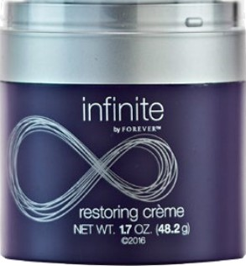

infinite by Forever M restoring créme

The best of science and nature for younger, smoother skin.

infinite by ForeverT^ restoring créme absorbs fast and leaves skin feeing exceptionally smooth and moisturized thanks to over 15 skin conditioning ingredients. We've combined the best of science and nature to bring you an advanced, multifaceted anti-aging formula that feels light and smooth against your skin and absorbs fast without any greasy or heavy feeling.

Powerful botanical ingredients like acai and pomegranate provide antioxidant support while leaving skin feeling moisturized and smooth. The centipeda cunninghamii plant, native to Australia, works to enhance the many benefits of aloe. Together, these ingredients deliver proven results for soothing skin while vitamin B3 and beet root even out tone and texture to suppon a youthful complexion.

Ingredients such as squalane, jojoba esters, glycolipids and beeswax show significant moisturizing propenies and help restoring créme sweep across your skin. An anti-aging essential oil blend of lavender, petitgrain, basil, eucalyptus, lime and orange-peel support aloe to replenish and rejuvenate parched skin.

To finish off this moisturizing powerhouse, we've added the latest chemistry to provide a new sugar structure that improves skin's water barrier and retention. As a finishing touch, infinite by Forever’M restoring créme seals in all of the powerful benefits to keep your skin nourished and younger looking.

* Anti-aging formula supports younger looking skin
* Soothes and moisturizes
* Over 15 skin conditioning ingredients

CONTENTS

1.7 OZ. (48.2 g)

DIRECTIONS

Apply one full pump and massage into face and neck to help skin appear rejuvenated.

CERTIFICATIONS

IASC Certified

INGREDIENTS

Aloe Barbadensis L0af JuiC6 (Stabiliz6d" Aloe Venn Get/ gel d'doés oFcind stabilise"), Wat6r (Aqua/Eau), lsoamyl LauratB, Propanediol, PofygIyceryl-6 Distearat6,CapryIic/ Capric Triglyceride, Jojoba Esters, Cetyl Aloohol, Fructooligosaccharides, Beta Vulgaris (Beet) Root Extract,Cetearyi Alcohol, Hydroxyacetophenone,

Coca-Glucoside, Squalane, Po@lyceryI-3 Beeswax, XyIityIgIucoside,AnhydroxyIitoI, Xylitol, Caprylyl Glycol, Ethylhexylglyoerin, Hexylene Glyclol, Sodium Hyaluronate, Hydrolyzed Com Starch, Pofyacrylate

Crosspo er-6, BBta GluCan, Centipeda Cunninghamii Extract, Butylene Glycol, Hydrolyzed Jojoba Esters, Linoleic Acid, Linolenic Acid, Niacinamide, Oleic/ Linolefc/Linolenic Polyglycerides, Glycosphingolipids and Glycolipids, EutBrpe Oleracea Fruit Extract, Punica Granatum Extract, Glycerin, Caesalpinia Spinosa Gum, Arginine, Xanthan Gum, Cametlia Sinensis Leaf Extmct, Phenoxyethand, Fragrance (Parfum).

# Aloe Actirator

#612

FAST FACTS

* Cleans, soothes and refreshes
* A powerful skin oonditioner

SKINCARE

* + 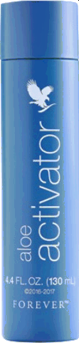Gentle for the entire face, even eye area

Gluten Free Suitable for vegetarians Sukable for vegans

CONTENTS

4.4 OZ. (130 mL}

DIRECTIONS

Aloe activator is a multi-purpose product to clean or freshen, apply to a cotton ball and gently wipe across skin. For an Aloe Mask, mix 1 tsp mask powder with 1 tsp Joe actkator and apply a thin

layer to clean skin. After 20 minutes, rinse thoroughly

with warm water. Use 2-3 times weekly.

Aloe Activator

Moisturize, refresh and soothe with the power of aloe.

With over 98% aloe vera gel, aloe activator leaves skin feeling refreshed and soothed from the moment it touches your face. Aloe is ideal for sensitive skin and its many essential components like vitamins A, C and E make aloe activator a perfect addition to any skin care regimen.

Aloe is paired with allantoin, which is not only an effective moisturizer, but also a perfect complement to gently soften and smooth skin. Of course, it’s the quality of the aloe that makes all the difference. Forever's aloe activator is made with pure inner-leaf aloe vera from our own fields. Every leaf is hand harvested, hand filleted and packaged within hours to ensure maximum freshness and potency.

Aloe activator is an enriching moisturizer, containing enzymes, amino acids and polysaccharides. This step in your daily beauty ritual may become your new favorite, as it not only feels good to apply, but the after-effects will leave your skin looking and feeling better.

Aloe activator is gentle enough for use on the entire face, even around the eyes. Use it as a moisturizer and refresher on its own.

CERTIFICATIONS

IASC Certified



INGREDIENTS

Aloe Barbadensis Leaf Juice (Stabilized Aloe Vera Gel/gel d'aIoés ofcinal stabilisé), 1,2-HexanedioI, Allantoin, Disodium EDTA, Potassium Sorbate.

Balancing Toner

#560

FAST FACTS

* Refreshes, soothes and hydrates
* Smooths skin's tone and texture
* Minimizes the appeamnce of pores

SKINCARE

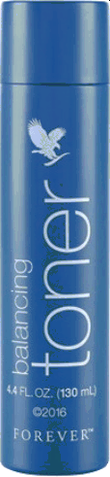Gluten Free Suitable for vegetarians Sukable for vegans

CONTENTS

4.4 OZ. (130 mL}

DIRECTIONS

Apply a generous amount to face and neck after cleansing using a cotton ball or pad. Use twice daily to minimize the appearance of pores and hydrate skin.

Balancing Toner

Supports skin's pH balance.

Does your skin need some extra attention after cleansing?

Forever's balancing toner is designed to ensure all din and debris is washed off, while minimizing the appearance of pores and adding extra hydration, making it ideal for use between cleansing and moisturizing.

Balancing toner provides an exclusive blend of seaweed extract and sodium hyaluronate to moisturize and soften skin while supposing a youthful appearance. The addition of cucumber extract adds another layer of soothing hydration while promoting improved skin tone and texture, thanks to naturally-occurring lignans.

White tea extract is a rich antioxidant with a high polyphenolic content that works with aloe to balance fluctuations of the skin and fight free radicals. To further supercharge this powerful formula, we used hyaluronic acid, which has been called a molecular sponge because of its water attracting abilities.

Only the freshest, purest aloe from our own fields is used in balancing toner to ensure only the finest, most potent ingredients refresh and nourish your skin. Every aloe plant is carefully nurtured, hand harvested and hand filleted to extract only pure, powerful inner-leaf gel.

Notice a profound difference in the way you skin looks and feels when you add balancing toner to your routine!

CERTIFICATIONS

IASC Certified



INGREDIENTS

Aloe Barbadensis Leaf Juice, (Stabilized Aloe Vera Ge9 Water (Aqua/Eau), Propanediol, Sorbitol,

1, 2-HeanedioI, Chondrus Crispus Extract,

Sodium Hyaluronate, Glycerin, Cucumis Sativus (Cucumber) Fruit Extract, Camellia Sinensis Leaf Extract, Beta Glucan, Sodium Lactate, Phytic Acid, Allantoin, Potassium Sorbate.

Awakening Eye Cream

#561

FAST FACTS

SKINCARE

* Diminishes the appeamnce of pufiness and dark circles
* Significantly reduces appearance of wrinkles
* Eyes appear more rested, aleit and rejuvenated

Gluten Fre0 Suitable for vegetarians

eye cream

CONTENTS

0.74 FL. OZ. (21 g)



DIRECTIONS

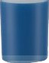Using your finger, gently dab a modemte amount below and around the eye area.

CERTIFICATIONS

Cruelty Free, IASC Certified, Koshe Ceitñed



Awakening Eye Cream

Beautify the eye.

Awakening eye cream combines patented ingredients with peptide technology to improve and smooth the sensitive eye area, visibly reducing the appearance of lines, wrinkles and dark circles.

This groundbreaking formula helps with normal collagen formation to promote optimal skin hydration and firmness. By supposing healthy collagen, awakening eye cream improves skin smoothness, resulting in plumper, firmer skin around the eye area.

Awakening eye cream also contains a special peptide that has been shown to reduce the appearance of eye puffiness and dark circles in as little as 15 days!

A cutting-edge ingredient, albizia julibrissin bark extract, is shown to have a lifting action on the sagging upper eye lid and helps revitalize the delicate skin around the eye for a total eye perking experience.

Blur the look of crow's feet and fade the appearance of dark circles with awakening eye cream. Instead of dry, puffy eye skin, eyes appear more rested, alen and rejuvenated.

All these powerhouse ingredients make the most advanced eye cream to allow your beaus to shine. Have striking eyes that look brighter and younger with awakening eye cream.

INGREDIENTS

Aloe Barbadensis Leaf Juice (Stabilized Aloe Vera Get, Water, Caprylic/Capric Triglyceride, Isoamyl Laurate, Glycerin, PoIygIyceryI-6 Distearate, Jojoba Esters, Propanediol, Lauryl Laurate, Cetearyl Olivate, Sorbitan Olivate, Polyhydroxystearic

Acid, Ammonium Acryloyldimethyltaurate/

VP Copolymer, PoIyglyceryI-3 Beeswax, Cetyl Alcohol, Hydroxypropyl Cyclodextrin, Palmitoyl Tripeptide-38, Xylitylglucoside, Anhydroxylitol, Xylitol, Albizia Julibrissin Bark Extract, Darutoside, Magnesium Chloride, Palmitoyl Tripeptide-5, Tetradecyl Aminobutyroylvalylaminobutyric

Urea Tñfluoroacetate, Palmitoyl Dipeptide-5 Diaminobutyroyl Hydroxythreonine, Panthenol, Sodium Hyaluronate, Dunaliella Salina Extract, Butylene Glycol, Acetyl Tetrapeptide-5, Hydrolyzed Collagen, Hydrolyzed Corn Starch, Beta Vulgaris (Beet) Root Extract, Caprylhydroxamic Acid, Caprylyl Glycol, Ethylhexylglycerin, 1,2-HexanedioI, Linoleic Acid, Linolenic Acid, Arginine, Hydrolyzed Sodium Hyaluronate.



F O R E V E R®

Smoothing EJoliator

#559

FAST FACTS

* Smooths skin tone and texture

SKINCARE

* + Gently exfoliates to uncover silky soft skin
  + Enzymatic extracts resurfaoe the skin

Gluten Free Suitable for vegetarians Sukable for vegans

CONTENTS



2 FL. OZ. (60 mL)

DIRECTIONS

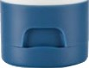Apply moderate amount onto wet fingers. Gently work in a circular motion over the face, avoiding the eye area. Rinse thoroughly. For refreshed skin, use 2-3 times weekly. Before using, twist off cap and remove seal.

**Smoothing Exfoliator**

Smooths skin tone and texture.

Old skin can look flaky, tired and dull. The right exfoliator removes dead skin cells to reveal brighter skin with a smooth tone and texture. Forever's smoothing exfoliator is gentle enough to get the job done without stressing the soft, newer skin underneath.

Instead of using harsh chemicals or sharp fragments, smoothing exfoliator uses five powerful and natural ingredients that work together to provide a complete and rejuvenating cleansing experience.

Jojoba beads gently roll across the skin to remove dirt and debris while sustainably-sourced bamboo powder sweeps the skin to remove dead skin cells.

Bromelain, papain and lemon essential oil create a perfect natural skin tonic. Pineapple-derived bromelain has enzymatic abilities that assist in destroying the keratin of dead skin cells allowing them to be removed more easily. Papain, from papaya, assists in rejuvenating skin and is a rich source of vitamins C, A, E and pantothenic acid.

Forever's smoothing exfoliator is also infused with antioxidants like grape juice extract to provide the most effective and gentle

exfoliating experience and lemon essential oil for instant hydration of

the younger skin below the surface.

Of course, this exclusive formula has a high content of pure inner- leaf aloe vera gel to smooth and condition skin. Make the most of

your skin care routine with smoothing exfoliator.

CERTIFICATIONS

IASC Certified



INGREDIENTS

Aloe Barbadensis Leaf Juice (Stabilized Aloe Vera Get, Water, Hydrogenated Jojoba Oil, Propanediol, Glyceryl Stearate, Bambusa Arundinacea Stem Powder, Sodium Cocoyl Isethionate, Cetyl Alcohol, Cocamidopropyl Hydroxysultaine, Stearyl Alcohol, Decyl Glucoside, Stearyl Phosphate, Hydrated Silica, Hydroxyacetophenone, Caprylhydroxamic Acid, Caprylyl Glycol, Ethylhexylglycerin, Papain, Bromelain, Maltodextrin, Vitis Vinifera (Grape) Juice Extract, Citrus Limon (Lemon) Peel Oil, Polyacrylate Crosspolymer-6, Sodium Lactate, Phytic Acid, Xanthan Gum, Disodium EDTA, Chlorphenesin.

Protecting Day Lotion

#561

FAST FACTS

SKINCARE









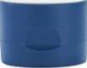

Protecting Day Lotion

OOl

Broad spectrum protection combined with skin care ingredients.

Protecting your skin from sun damage, premature aging, and other skin-related issues is more important than ever. Stan your day off right with Forever's protecting day lotion, now with an improved formula targeted for all skin types. The broad spectrum, SPF 20 formula pulls double duty, shielding your face from harmful UVA/UVB rays and nourishing it with a blend of skin-conditioning ingredients.

A blend of oils that includes brassica napus, castor and desert date is rich in antioxidants, protecting the skin from free radicals. Castor and desen date oils combine with sunflower oil, which all contain high amounts of essential fatty acids to give your skin a soft, smooth texture. Although rich in nutrients for your skin, these oils absorb quickly and won't clog pores.

This new formula also contains linoleic, oleic and palmitic essential fatty acids. Each a component of skin-replacement lipids, these ingredients mimic the fat structure of the skin to prevent epidermal water loss, keeping the skin moisturized during sun exposure.

The broad spectrum, UVA/UVB sun protection comes from natural mineral zinc oxide. This reef-friendly, non-nano zinc includes advanced coating technology to shield your skin without the telltale sunscreen white cast. No matter your daily level of sun exposure, Forever's protecting day lotion is the perfect addition to any skin

care routine.

* Diminishes the appeamnce of pufiness and dark circles
* Significantly reduces appearance of wrinkles
* Eyes appear more rested, aleit and rejuvenated

Gluten Fre0 Suitable for vegetarians

CONTENTS

2 FL. OZ. (60 mL)

DIRECTIONS

Apply generously and evenly 15 minutes before sun exposure. Reapply at least every 2 hours and after any wate activity.

CERTIFICATIONS

IASC Certified



INGREDIENTS

Water, Aloe Barbadensis Leaf Juice (Stabilized Aloe Vera Get, Propanediol, Brassica Napus Seed Oil, lsononyl Isononanoate, Ricinus Communis (Castor) Seed Oil, Butyloctyl Salicylate, Caprylic/ Capric Triglyoeride, Euphorbia Cerifera (Candelilla) Wax, Bentonite, Diethylhexyl 2,6-NaphthaIate, Cetearyl Alcohol, Sodium Chloride, PoIyglyceryI-8 Oleate, Behenyl Alcohol, Phenoxyethanol, Polyhydroxystearic Acid, Helianthus Annuus (Sunflower) Seed Oil, Xanthan Gum, Magnesium Aluminum Silicate, Glyceryl Caprylate, Cetearyl Glucoside, Linoleic Acid, Lecithin, Canarium Luzonicum Gum Nonvolatiles, Phytosteryl Canola Glycerides, Citric Acid, Balanites Roxburghii

Seed Oil, Oleic Acid, Palmitic Acid, Glyceryl Undecylenate, Stearic Acid, Triolein, Tocopherol

Aloe Body Lotion

#647

FAST FACTS

* Promotes skin's hydration
* Promotes soft-feeling skin

SKINCARE



ALOE BODV LOTIOr



**Aloe Body Lotion**

Fast absorbing lotion, perfect for daily use.

Forever's Aloe Body Lotion is the perfect everyday moisturizer to soften skin and leave it feeling smooth, hydrated and healthy. Our lightweight formula absorbs quickly to deliver the benefits of pure aloe vera and other moisturizing ingredients almost instantly.

We combined a high concentration of pure inner leaf aloe vera with plant-based oils and botanicals to put nature's most powerful skin enhancing ingredients to work for you. Aloe forms the ideal base for our formula by moisturizing and promoting healthy, youthful looking skin. Argan oil contains vitamin E and fatty acids that help soften skin while hydrolyzed jojoba esters help promote appearance of firmness and skin elastici .

The addition of macadamia seed oil makes Aloe Body Lotion an ideal choice for dry and mature skin due to its high palmitoleic acid content, which promotes healthy looking skin. But this formula isn’t just for people with dry or mature skin. Forever created this silicone- free formula for anyone with normal to dry skin by adding ingredients like sodium hyaluronate, which forms a protective barrier on the skin and helps retain moisture. Aloe Body Lotion also features a bright aroma featuring light florals for a scent that's universally appealing.

When you need a go-to daily lotion that leaves skin feeling soft and silky, but never greasy, make sure you have Forever's Aloe Body Lotion close by.

* Support's skin's natural moisture barrier
* Promotes healthy, youthful-looking skin
* Absorbs quickly into the skin, leaving behind a silky, non-greasy fee

*z o— o*

Gluten Free Suitable for vegetarians Sukable for vegans

CONTENTS

8 FL. OZ. (236 mL)

DIRECTIONS

Apply liberally and gently massage until lotion is completely absorbed into the skin.

CERTIFICATIONS

IASC Certified



INGREDIENTS

Aloe Barbadensis Leaf Juice (Stablized Aloe Vera Gel), Water (Aqua), Caprylic/Capric Triglyceride, Propanediol, C13-15 Alkane, Glyceryl Stearate SE, Heptyl Undecylenate, Glyceryl Stearate, Arginine, Phenoxyethanol, PEG-100 Stearate, Hydroxyacetophenone, Acrylates/C10-30 Alkyl Acrylate Crosspolymer, Fragrance, Caprylyl Glycol, Disodium EDTA, Xanthan Gum, isosorbide

Dicaprylate, Potassium Sorbate, Ethylh I I cerin, Hexylene Glycol, Hydrolyzed Jojoba Esters, Argania Spinosa Kernel Oil, Rosa Canina Fruit

Oil, Simmondsia Chinensis (Jojoba) Seed Oil, Macadamia Integrifolia Seed Oil, Niacinamide, Sodium Hyaluronate.

#### Radiance Forever

###### Facewash

FAST FACTS

SKINCARE

#87





Radiance By Forever Facewash

Gentle, natural cleanse for radiant skin.

Radiance by Forever Facewash is formulated with a blend of natural extracts, offering a deep yet gentle cleansing experience. Infused with aloe vera, licorice, bamboo, apple, carrot, and rose flower extracts, this facewash provides comprehensive skincare benefits. It works to eliminate din, impurities, and excess oil while keeping the skin hydrated and supple. The combination of deep cleansing and gentle exfoliation ensures that your skin remains soft, radiant, and refreshed.

The inclusion of apple extract aids in gently exfoliating the skin, helping to unclog pores and promote healthy cell turnover. This, combined with aloe vera's natural hydrating propenies, ensures that your skin stays moisturized without feeling dry or tight. Licorice and rose extracts are particularly beneficial for reducing inflammation and soothing irritation, making this facewash ideal for sensitive skin types or those prone to redness.

Bamboo, licorice, and carrot extracts add an antioxidant boost, promoting a youthful glow and helping to combat the appearance of dark spots and pigmentation. These ingredients work together to not only cleanse but also enhance skin health, leaving it smooth, soft, and rejuvenated. The antioxidants also protect the skin from environmental damage, maintaining its natural radiance.

Overall, Radiance by Forever Facewash is designed to provide deep cleansing, hydration, and gentle exfoliation in one simple step. It unclogs pores, soothes irritation, reduces dark spots, and promotes youthful skin, making it an essential part of your daily skincare routine.

* Deep cleansing with natural extmcts
* Hydrates and nourishes the skin
* Gently exfoliates, unclogs pores
* Reduces dark spots and pigmentation
* Promotes soft, radiant, youthful skin

*%*

Sulphate Free Paraben Free Dermatobglcally teeted

**CONTENTS**

E

8

**DIRECTIONS**

Wet your face. Use sufficient quantity to work up a lather on your face. Massage for a few seconds and rinse off with water. Pat dy. Follow this up with a moisturizer.

**INGREDIENTS**

Purified Water, Sodium Lauryl Sarcosinate, Glycerin, Cocamidopropyl Betaine, Geogard ECT (Benzyl Alcohol, Salicylic Acid, Glycerin, Sorbic Acid), Carbopol (Acrylates/C10-30 Alkyl Acrylate Crosspolymer), Polysorbate 20, Fragrance, Bamboo Extract (Bambusa Arundinacea), Licorice Extract (Glycyrhiza Glabra), Apple Extract (Pyrus Malus Fruit), Carrot Extract (Daucus Carota

Sativa), Aquaxly (Xylitylglucoside and Anhydroxylitol

and Xyitol), Rose Extract (Rosa Damascena), TEA (Triethanolamine), Aloe Vera Extract (Aloe Barbadensis), EDTA(EthyIenediaminetetraacetic Acid).

Radiance Forever

# Moisturizer

FAST FACTS

SKINCARE

#88





Radiance By Forever Moisturizer

Nourishing, lightweight hydration for radiant skin.

Radiance by Forever Moisturizer is a luxurious blend of natural extracts, expenly formulated to hydrate and nourish the skin. Infused with aloe vera, moringa oil, CICA, allantoin, wheat germ oil,

saffron, and neem extract, this moisturizer works to provide essential nutrients that promote overall skin health. The rich combination of these ingredients ensures that your skin remains soft, smooth, and well-hydrated throughout the day, making it an essential addition to your skincare routine.

Wheat germ oil and moringa oil are packed with vitamins and antioxidants, which help to protect the skin from damage caused by free radicals. This powerful duo not only promotes healthy skin but also aids in repairing and rejuvenating the skin's appearance.

Aloe vera, CICA, and allantoin are included to calm irritation, reduce redness, and suppon the skin's natural healing processes. Together, these ingredients create a soothing formula that is ideal for all skin types, including sensitive skin.

Saffron and wheat germ oil provide additional antioxidant protection, working to even out skin tone and diminish the appearance of fine lines and uneven texture. Neem extract, along with zinc oxide,

plays a crucial role in controlling acne and soothing inflammation, while also minimizing the appearance of pores. This multifaceted approach ensures that your skin looks its best, feeling revitalized and balanced.

Overall, Radiance by Forever Moisturizer is designed to deliver deep hydration while addressing multiple skin concerns. Its lightweight formula absorbs quickly, leaving your skin feeling soft and refreshed without any greasy residue. Embrace a healthier complexion and achieve a radiant glow with this nourishing moisturizer that promotes lasting hydration and overall skin vitality.

* Hydrates and nourishes skin effectively
* Packed with vitamins and antioxidants
* Calms irritation and reduces redness
* Evens skin tone and minimizes fine lines
* Lightweight formula absorbs quickly, non-greasy

$tJphate Freo P aben Fun D0rrrat0Iogica!Iy Tected Mir¥val Oil Free

**CONTENTS**

E

8

**DIRECTIONS**

Take suficient quantity and massage on dean skin. Use circular motions to massage until absorbed.

**INGREDIENTS**

Purified Water, Glycerin, Viscolam@ At 100 (Sodium Polyacryloyldimethyl Taurate, Hydrogenated Polydeoene, Trideceth-10), Caprylic/Capric Triglyceride, Olivem 1000 (Cetea›yl Olivate, Sorbitan Olivate) Neem Extract (Azadirachta Indica), Geogard ECT (Benzyl Alcohol, Salicylic Acid, Glycerin,

Sorbic Acid, Hydrolyzed Jojoba Esters, Moringa Oil (Moringa Oleifera), Wheatgerm Oil (Triticum Vulgare Germ), Jojoba Oil (Simmondsia Cinensis), Aquaxyl (Xylitylglucoside And) Arihydroxylitol (and) Xylito§, Carbopol (Acrylates/C10-30 Alkyl Acrylate Crosspolymer), Fragrance, Saffron Extract (Crocus Sativus flower), Centella Extract (Centella Asiatica), TEA (Triethanolamine), Allantoin, Zinc Oxide, Aloe vera Extract (Aloe Barbadensis )

#### Radiance Forever

###### Mask Scrub

#90

FAST FACTS

* Reducing Skin tanning

SKINCARE



RADIANCE



’DUO MASK SCR I '

wirn

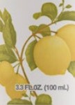

Radiance By Forever Mud Mask Scrub

Purify, nourish, and reveal your skin's natural glow with the perfect balance of detoxifying and soothing ingredients.

Only nature can deliver such a powerful yet gentle formula. Infused with the calming propenies of Aloe Vera Powder, this advanced treatment soothes, hydrates, and comforts the skin, leaving it feeling refreshed and revitalized.

Bamboo Charcoal works deep within the pores, drawing out toxins, impurities, and excess oil, while Rice Bran Oil and Wheat Germ Oil provide a rich dose of antioxidants, vitamins, and essential fatty acids to nourish and protect.

The cooling effect of Cucumber Extract helps minimize puffiness and calm inflammation, restoring your skin's smooth and healthy appearance.

With regular use, you’II notice refined skin texture, reduced fine lines, and a radiant, balanced complexion. Hydrating yet purifying, this formula supports the skin's natural barrier and leaves your skin soft, smooth, and glowing.

Use two to three times a week to detoxify and renew your skin, unlocking your healthiest, most radiant look yet.

* Twin Action - Mud Mask + Faoe Scrub
* Improves the barrie of the skin
* Reduces pigmentation
* Brightens the Skin
* Balanced ingredients for all skin types

Sulphate Free Paraben Free Dermatobglcally teeted

CONTENTS

100mL

DIRECTIONS

Application Scrub:

On a clean face, apply the face mask in sideward strokes. Let in dry for 10 -15 minutes, sit back and relax. Dampen your skin and gently massage in light circular motion to exfoliate the dead cells. Wash your face with water/gently wipe off with a clean wet towel/tissue. Tighten your poras to avoid dust grime back to your Skin with a Toner. Sed in the hydmtion with a moisturizer.

INGREDIENTS

Purified Water, Bentonite, Kaolin, Caprylic/ Capric Triglyceride, Glycerin, Glyoeryl Stearate (and PEG 100 Stearate, Cetyl Alcohol, Olivem 1000 (Cetearyl Olivate, Sorbitan Olivate), Zinc Oxide, Titanium Dioxide, Cucumber (Cucumis Sativus Fruit Extract, Wheatgerm (Triticum Vulgare Germ) Oil, Lemon (Citrus Limon) Fruit Extract, Rosemary (Rosmarinus, Officinalis) Extract, Geogard

ECT (Benzyl Alcohol (and) Salicylic Acida (and}

Glycerine (and) Sorbic Acid), Rice Bran (Oryza Sativa Bran) Oil, Aquxal (Xylitylglucoside (and) Anhydroxylitol (and) Xylitol), Sodium Benzoate, Charcoal (Bamboo Charcoal) Powder, Xarithum Gum, Salicylic Acid, Disodium EDTA, Allantoin, Menthol, Fragrance, Aloe vera Extract (Aloe: Barbadersis)



F O R E V E R‘

#### Radiance Forever Toner

#89

FAST FACTS

* Maintains the skin's naturd pH
* Keeps skin hydrated
* Tightens pores

SKINCARE

* + Provides an on the go comprehensive skincare

solution

Sulphate Free Paraben Free Dermatobglcally teeted



?DIAh

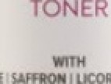



Radiance By Forever Toner

Forever Radiance Toner is a gentle yet powerful addition to your skincare routine. Specially formulated to restore and balance the skin's natural pH, this toner works to reduce irritation and inflammation, leaving your skin refreshed and calm after every application.

Infused with skin-loving ingredients like Licorice Extract (Mulethi) and Aloe Vera Liquid Extract, this toner hydrates and nourishes, helping to soothe sensitive skin while visibly reducing redness. It brightens and evens out your complexion by fading dark spots and hyperpigmentation, promoting a radiant, even-toned glow.

Forever Radiance Toner also preps the skin for maximum absorption of subsequent skincare products, ensuring you get the most out of your beauty routine. With Geogard ECT, a COSMOS-approved eco- friendly preservative system, this toner offers superior safety and stabili while being gentle on your skin and kind to the environment.

Reveal soft, supple, and balanced skin, perfectly primed for your next skincare steps.

CONTENTS

DIRECTIONS

On a clean face (after cleansing Scrub mask application), spmy the toner avoid eye area. Let in dry on its own. Seal in the hydmtion with a

E

8

moisturizer. You can apply toner multiple times in a

day to hydrate but follow up with a moisturizer only

on a clean face.

INGREDIENTS

Purified water, Glycerin, Saffron (Crocus Sativas) Flower Extract, Centella Extract (Centella Asiatica), Witch Hazel (Hamamelis Virginiana} Extract,

Geogard ECT (Benzyl Alcohol & Salicylic Acid & Glycerine & Sorbic Acid), Licorice (Glycyrrhiza Glabra) Root Extract, Allantoin, Fragrance, Aloe Vera Extract (Aloe Barbadensis)





RADIANCE RADIANCE

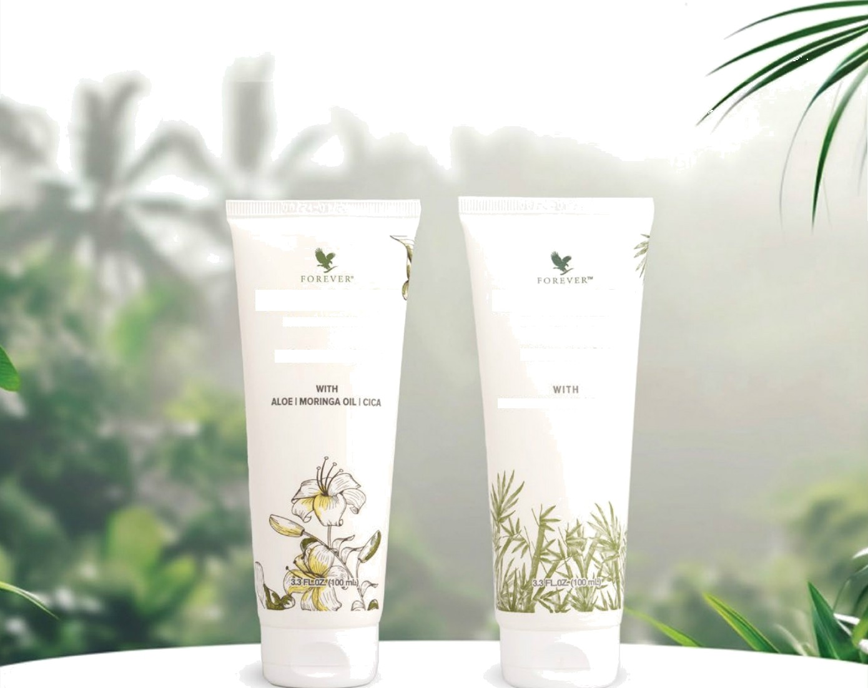

BY F O R i: V I'. R- BY I t\ l\ \” \’ F. k”

MOISTURISER FACE WASH

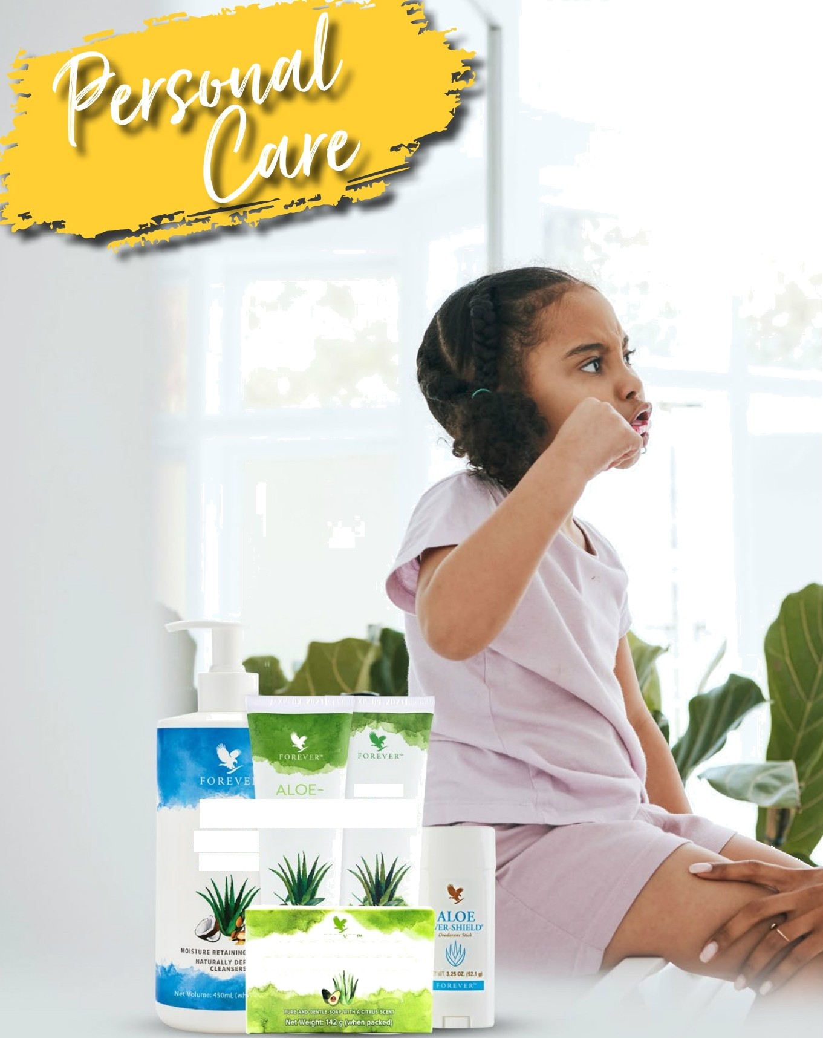

ALOE-

3OJOBA 3O3OBA

L ÊJONDlTlONąiHAVPOO

LIQUIE

SOAP

ALOE AVOCADO FACE 6 BODY SOAP

COOLI.NG

LOTIØN

ALO.

ûOD”

FOREVERO•...

BRIGHȚ-

/AS\ T THGbL

.

DREAM iSIRE|

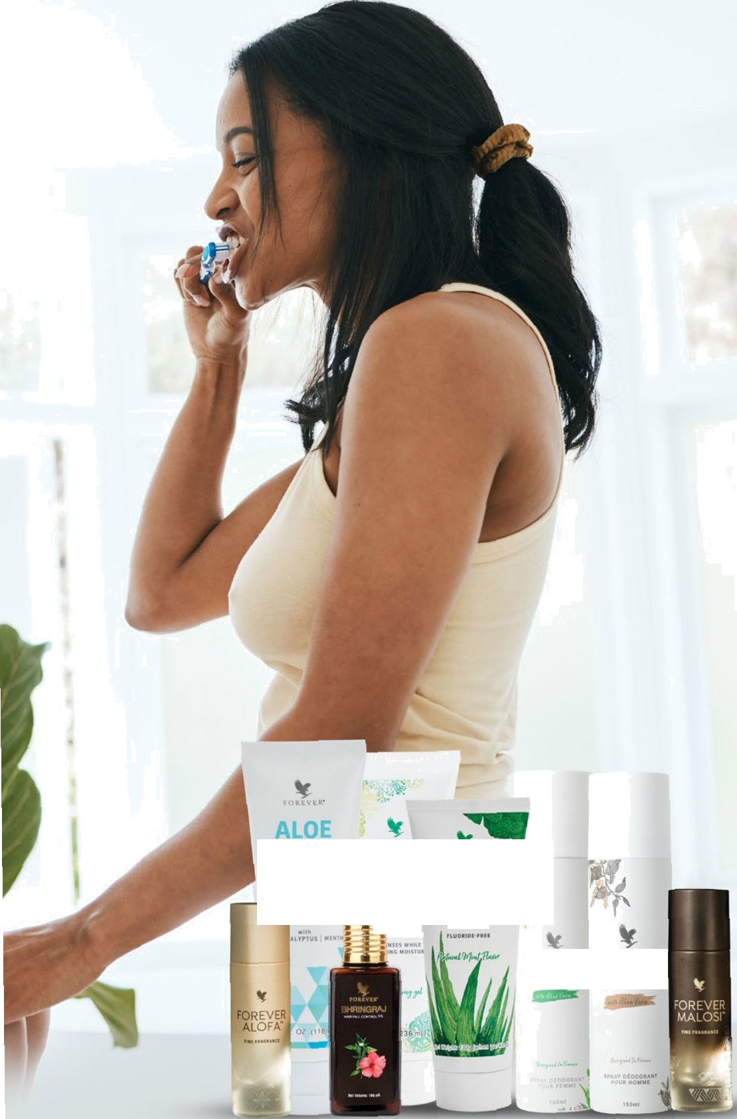

Aloe Avocado Face

 Body Soap

#284

FAST FACTS

* Rich texture
* Naturally-derived cleansers
* Perfect for all skin types
* Freshly-picked citrus scent

PERSONAL CARE

Gluten Fre0 Suitable for vegetarians Sukable for vegans



AI.OF AVOCA fD1



Aloe Avocado Face & Body Soap

Gentle cleansing that leaves skin soft and supple.

Clean, healthy skin is the foundation of natural beauty. And there's no better way to achieve that beauty than with natural ingredients like pure avocado oil and aloe vera from Forever's own fields. Our Aloe Avocado Face & Body Soap moisturizes as it cleans, leaving you with softer, smoother and more radiant skin.

Avocados are a nutrient-dense fruit containing many beneficial vitamins and minerals, including vitamins A, C and E. Avocado’s high fat content creates a rich base for our soap and helps even dry skin feel smooth after cleansing. Aloe Avocado Face & Body

Soap contains hand harvested, pure aloe vera to help condition and soothe, leaving your skin feeling moisturized all day long.

Forever's Aloe Avocado Face & Body Soap smooths, nourishes and moisturizes without irritation, even for those with sensitive skin. Gentle enough for your face or your entire body, the freshly-picked citrus scent will help wake you up in the morning and the softness from Aloe Avocado Face & Body Soap will last throughout the day.

For more than A0 years, Forever has sought out the highest quality ingredients to provide you with products that bring science and nature together for skin that looks and feels beautiful.

CONTENTS

NETWT 5 OZ. (142 g)

DIRECTIONS

Use Aloe Avocado Face & Body Soap for cleansing the skin as needed. Rinse completely, then gently pat dry with a towel.

INGREDIENTS

Sodium Palmate, Sodium Cocoate (or) Sodium Palm Kernelate, Water, Glycerin, Fragrance, Aloe Barbadensis Leaf Juice (Stabilized Aloe Vera Gel), Persea Gratissima (Avocado) Oil, Hydrogenated Vegetable Oil, Sodium Chloride, Yellow 10 (CI 47005), Red 4 (CI 14700), Green 3 (CI 42053),

Sodium Gluconate, Tetrasodium Glutamate Diacetate, Titanium Dioxide ( CI 77891), Iron Oxides (CI 77499, CI 77491, CI 77492)

Aloe-Jojoba Conditioner

#641



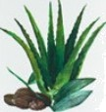

81 15 T u gI I I NG r 0 4 G . ^



Aloe Jojoba Conditioner

**Softness and shine with a hydrating boost.**

A good conditioner can make all the difference when it comes to getting the most out of your hair care routine. It softens, smooths and makes hair more manageable. Forever's Aloe-Jojoba Conditioner does all this while nourishing deeply and boosting hair and scalp hydration without added sulfates.

Our lightweight formula is perfect for daily use and includes three different oils to lock in moisture without weighing hair down. Jojoba oil is rich in natural fats to strengthen hair and promote thickness. Argan oil, dubbed “liquid gold of Morocco," nourishes hair with the antioxidant power of vitamin E. We also added rosehip oil to keep hair soft and moisturized while fortifying with vitamins C, E and B.

The backbone of Aloe Jojoba Conditioner is stabilized aloe vera gel from our own fields. Our inner leaf aloe vera contains 75 active components that help this conditioner soften the scalp and bring out your hair's natural shine.

Forever Aloe Jojoba Conditioner pairs perfectly with Aloe Jojoba Shampoo to improve combability of hair while smoothing the strands for easy styling. This soothing conditioner features the same invigorating fragrance as our Aloe Jojoba Shampoo: tropical fruit, sugared sweet cream and melon. Our formula is gender and age neutral, making it

perfect for the entire family. Give your hair the very best of what nature

PERSONAL CARE

FAST FACTS

* Lightweight conditioner for every hair type
* Softens and smooths hair
* Supports hair and scalp hydration
* Locks in moisture with three different oils
* Gentle on the scalp

Gluten Free Suitable for vegetarians Sukable for vegans

CONTENTS

10 FL. OZ. (2g6 mL)

DIRECTIONS

After shampooing with Aloe-Jojoba Shampoo, massage Aloe-Jojoba Conditioner into hair and leave on for 2 to 3 minutes. Rinse completely and dry.

INGREDIENTS

Aloe Barbadensis Leaf Juice (Stabilized“ Aloe Vera Gel/gel d'aIoés officinal stabilises, Water (Aqua/ Eau), Cetyl Alcohol, Behentrimonium Chloride, Cetearyl Alcohol, isoamyl Laurate, 1,2-HexanedioI, Argania Spinosa Kernel Oil, Rosa Canina Fruit

Oil, Simmondsia Chinensis (Jojoba) Seed Oil, Caprylyl Glycol, Ethylhexylglycerin, Hexylene Glycol, Hydrolyzed Jojoba Esters, Phenoxyethanol, Fragrance (Parfum).

Aloe-Jojoba Shampoo

#640







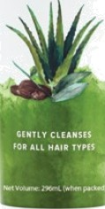

Aloe-Jojoba Shampoo

**Deep cleansing and nourishing power for all hair types.**

Made with pure inner leaf aloe vera and hair strengthening ’o'oba Oil, Forever's Aloe-Jojoba Shampoo is perfect for everyday use to bring out the best in your hair. Enjoy the refreshing fragrance of a tropical fruit medley with hints of sweet cream as the rich natural lather helps easily rinse away dirt and oil.

With no added sulfates, Aloe-Jojoba Shampoo helps maintain your scalp's moisture balance while keeping it soft and manageable.

Forever's own stabilized aloe vera gel not only helps your hair retain moisture but works as a natural emulsifying agent that leaves hair feeling clean and renewed with a beautiful shine.

In addition to cleansing your hair, we've added jojoba oil, which is rich in natural fats to promote strength and thickness. This lightweight oil is nourishing, soothing and gentle on the scalp. Forever boosted the

fortifying power of this shampoo even funher with argan oil, vitamin B5 and rose hip oil. Together, these potent ingredients provide nutrients, unsaturated fatty acids and antioxidants to support healthy hair and help keep it moisturized and soft.

Forever's Aloe—Jojoba Shampoo is perfect for your whole family. Experience the feeling of deep clean that leaves your hair looking and feeling its absolute best. To achieve optimal results, follow your shampoo with Forever's Aloe-Jojoba Conditioner!

PERSONAL CARE

FAST FACTS

* All-purpose shampoo for every har type
* Gentle on scalp
* Natural lather to easily rinse away dirt and oil
* Helps promote soft, manageable hair

Gluten Fre0 Suitable for vegetarians Sukable for vegans

**CONTENTS**

10 FL. OZ. (2g6 mL)

**DIRECTIONS**

Apply to wet hair and massage to stimulate scalp and create a rich lathe. Rinse thoroughly. For best results follow with Aloe-Jojoba Conditione.

**INGREDIENTS**

Aloe Barbadensis Leaf Juice (Stabilized“

Aloe Vera Get, Water, Sodium C14-16 Olefin Sulfonate, Cocamidopropyl Hydroxysultaine, Sodium Lauryl Glucose Carboxylate, Lauryl Glucoside, Sorbitan Oleate Decylglucoside Crosspolymer, Guar Hydroxypropyltrimonium Chloride, Hydroxyacetophenone, Chlorphenesin, Disodium EDTA, Fragrance, Potassium Sorbate, Dimethicone PG-DiethyImonium Chloride, Citric Acid, Cetrimonium Chloride, Propanediol, Argania Spinosa Kernel Oil, Panthenol, Rosa Canina Fruit Oil, Simmondsia Chinensis (Jojoba) Seed Oil.

##### Aloe Ever-Shield

#067



ALOE



' ' 3.25 02. l9z g



Aloe Ever-Shield

TM

All-day odor protection with the soothing power of aloe.

Fresh-scented and gentle on sensitive skin, Aloe Ever-ShieId’M offers all-day protection against underarm odor with the soothing power of aloe.

Aloe Ever-ShieId’^ is made with a high content of pure inner leaf aloe vera gel from Forever's own fields. The rich texture combined with the natural soothing power of aloe allows Aloe Ever-ShieldTM to glide on smoothly and it won't stain your clothes! Gentle on skin, you can apply it directly after showering without irritation.

The clean, pleasant aroma is never overpowering. Maintain that fresh feeling all day, even when the temperature rises and pressure is on. Tackle the day with confidence knowing Aloe Ever-ShieldTM is here to keep you feeling fresh and clean.

PERSONAL CARE

FAST FACTS

* No harsh duminum salts
* Great fbr all skin types, even sensitive skin
* Rich, soothing texture
* Does not stain clothes

Gluten Free Suitable /br vegetarians Sukable for vegans

CONTENTS

NETWT 3.25 OZ. (92.1 g)

DIRECTIONS

Apply Aloe Eve-Shield under your arms every day for a fresh and clean feeling all day long.

INGREDIENTS

Propylene Glycol, Water, Sodium Stearate, Aloe Barbadensis Leaf Juice (Stabilized Aloe Vera Gel), Fragrance (Parfum), Triclosan.



F O R E V E R‘

Forever Bright Toothgel

#028

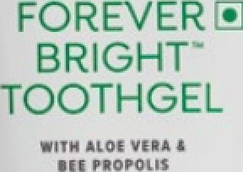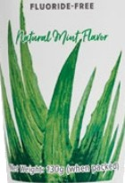

Forever BrightTM Toothgel

Advanced teeth cleaning power for the whole family.

Forever BrightTM toothgel combines aloe vera with natural ingredients for clean teeth, fresh breath and refreshing flavor. Our formula is fluoride-free so your whole family can enjoy the combination of natural peppermint and spearmint with a frothy texture that will leave your mouth feeling fresh and clean.

This innovative toothgel is made using stabilized aloe vera gel from Forever's own fields and can help you fight plaque as part of a regular brushing routine. Forever BrightTM also contains bee propolis, which has been shown to help promote gum health and prevent bad breath.

Forever conducted years of research, collaborating with scholars and dentists to create a perfect aloe-based formula that is safe and effective for the entire family.

With no animal by-products, Forever Bright’^ is a great option for vegetarians. Brushing your teeth twice a day and maintaining a balanced diet is the best way to ensure your teeth look and feel great. Our toothgel is the perfect addition to your daily routine.

Treat your mouth to the invigorating sensation and cleaning power of

Forever BrightTM.

Diclaimcf! Forever Living prodr+cts arc undor Health supplement' Nutraccutll categories. The product is not intended to diagnose, prevent, beat or cure any d fseasc. Consult your medical care practitioner or dictitian in case of p . lactzition or if on any medication. NOT FDR MEDICINAL USE. Do not exceed the stated rooommcnded dcily usage. Store out of the reach of children in a cal, dry place. Please refer individual product labs for further details.

PERSONALCARE

FAST FACTS

* For a fresh and clean feeling
* Fluoride-free
* Contains bee propolis
* Refreshing natural mint flavor

Gluten Fre0 Suitable for vegetarians

CONTENTS

4.6 OZ. (130 g)

DIRECTIONS

Brush after meals with Forever Bright’M Toothgel for a healthy-looking smile. Do not use if seal is cut, broken or missing.

CERTIFICATIONS

Kosher KL & IASC Certñed



INGREDIENTS

Aloe Barbadensis Leaf Juice (Stabilized Aloe Vera Get, Sorbitol, Hydrated Silica, Glycerin, Sodium Lauryl Sulfate, Flavour (Aroma), Sodium Saccaharin, Carrageenan, Sodium Benzoate, Chlorophyllin-Copper Complex, Propolis Extract.



F O R E V E R‘

# Dream Forever

#032





Dream by Forever

For the Classic Beauty inside out

Absolute sophistication embodies the Dream by Forever Deodorant. She radiates a graceful and outstanding beauty in a timeless manner. She is authentic and true to oneself and others. She is smart, driven and confident as a daughter, sister, wife and mother. She is consistent and focused who inspires and leads others. She is what you stand for, she is each one of you. Sophisticated and

refined, Dream by Forever is the fragrance of a woman with dreams,

who is accomplished in her own way and is accustomed to shine.

Dream by Forever illuminates the sophistication in women. This fragrance is for women who have big dreams, are graceful, confident, consistent, focused, inspiring, accomplished and outstanding. It is for each one of you and that's what keeps you dazzling.

A radiant blend of flowers and oriental notes along with moisturizing and nourishing aloe vera. Dream by Forever has naturally derived ingredients. A no gas deodorant which lasts longer up to 8 — 9 hours. Dream big and Shine on with this classic fragrance.

PERSONAL CARE

FAST FACTS

* A floral oriental fmgmnœ from naturally deñved ingredients
* Enriched with moisturizing and nourishing aloe vea
* No gas deodorant — Contains perfume rather than vaporizer making it Iong lasting
* 2x perfume as œmpared to a standard deodorant
* Prevents the odour formation leaving a pleasarit fmgmnœ all day Iong
* No Aluminium
* Can safely be applied on skin
* Extremely deliœte, dso suitable for sensitive skin
  + RIPT tested
* Parabœ Free
* Upto 1020 sprays
* Non pressuñzed œntainer, safe to use
* Alœhol of Vegetable origin

CONTENTS

NETWT 150 ml

DIRECTIONS

Shake the can before use. Hold the can upright 15cms away from the body and spray

INGREDIENTS

Denatured Ethyl Alcohol (Ethyl Alcohol (95%v/v) Contents: 80% w/w Denatured with TBA -r Bitrex.), Aqua, Parfum, Mandarin Oil, Benzoin extract, Elemi oil, Patchouli oil, Pink peppercorn extract, Ylangylang oil, Aloe Barbedensis Leaf Juice.

Desire  Forever

#033









Desire by Forever

For a man who desires to **be confident,** accomplished and multi- dimensional

Desire by Forever is for a man with confidence. One who dares to be challenged — dynamic, driven. This fragrance is for a man who has a constant desire to better himself, surpass competition. A strong man in tune with the world around him. A multi-dimensional man of the new century — confident and accomplished.

Desire embraces the confidence of a man in today's day and age. This fragrance reflects the spirit of a man who has a desire for freedom, liberty and strength. Desire man is a multi-dimensional man - confident and accomplished who dares to be challenged and desires to excel Forever. Desire by Forever is a no gas deodorant

spray which lasts for up to *8 —* 9 hours. It belongs to Oriental, woody and fruity family.

PERSONAL CARE

FAST FACTS

* An oriental, woody and fruity fmgmnce from naturally derived ingredients
* Enriched with moisturizing and nourishing aloe vea
* No gas deodorant — Contains perfume rather than vaporizer making it long lasting
* 2x perfume as compared to a standard deodorant
* Prevents the odour formation leaving a pleasant fmgmnce all day long
* No Aluminium
* Can safely be applied on skin
* Extremely delicate, dso suitable for sensitive skin
  + RIPT tested
* Paraben free
* Upto 1020 sprays
* Non pressuñzed container, safe to use
* Alcohol of Vegetable origin

CONTENTS

NETWT 150 ml

DIRECTIONS

Shake the can before use. Hold the can upright 15cms away from the body and spray

INGREDIENTS

Denatured Ethyl Alcohol (Ethyl Alcohol 95%v/v) Contents: 80% ww Denatured with TBA + Bitrex.), Aqua, Parfum, Guaiacwood Oil, Lemon Oil, Patchouli Oil, Mandarin Oil, Black Pepper Oil, Cedarwood Oil, Cistus Labdanum extract, Elemi Oil, Eugenol, Geranium Oil, Lavandin Oil, Nutmeg

Oil, Pink Pepperoorn extract, Aloe Barbadensis Leaf Juice.

Aloe Liquid Soap

#633

FAST FACTS

PERSONAL CARE





LIQUID

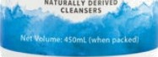SOAP

Aloe Liquid Soap

**A powerful, gentle and versatile cleanser**

for the whole family.

Cleanse and maintain skin's moisture with Forever's Aloe Liquid Soap. Our creamy, pearlescent formula cleans and nourishes to leave your skin feeling fresh and renewed. Whether it's on your kitchen counter or in the shower, Aloe Liquid Soap harnesses the power of aloe with other quality ingredients to provide a versatile whole-body cleansing experience for the entire family.

By combining the best of nature with pure aloe vera from our own fields, Forever has created a liquid soap that leaves skin feeling soft and clean. Aloe soothes and softens, while argan oil delivers vitamin E and natural fatty acids to condition and promote healthy skin. This extraordinary ingredient is known as “liquid gold of Morocco” and is carefully harvested from the fruit of the tree.

We also boosted the skin enhancing benefits of Aloe Üquid Soap with jojoba esters and cucumber fruit euract to help maintain moisture. The soothing propenies combine perfectly with alœ vera to gently cleanse and leave skin feeling smooth and soft. But the benefts don't stop there. We've added Arnica fruit extract, harvested from a yellow Power that grows in the mountains, to help stimulate skin and leave it feeling fresh and rejuvenated. Top notes of citrus mingle with a backdrop of woodsy and floral aromas like cinnamon spice, cedar leaf and rose for a fragrance that enhanœs the feeling of freshness.

With a combination of natural oils, ecracts and pure aloe vera, Aloe Liquid Soap has just what your skin needs to feel clean, nourished and renewed.

* Naturally derived cleansers help support a gentle lather
* Argan oil and jojoba infuse moisture into your skin
* Soft on sensitive skin
* Suitable fbr the entire family

Gluten Free Sultable for vegetarlans Sukable for vegans

**CONTENTS**

473 mL

**DIRECTIONS**

Dispense, wet, lathe and rinse œmpletely.

**INGREDIENTS**

Aloe Barbadensis Leaf Juice (Stabilized Aloe Vera Ge9, Water, Sodium C14-16 Olefin Sulfonate, Cocamidopropyl Hydroxysultaine, Propanediol, Cocamidopropyl Betaine, Disodium Cocoyl Glutamate, Sodium Methyl 2-SuIfoIaurate, PEG- 120 Methyl Glucose Dioleate, Glycol Distearate, Hydroxyacetophenone, Sodium Chloride, Disodium 2-SulfoIaurate, Disodium EDTA, Phenoxyethanol, Chlorphenesin, Laureth-4, Caprylyl Glycol, Fragrance, Citric Acid, Hydrolyzed Jojoba Esters, Potassium Sorbate, Sorbic Acid, Argania Spinosa Kernel Oil, Glycerin, Arnica Montana Flower Extract, Cucumis Sativus (Cucumber) Fruit Extract.

Aloe Body Wash

#646

FAST FACTS

* Gentle yet powerful cleanser

PERSONAL CARE



‹LOE

ODV

/ASH

* Removes dirt and oil to leave skin feeling clean

and soft

* Retains skin's moisture
* Maintains and promotes skin hydration
* Leaves skin feeling clean and fresh

*,*

Gluten Fre0 Suitable for vegetarians Sukable for vegans

CONTENTS

8 FL. Oz. (236 mL)

DIRECTIONS

Apply to a showe puff, loofah or sponge and gently soap the entire body using a circular motion. Rinse well.

Aloe Body Wash

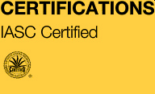

Gentle, powerful cleansing with skin-conditioning aloe.

Let the best of what nature has to offer nourish and cleanse your skin with Forever's new Aloe Body Wash. This sulfate free formula features powerful yet gentle cleansing with skin conditioning ingredients that will wash away dirt and leave your skin feeling soft and refreshed.

Aloe Body Wash is pH balanced to help retain skin's moisture and promote hydration. Key ingredient, aloe vera, aids anti-aging by promoting moisturizing while vitamins A, C and E nourish and support healthy-looking skin.

Our formula features a rich, inviting fragrance of woods, amber and a warm blend of herbs for a scent that is universally appealing. You may notice something a little different about Aloe Body Wash's unique color. The pleasing shade of seafoam green comes from naturally-derived copper chlorophyll!

You'll feel the difference right away as Aloe Body Wash forms into a rich, creamy foam that rinses away easily without stripping your skin of moisture. The gentle cleansing is made possible with ingredients like argan oil, arnica flower extract and hydrolyzed jojoba esters, which help soften skin while increasing hydration and smoothness.

Don't reach for another body wash that leaves your skin feeling dry or stripped of nutrients. With Aloe Body Wash, you'll get the powerful cleansing you're looking for with the perfect blend of ingredients to

leave your skin looking and feeling healthy and refreshed.

INGREDIENTS

Aloe Barbadensis Leaf Juice (Stablized“ Aloe Vera Gel/gel d'aIoés officinal stabilise“), Water (Aqua/ Eau), Cocamidopropyl Betaine, Cocamidopropyl Hydroxysultaine, Propanediol, Sodium Methyl

2-SuIfoIaurate, Sodium Cocoyl Glycinate, Sodium Cocoamphoacetate, Polyacrylate CrosspoIymer-6, Disodium 2-SulfoIaurate, Lauryl Glucoside, Hydrolyzed Jojoba Esters, Chondrus Crispus Extract, Argania Spinosa Kernel Oil, Amica Montana Flower Extract, Glycerin, Sodium Cocoyl Glutamate, Sodium Lauroyl Lactylate, Glycol Distearate, Laureth-4, Sodium Hyaluronate, Caprylyl Glycol, Hydroxyacetophenone, Disodium EDTA, Citric Acid, Chlorphenesin, Phenoxyethanol, Sorbic Acid, Potassium Sorbate, Fragrance (Parfum), Chlorophyllin-Copper Complex (CI 75810).

Aloe Cooling Lotion

#564

FAST FACTS

PERSONAL CARE

* Cooling lotion with menthol, eucalyptus and aloe.
* Conditions skin and easy to massage into musdes and joints.
* Provides a powerful, refreshing sensation.
* Helps ease tired musdes with a cooling, soothing effect.
* Aids with recharging and refreshing port-exercise
* Quick-absorbing, non-greasy feel on the skin

Gluten Fre0 Suitable for vegetarians Sukable for vegarfi

CONTENTS

Y 4FL. OZ (118mL)

Aloe Cooling Lotion

" DIRECTIONS

Apply liberally and massage into skin as needed. Avoid contact with eyes. Should contact occur, flush with water for several minutes.

Recharge tired muscles and joints with invigorating ingredients

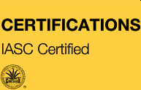

Refresh tired muscles and joints after a long day or challenging workout with Aloe Cooling Lotion. Our light, invigorating formula provides an instant cooling sensation, both revitalising hard-working muscles and promoting recovery.

Perfect to put in your gym bag or on your nightstand, Aloe Cooling Lotion contains uplifting menthol, eucalyptus oil, camphor, rosemary extract and Methylsulfonyl Methane, or MSM —an organic compound which is the third most abundant mineral in our body.

Let the power of menthol, inner leaf aloe and other natural ingredients support your active lifestyle. Experience a relaxed sensation by massaging Aloe Cooling Lotion into your skin at the end of a long day or post-workout.

INGREDIENTS

Aloe Barbadensis Leaf Juice (Stabilze Aloe Vera Gel/gel d'aIoés officinal stabilsé), Water (Aqua/Eau), Dimethyl Sulfone, Menthol, Arginine, Glycerin, Carbomer, Dimethicone, Eucalyptus Globulus Leaf Oil, Camphor, Allantoin, Sodium Hyaluronate, Borago Officinalis Extract, Rosmarinus Officinalis (Rosemary) Leaf Extract, Disodium EDIA, Caprylyl Glycol, Hexylene Glycol, Ethylhexylgycerin, Polysorbate 80, Ascorbic Acid, TocopheroI,PhenoxyethanoI, Potassium Sorbate.

###### Forever Bhringraj hair Fall Control Oil

FAST FACTS

PERSONAL CARE

#082

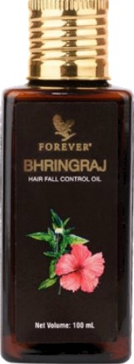

Forever Bhringraj Hair Fall Control Oil

Forever Bhringraj Hair Fall Control Oil blends the ancient wisdom of Ayurveda with modem hair care technology to deliver a holistic solution for your hair needs. This lightweight, fast-absorbing oil is expertly formulated to address common hair concerns while promoting overall scalp health. With its natural conditioning agents and anti-bacterial propenies, it helps fight frizz, restores moisture, and enhances the shine of your hair.

Enriched with Bhringraj, Aloe Vera, Neem, Tea Tree Oil, Amla, and Grapeseed Oil, this premium hair oil provides comprehensive benefits. Bhringraj strengthens the hair shaft and supports healthy growth, while Aloe Vera restores the natural pH balance of the scalp. Neem cleanses and strengthens hair follicles, and the antibacterial propenies of Tea Tree Oil help prevent scalp infections. Amla treats dandruff with its antifungal properties, and Grapeseed Oil moisturizes the scalp to alleviate dryness and discomfort.

This product has been “clinically tested and approved. 100% agreed reduction in hair fall. 100% agreed it promotes hair growth. 97% agreed it makes hair stronger. 100% agreed it strengthens hair. 100% agreed on quick absorption into the scalp.100% agreed it rinses of well.100% agreed on no scalp irritation.

Forever Bhringraj Hair Fall Control Oil is an exceptional choice for those seeking a natural and effective hair care solution.

*Clinically tested and approved, following a 28 days study involving 36 volunteers.

* A blend of 22 natural ingredients
* Clinically tested and approved.
* Strengthens hair and reduces hair breakage.
* Lightweight, fast-absorbing oil
* Shows improvement in hair groMh
* Designed to: Nourish, Rejuvenate, Strengthen

hair

CONTENTS

100mL

DIRECTIONS

Step 1: Apply the oil in the palms of your hands and massage into the scalp.

Step 2: Distribute the oil down to the ends of your

hair.

Step 3: Once you are done applying the oil, you can wrap your hair in a hot towel for 10 minutes for better results.

Step 4: Keep it on for 2 -3 hours and shampoo and condition as normal.

Claims

Sulphate Free | Pamben Free | Mineral Oil Free I Cruelty Free I FRA approved I Formulated for Indian Hai I DermatologicallyTested I Tested for Hair Tensile strength

INGREDIENTS

Sunflower (Helianthus Annuus) Oil, Grapeseed (Vitis Vinifera) Oil, Sesame (Sesamum Indicum) Oil, Coconut (Cocos Nucifera) Oil, Almond (Prunus Amygdalus Dulcis) Oil, Argan (Argania Spinosa Kernel) Oil, Rosemary (Rosmarinus Officinalis) Oil, Cedarwood (Juniperus Virginiana) Oil, Indian Gooseberry (Phyllanthus Emblica) Extract, Fenugreek (Trigonella Foenum-Graecum) Extract, Aloe Vera (Aloe Barbadensis) Extract, Henna (Lawsonia lnermis) Extract, Lavender (Lavandula Angustifolia) Oil, Fragrance, Bhringraj (Eclipta Alba) Extract, Bhrami (Baoopa Monniera) Extract, Hibiscus (Hibiscus Sabdariffa) Extract,

Ashwagandha (Withania Somnifera) Extract, Neem

(Azadirachta Indica) Extract, Shikakai (Acacia Concinna) Extract, Tea Tree (Melaleuca Alternifolia) Oil, Camphor, Jatamansi (Nardotachys Jatamansi) Root Extract, Onion (Allium Cepa Bulb) Seed

Forever Alofa Fine Fragrance

#643

FAST FACTS

PERSONAL CARE

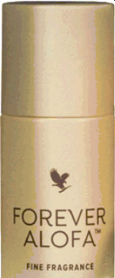



Forever AlofaTM Fine Fragrance

A crisp, delicately sweet fusion for an alluring warm floral

scent

Envelop your senses with the power and love of the Samoan people in this exclusive fragrance that pays tribute to Forever's Founder, Rex Maughan, and his deep connection with the Samoan Islands.

As a Samoan word, alofa means love — a word woven into the fabric of Forever by Rex, who often said, “The power of Forever is the power of love.”

Forever AlofaTM Fine Fragrance delivers this sense of love in an alluring scent crafted and blended exclusively for Forever. The complex fragrance features a carefully selected combination of botanicals that captivate. Floral notes like sweet jasmine intertwine with crisp citrus and warm aromas of sandalwood. The result is a unique scent that captures the essence of elegance.

Beyond its fragrant appeal, the bottle delights too. Forever Alofa is housed in a thoughtfully designed bottle featuring cultural, traditional artwork designed by a Samoan artist that represents the meaning for alofa.

This expenly crafted fragrance provides a beautiful finishing touch for everyday wear or a special occasion. Feel the power of love surround you with Forever Alofa

* Botanical blend of Bard, citrus and warm notes
* Unique and elegant
* Perfect for any occasion

CCONTENTS

1 FL. OZ. (30 mL)

DIRECTIONS

Apply as desired.

CERTIFICATIONS

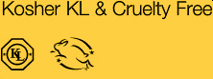

INGREDIENTS

Alcohol Denat., Fragrance (Parfum), Water (Aqua)

Forever Malosi

Fine Fragrance

FAST FACTS

PERSONALCARE

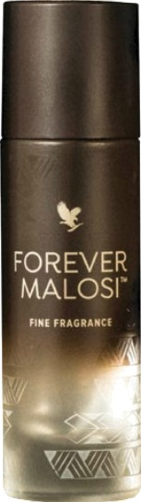#644

Forever MalosiTM Fine Fragrance

An intriguing woodsy scent with refreshing, spiced

nuances

Envelop your senses with the power and love of the Samoan people in this exclusive fragrance that pays tribute to Forever's Founder, Rex Maughan, and his deep connection with the Samoan Islands.

As a Samoan word, malosi means power — a word woven into the fabric of Forever by Rex, who often said, 'the power of Forever is the power of love.”

Experience this power through Forever MalosiTM Fine Fragrance, a distinctive, sophisticated scent crafted and blended exclusively for Forever. The bold fragrance features a carefully selected combination of botanicals that captivate. Spiced woodsy notes like bergamot and sandalwood mingle with the refreshing aromas of cypress and citrus. The result is a well-rounded scent perfect for everyday wear or a formal night on the town.

Beyond its fragrant appeal, the bottle delights too. Forever Malosi is housed in a thoughtfully designed bottle featuring cultural, traditional artwork designed by a Samoan artist that represents the meaning for malosi.

When you apply Forever Malosi, you're choosing power and confidence as you go about your day or night. This expertly crafted fragrance is an enticing addition to your daily routine that provides an alluring finishing

touch.

* Botanical blend of Moral, citrus and warm notes
* Unique and elegant
* Perfect for any occasion

CCCONTENTS

1 FL. OZ. (30 mL)

DIRECTIONS

Apply as desired.

CERTIFICATIONS

Kosher KL & Cruelty Free

INGREDIENTS

Alcohol Denat., Fragrance (Parfum), Water (Aqua)

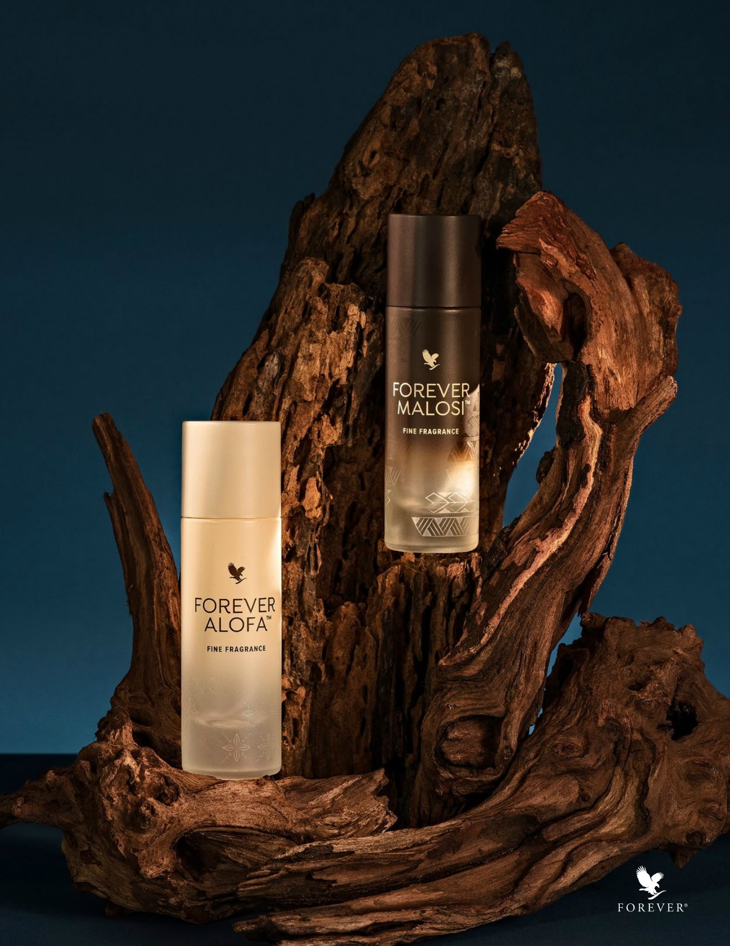





###### Aloe First Spray

#040







Aloe First Spray

TM

Fast-acting, easy-to-use soothing power.

Aloe FirstTM is a perfect addition to your first aid kit or medicine cabinet. This exclusive skin soothing formula is made using stabilized aloe vera gel from our own fields. But we didn't stop there. Aloe FirstTM also contains bee propolis and a proprietary blend of eleven powerful plant extracts.

Of course, aloe vera is the primary and most powerful ingredient for a reason. For centuries, aloe has been used as a remedy to soothe minor burns and provide a sense of relief to irritated skin. We added bee propolis to Aloe First TM because it elevates the natural soothing and cleansing properties of aloe.

Because Forever operates its own fields, we control every aspect of aloe vera production. That means every leaf is hand-filleted to ensure only the purest, highest quali aloe vera makes its way into Forever's Aloe FirstTM.

The combination of aloe and botanical extracts make this a wonderfully soothing mist for use on minor cuts, scrapes, burns and sunburn.

The pH-balanced spray is easy to apply and gets to work fast! As an added benefit, Aloe FirstTM is also great for use on your hair. It provides a great barrier between your hair and the elements.

Make sure you always have a bottle of this versatile spray around to experience the fast-acting soothing power of aloe vera when you

HOUSEHOLD

FAST FACTS

* Soothes minor skin irritations
* Perfect addition to any first-aid kit
* Good fbr hair
* Soothes sunburn

Gluten Free Suitable Air vegetarians

CONTENTS

16 FL. OZ. (1pt.) (473 mL}

DIRECTIONS

Apply liberally to the skin as needed to soothe and moisturize.

CERTIFICATIONS

IASC Certified



INGREDIENTS

Aloe Barbadensis Leaf Juice (Stabilized Aloe Vera Get, Water, Allantoin, Glycerin, Tocopherol, Bee Propolis, Calendula Officinalis Flower Extract, Achillea Millefolium Extract, Thymus Vulgaris (Thyme), Chamomilla Recutita (Matricaria) Flower Extract, Taraxacum Officinale (Dandelion) Root Extract, Eucalyptus Globulus Leaf Extract, Passiflora Incarmata Extract, Salvia Officinalis (Sage) Leaf Extract, Zingiber Officinale (Ginger) Root Extract, Borago Officinalis Extract, Santalum Album (Sandalwood) Extract, Polysorbate 20, Sodium Citrate, Diazolidinyl Urea, Methylparaben.

###### Forever hand Sanitizer

#6318

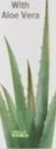

Forever Hand SanitizerTM

Effective, gentle sanitizer for soR hands

Forever Hand Sanitizer is a powerful yet gentle solution for keeping your hands clean and germ-free. Formulated with 70% alcohol of vegetable origin, it effectively kills 99.99% of germs, providing you with peace of mind wherever you go. This sanitizer is particularly essential in today's environment, ensuring that you can maintain hygiene without compromising on skin health.

In addition to its germ-fighting properties, Forever Hand Sanitizer features a moisturizing formula enriched with glycerin and aloe leaf juice. These ingredients work together to keep your hands soft and hydrated, preventing the dryness often associated with frequent hand sanitization. The non-drying formula ensures that your hands feel comfortable and cared for, making it suitable for daily use, even for those with sensitive skin.

The quick-drying nature of this sanitizer makes it an ideal choice for on-the-go lifestyles. Whether you're at work, traveling, or running errands, Forever Hand Sanitizer dries rapidly, allowing you to return to your activities without the wait. Its compact and ponable design means it can easily fit into your bag, purse, or pocket, making it convenient to carry wherever you need it.

Lastly, the soothing aloe fresh fragrance adds a pleasant touch to your sanitization routine. With Forever Hand Sanitizer, you don't just get effective germ elimination; you also enjoy a refreshing scent that leaves your hands feeling revitalized. Overall, this hand sanitizer is a practical, effective, and skin-friendly choice for maintaining hygiene in

any situation.

HOUSEHOLD

FAST FACTS

* Kills 99.99% of germs effectively
* Moisturizes with glycerin and aloe
* Non-drying formula, gentle on skin
* QuiGk-drying for on-the-go use
* Portable, compact design for convenience

COPOSITION

Each ml Contains: Extract of aloe vera (aloe barbadensis) (if.) 0.50mg. processed in Prasanna base-q.s. Prasanna is extra neutral alcohol (content 7096w/w).

CONTENTS

50mL

DIRECTION FOR USE

FOR EXTERNAL USE ONLY. Apply on your palm, spread and rub over back of hands and finger tips. Let it dry. Do not touch any surface before it is completely dry.

  

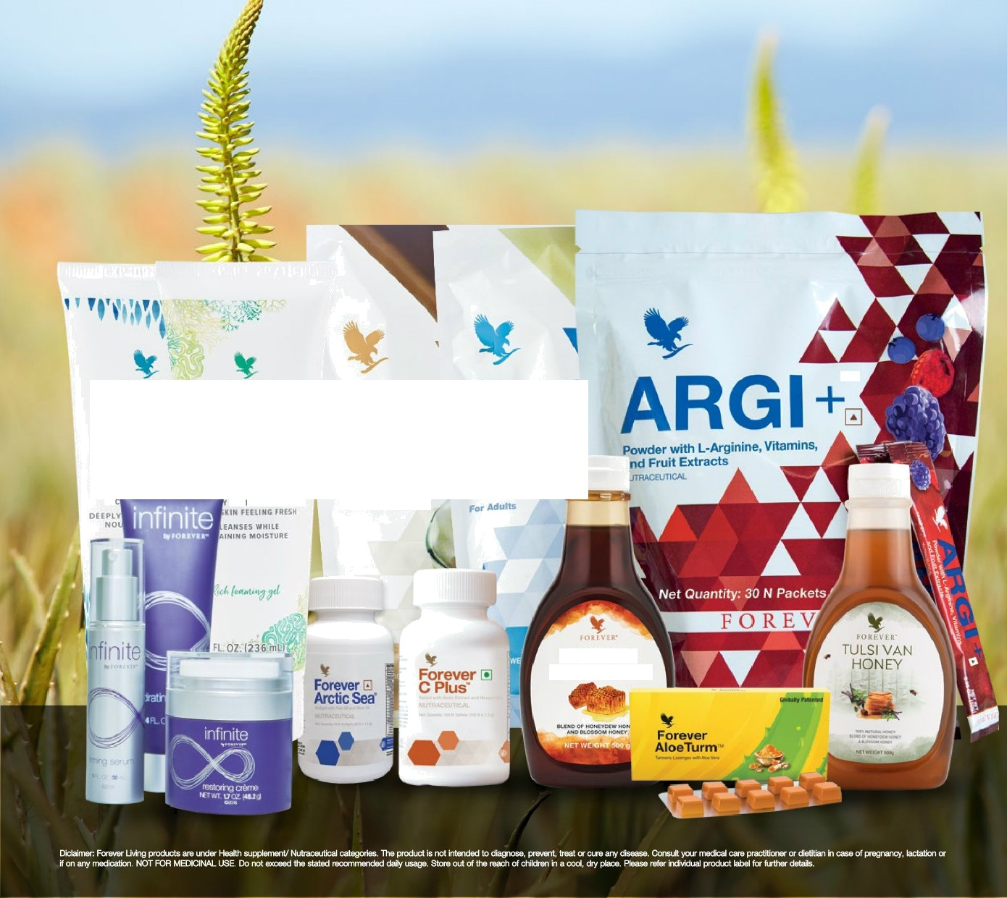

ALOI ALOE BOD' 3ODY L ASH

Forev‹

8EALTH 8UPPLEMEHT

Lite UI

Chocotate Flavoured

S-oy Protein with Added V tgfntns and Minerais

TM

ç:te Vf\

E L UPPLCME NT ”

FOREVER

BEE HONEY

 

ALOE- 3O3OBA

ALOE-

JOJOBA

SHA/vtPO£tONDlTlOwE

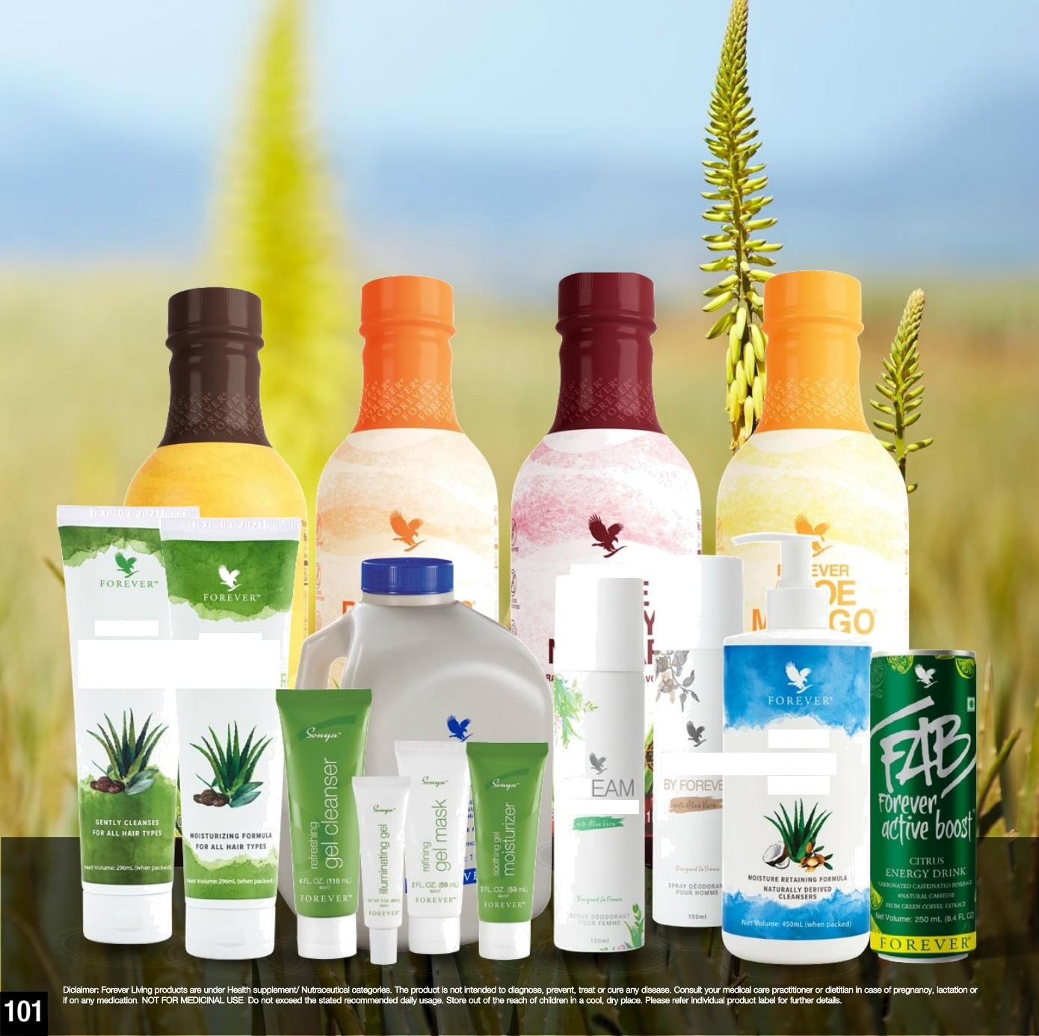

DR

CY FORM

ALOE

--SIR LIQUID

SOAP



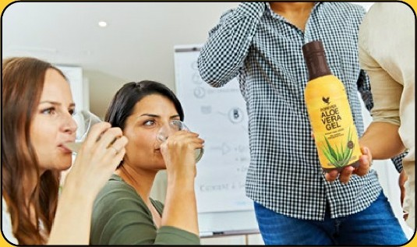





F O R E V E R°

Customer care nurriber - 91 22’ 66.é.1’ 4000

’Website.- [www.foreverIiving.com](http://www.foreverIiving.com/)

Email - flpcare 2pindia.net

’social. ”f ^pinbia ’C”/flpindia /flpindia ./flpindia